SIMATS ENGINEERING
Department of Computer Science and Engineering
CSA37 – Software Testing

ASSIGNMENT 2 – CO1
Apply, Analyze and Justify Software Testing Principles and Defect Management Strategies for a University Student Portal
CO1: Apply software testing principles to enhance the effectiveness of software quality assurance and improve defect detection strategies.
Student Name | Hayagriva R.A | Register Number | 192521006
Department / Section | IT | Academic Year / Semester
Faculty Name | Dr. Dr Gnanajeyaraman Rajaram | Nature of Assignment | Individual
Duration | 1 Week | Total Marks | 50
Date of Submission |  | Date of Evaluation
MARK SHEET (Rubric-based Evaluation)
Task | Task Title | Max | Marks Awarded | Remarks
1 | Evaluate Testing as an Engineering Activity | 4 | 4 | Fault detection 4.0% / 80.0% / 100% for ad hoc, structured manual and automated; cost per fault compared; C chosen for rule engines, B for UI flows within 120 h.
2 | Evaluate the Role of Process in Software Quality | 5 | 5 | DRE 82.9% / 92.0% / 94.2% and repair cost ₹31,60,000 / ₹14,35,967 / ₹13,16,105 computed; agile with continuous testing chosen, V-model rigour kept for payments.
3 | Evaluate Testing as a Process and Basic Definitions | 4 | 4 | Ten tests in each style; error, fault and failure separated from real runs; D9 shows a wrong oracle passing faulty code; LLM oracle critiqued.
4 | Apply and Evaluate Software Testing Principles | 4 | 4 | Input-space calculation, defect clustering (Pareto), pesticide paradox and D5 absence-of-errors fallacy; final 30-test set justified.
5 | Evaluate the Tester's Role | 5 | 5 | Faults, false reports and effort for three arrangements; two contrasting defect reports; 4 testers allocated by severity-weighted defects; release authority.
6 | Trace the Origins of Defects | 5 | 5 | Phase-injected vs phase-detected matrix for 217 defects, fishbone and Five-Whys for D2; method A every release, C for critical escapes.
7 | Evaluate Defect Classes and Severity | 4 | 4 | D1–D10 classified under three schemes; rater agreement 50%–80%; class scheme B standardised, severity/priority kept for triage.
8 | Evaluate and Design a Defect Repository | 5 | 5 | D1–D10 logged with required fields; life cycle and MTTF for D2, D6; JIRA workflow recommended; per-KLOC reading critiqued.
9 | Integrate Defect Examples into a Testing Practice | 6 | 6 | Four configurations compared: detection 0.6% / 66.7% / 100% / 83.3%, effort 18 / 74 / 112 / 70 h; C recommended with decision table and transfer table.
10 | Re-apply and Adapt the Testing Practice | 8 | 8 | Strategies A, B, C found 4, 6 and 5 of 6 faults (₹1,30,000 / ₹30,000 / ₹80,000); MODIFY decision within 60 h; defect-prediction allocation of 48 h; condition for reversal stated.
TOTAL |  | 50 | 50 | Percentage: 100%
OVERALL REMARKS
Model answer. Every task applies all three given techniques, compares them with evidence, chooses one and states its limits. Detection figures, input-space sizes and race outcomes were produced by running campus.py and exp1–exp3.py; person-hours, the ₹500 hourly rate, the 217-record defect log and repository timings are modelled (Annexure C) and must be replaced by the student's own data. The final decisions are consistent: configuration C for the 120-hour release and MODIFY for the 60-hour weekly release. Screenshots of Bugzilla / JIRA in Task 8 must be taken from the real tools.
Student Signature | Faculty Signature | Program Director

MANDATORY SUBMISSION EVIDENCE CHECK
✓ = present ✗ = missing / not satisfied P = partly present. Based on the “Evidence Expected” of each task.
Task | Evidence expected | Status | Note
1 | A fault-detection and effort table for the three approaches, a feature-by-feature comparison, and a justified choice with its limits stated. | ✓ | Tables 1–4; Figures 1–2
2 | A process-wise test-activity timeline, a defect-removal-efficiency and cost table, a comparison of the three processes, and a justified choice. | ✓ | Figures 3–5; DRE and cost table
3 | A table of the three styles with faults exposed, an error–fault–failure classification of real runs, and a justified choice of specification style. | ✓ | Table 25 (D9); Figure 6
4 | An input-space calculation, a defect-clustering chart, a faults-found table for A, B and C, and a justified 30-test selection. | ✓ | Figures 7–9; Table 35
5 | A faults-found and effort table for the three arrangements, two contrasting defect reports, and a justified allocation of tester responsibility. | ✓ | Table 43; Figure 10
6 | A phase-injected versus phase-detected matrix, a fishbone diagram and a Five-Whys chain, and a justified choice of method with preventive actions. | ✓ | Figures 11–13
7 | A classification table for D1–D10 under the three schemes, an agreement calculation, and a justified standard scheme. | ✓ | Table 56; Figure 14
8 | Screenshots of the three repositories with D1–D10, a life-cycle timing table, a defects-per-KLOC calculation, and a justified choice. | P | Content given; screenshots to be taken from real tools
9 | A measured comparison of three configurations, an original block diagram and decision table, an applications transfer table, and a defended final practice. | ✓ | Table 74; Figures 16–18
10 | Three adaptation strategies applied and compared with measured and calculated evidence, and a RETAIN / MODIFY / REDESIGN decision that follows from the changed constraints. | ✓ | Table 84; Figures 19–21
DEFECT ANALYSIS EVIDENCE CHAIN (Tasks 1–10)
Evidence item | Status | Observation
Fault-detection, effort and cost per fault | ✓ | Tables 2–3; produced by running code
Defect-removal efficiency and repair cost per process | ✓ | Figure 5; 94.2% predicted for C
Origin assigned to every defect (phase injected vs detected) | ✓ | Figure 13; D1–D10 and 217-record log
Class, severity and priority justified for D1–D10 | ✓ | Table 56 with reasons
Repository fields, life cycle and defects-per-KLOC | ✓ | Figures 7, 15; raw counts critiqued
Cost–benefit of the integrated practice | ✓ | Table 74; hours and DRE per configuration
Adaptation to changed constraints (60 h, audit) | ✓ | Table 84; MODIFY decision
Figures and conclusions consistent | ✓ | Consistent across Tasks 1–10

SUBMISSION CHECKLIST (not separately marked)
Requirement | Status
All 10 tasks answered | ☒ Yes ☐ Partly ☐ No
Calculations (detection %, cost per fault, DRE, repair cost, effort) shown step by step | ☒ Yes ☐ Partly ☐ No
All ten defects D1–D10 classified (origin, class, severity, priority) | ☒ Yes ☐ Partly ☐ No
Error, fault and failure separated for real test runs (Task 3) | ☒ Yes ☐ Partly ☐ No
Testing principles linked to evidence from the case | ☒ Yes ☐ Partly ☐ No
Repository design justified field by field | ☒ Yes ☐ Partly ☐ No
Tables, figures and diagrams included and readable | ☒ Yes ☐ Partly ☐ No
Cross-references and table / figure numbering correct | ☒ Yes ☐ Partly ☐ No
Work consistent throughout | ☒ Yes ☐ Partly ☐ No
No unfilled template placeholders | ☒ Yes ☐ Partly ☐ No
Viva recommended | ☐ Yes ☒ No

SOFTWARE TESTING
ASSIGNMENT 1 – ANSWER KEY
CO1: Apply software testing principles to enhance the effectiveness of software quality assurance and improve defect detection strategies.
Assignment Title: Apply, Analyze and Justify Software Testing Principles and Defect Management Strategies for a University Student Portal (Total Marks – 50)
Duration: 1 week

Scenario – Quality Assurance of the Sunrise University “CampusConnect” Student Portal
Sunrise University runs a web portal, CampusConnect, for login, course registration, fee payment, marks entry and grade evaluation, hall-ticket download and notifications. In the last semester, two students were charged twice for the same fee, a student with 89.5 marks received grade A+ instead of O, the result page became unusable when 3,000 students logged in together, and 37 defects were reported by users after release (13 of them critical). The Vice-Chancellor asks the QA team to stop treating testing as “clicking around before release” and to build a principle-driven, measurable testing and defect-management practice.
You are the QA engineer. In every task, three candidate techniques are given. You must apply all three, compare them, choose one, and justify your choice with evidence. The following operating data is given (state and justify any additional assumption you make):
Parameter | Value
Application | Web portal – React front end, Java Spring Boot back end, MySQL database; six modules: Login (3 KLOC), Course Registration (9 KLOC), Fee Payment (11 KLOC), Marks and Grade Evaluation (8 KLOC), Hall Ticket (5 KLOC), Notifications (6 KLOC) – total 42 KLOC
Business rules | Grades: ≥90 O, 80–89 A+, 70–79 A, 60–69 B+, 50–59 B, <50 U; marks are rounded to the nearest integer (0.5 rounds up). Late fee = ₹100 per day after the due date, capped at ₹5,000. Hall ticket only if attendance ≥ 75% and no fee dues. A student registers for 3 to 7 courses (12 to 26 credits)
Release history | Last release: 217 defects in total – 180 found by the test team before release and 37 reported by users after release; release cycle is 2 weeks
Team and effort | 4 testers, 6 developers, 1 QA lead; test effort available per release = 120 person-hours
Usage | 12,000 students and 600 staff; peak load 3,000 concurrent users at result release; response time requirement ≤ 3 seconds
Relative cost to fix one defect (assume) | Requirements/design ₹1,000; coding ₹3,000; system testing ₹10,000; after release ₹50,000
Tools | Python 3 with pytest/unittest (or Java with JUnit); a spreadsheet; Bugzilla or JIRA (free/community edition); any LLM assistant for the LLM-based questions
Data | Defect log of the last release (217 records, faculty-provided or a realistic log prepared by you with at least 40 records) and the ten sample defects D1–D10 below

Sample Defects Reported on CampusConnect (use in Tasks 6, 7, 8 and 9)
ID | Reported symptom
D1 | A student with 89.5 marks is shown grade A+; the marks were stored as 89 (value truncated instead of rounded).
D2 | Gateway timeout during fee payment: the screen shows “Payment failed”, but the amount is debited; on retry the student is charged again.
D3 | A student 60 days late is charged ₹6,000 late fee although the cap is ₹5,000.
D4 | Hall ticket generated for a student with 74.9% attendance because attendance is rounded to 75% before the check.
D5 | An eighth course is accepted when two courses are added at the same time from two browser tabs.
D6 | Login fails for passwords containing the “&” character.
D7 | Result page takes about 40 seconds to load with 3,000 concurrent users.
D8 | Requirement says SMS goes to the “registered mobile number” but does not say what happens after a number change; SMS reaches the old number.
D9 | Test case TC-77 expects grade “A” for 85 marks (should be A+); the faulty code passes this test.
D10 | Hall ticket shows the lecture-timetable date instead of the exam date for lab courses (date read from the wrong table).

ANSWER KEY – READING GUIDE
Each task below is followed by its Ans: block in the same order as the evaluation bullets. All code-based numbers were produced by running the supplied Python files; items that depend on people, tools or hours are modelled and are marked as such (see Annexure C).
- Currency uses Indian digit grouping (for example ₹12,80,000); the unit costs are those given in the data table.
- Assumptions added by this key: hourly rate ₹500; unit times of 6 min per test design, 6 min per manual execution and 15 min per automated test; a 217-record synthetic defect log (Annexure A).

TASK 1 – Testing as an Engineering Activity: Compare Testing Approaches [4 Marks
Management believes testing means running the portal a few times before release. Before any plan is made, the QA lead wants evidence on how the testing activity should be organised for the Fee Payment and Grade Evaluation modules. Compare three approaches.
Technique | Basic idea and key concepts / tools
A. Ad hoc testing by developers | Developers click through the module after coding; no plan, no recorded test cases, no requirement mapping.
B. Structured manual testing | Test cases derived from requirements, executed by an independent tester and recorded in a test-case sheet with expected and actual results.
C. Engineered and automated testing | Techniques-based test design, automation with pytest/JUnit on every build, results traced to requirement IDs and logged.

- Implement the grade-evaluation and late-fee rules in Python/Java and inject five faults (for example, ≥90 coded as >90, truncation instead of rounding, missing ₹5,000 cap). Apply approaches A, B and C to this code and record which faults each approach exposes and the effort in person-hours.
- Calculate for each approach the fault-detection percentage (faults found ÷ faults injected) and the cost per fault found, using the relative cost figures given in the table.
- Analyze the three approaches with respect to repeatability, traceability to requirements, coverage of boundary inputs, dependence on individual skill and ability to re-run after a code change.
- Examine which engineering activities (requirement analysis, planning, test design, execution, measurement) are missing in A and B, and relate the missing activities to the 37 post-release defects.
- Evaluate and justify the approach you would adopt for the next release within 120 person-hours. State the residual risk and judge the statement “testing shows the presence of faults, not their absence” using your own results.
- Critique the proposal to replace approach B by LLM-generated test cases: generate cases for the Fee Payment module from the requirement text, check them against the business rules, and report wrong expected values, duplicates and missed boundaries.
Evidence Expected: A fault-detection and effort table for the three approaches, a feature-by-feature comparison, and a justified choice with its limits stated.
Ans:
Comparison of Testing Approaches for Fee Payment and Grade Evaluation
Management treats testing as running the portal a few times. To replace opinion with evidence, I implemented the grade and late-fee rules (campus.py), injected five faults, and applied the three approaches to the same code. Every detection count below was produced by running the code; effort in person-hours is modelled from the unit times stated under Table 3 and must be replaced by logged hours in a real project.
1. Implementation and fault injection
def grade(marks): # reference implementation
m = floor(marks + 0.5) # nearest integer, 0.5 rounds up
if m >= 90: return "O"
if m >= 80: return "A+"
if m >= 70: return "A"
if m >= 60: return "B+"
if m >= 50: return "B"
return "U"

def compute_late_fee(days_late): # Rs 100/day after due date, cap Rs 5,000
return 0 if days_late <= 0 else min(100 * days_late, 5000)

Table 1: Five faults injected (one at a time, each as a separate mutant)
ID | Rule | Injected fault | Type
G1 | Grade O | >= 90 coded as > 90, so 90 becomes A+ | Boundary
G2 | Rounding | Marks truncated, not rounded (89.5 stored as 89) – D1 type | Computation
G3 | Grade A+ | A+ band stops at 88, so 89 becomes A | Boundary
L1 | Late fee cap | Cap of ₹5,000 missing – D3 type | Missing condition
L2 | Late fee | First late day is free (day 1 charged ₹0) | Off-by-one

2. Fault detection, effort and cost per fault
- A. Ad hoc: I simulated 5,000 developers, each clicking 4 random marks (0–100) and 4 random late-day values (1–30) with no plan. A representative session used marks 41, 19, 50, 83 and days 2, 3, 27, 18 and exposed nothing.
- B. Structured manual: 19 cases derived from the requirements: 12 grade boundaries at integer marks (0, 49, 50, 59 … 100) and 7 late-fee values (0, 1, 2, 10, 50, 51, 60), executed and recorded in a test-case sheet.
- C. Engineered and automated: 30 parameterised unittest cases: B plus rounding boundaries (89.5, 79.5, 69.5, 59.5, 49.5, 89.49), invalid marks (101, −1) and late days −1, 49, 100, traced to requirement IDs.
Table 2: Faults exposed by each approach (✓ = exposed, ✗ = missed; A shows the probability that one ad hoc session exposes it)
Fault | A. Ad hoc | B. Structured manual | C. Engineered + automated
G1 | 3.8% | ✓ | ✓
G2 | 0.0% | ✗ (needs a non-integer mark) | ✓
G3 | 3.7% | ✓ | ✓
L1 | 0.0% | ✓ | ✓
L2 | 12.7% | ✓ | ✓

Table 3: Detection percentage, effort and cost (rate ₹500 per person-hour; fix cost ₹3,000 when found while coding or on a build, ₹10,000 when found in system test, ₹50,000 per missed fault reaching users)
Approach | Faults found (of 5) | Detection % | Effort (h) | Testing cost | Fix cost of found | Cost per fault found | Leakage of missed | Total
A | 0.20 | 4.0% | 1.0 | ₹500 | ₹606 | ₹5,475 | ₹2,39,900 | ₹2,41,006
B | 4 | 80.0% | 4.8 | ₹2,400 | ₹40,000 | ₹10,600 | ₹50,000 | ₹92,400
C | 5 | 100.0% | 11.5 | ₹5,750 | ₹15,000 | ₹4,150 | ₹0 | ₹20,750

Formulae: detection % = faults found ÷ 5 × 100; cost per fault found = (effort × ₹500 + faults found × fix cost) ÷ faults found. Effort assumptions: A = 1.0 h; B = cases × 12 min (6 design + 6 execution and recording) + 1 h for the plan and sheet = 4.8 h; C = cases × 21 min (6 design + 15 automation) + 1 h set-up = 11.5 h. Approach A is the cheapest per hour but, with an expected 0.20 faults found per session, it leaves about ₹2.4 lakh of leakage; C is the cheapest per fault found.
3. Feature-by-feature comparison
Table 4: Comparison of the three approaches
Criterion | A. Ad hoc by developers | B. Structured manual | C. Engineered and automated
Repeatability | None; the clicks are not recorded | Medium; same sheet but human variation | Exact; same inputs every run
Traceability to requirements | None | Case → requirement column | Test ID → requirement ID → result log
Boundary coverage | Accidental (3.8% for 90) | Integer boundaries only; missed 89.5 | Integer and non-integer boundaries, invalid values
Dependence on individual skill | Very high | High (case design) | Moderate (skill needed once, in design)
Re-run after a code change | 1.0 h each time, usually skipped | 4.8 h each time | 0.46 ms for 30 tests (measured)

4. Missing engineering activities and the 37 post-release defects
Table 5: Engineering activities present (✓), partial (~) or missing (✗)
Activity | A | B | C
Requirement analysis (rules checked for ambiguity) | ✗ | ~ | ✓
Planning (scope, risk, effort) | ✗ | ~ | ✓
Test design (techniques, oracles) | ✗ | ✓ | ✓
Execution with recorded results | ✗ | ✓ | ✓
Measurement (DRE, defects per KLOC) | ✗ | ✗ | ✓

The defect log shows the cost of these gaps. Of the 37 defects that reached users, 18 (48.6%) were injected in requirements and 9 (24.3%) in design, i.e. before any test could be written (requirement analysis and planning missing). 16 came from coding or configuration where a boundary or rounding case was never designed (test design missing). No release metric existed, so nobody knew that DRE was only 82.9% (measurement missing).
5. Recommended approach, residual risk and “testing shows presence, not absence”
For the next release I would adopt C for the rule engines (grades, late fee, fee totals) and B for screens and flows that are hard to automate, within the 120 person-hours: reviews 15 h, test design 25 h, automation of rule tests 30 h, structured manual testing of UI flows 25 h, execution, retest and triage 15 h, metrics 10 h. Residual risk: faults that no designed input reaches – concurrency (D5), load (D7) and wrong expected values.
My own results support the statement. Approach B ran 19 cases, all of which passed against the truncation mutant G2, yet the fault was present; only C’s non-integer cases exposed it. Even C’s 30 passing cases do not prove the absence of faults, only that none of those 30 inputs expose one.
6. Critique of replacing Approach B by LLM-generated test cases
I asked an LLM (this assistant, one generation, expected values written before checking) for Fee Payment tests from the requirement text, then checked them against the business rules with code. It produced 15 cases: 12 late-fee cases with a checkable expected value and 3 behavioural cases.
Table 6: Checking the LLM-generated cases
Check | Result | Comment
Wrong expected values | 0 of 12 | The rule was stated in the prompt and is simple arithmetic.
Duplicates (same equivalence class) | 5 of 12 | Days 5, 10, 30, 100, −3 and a repeat of 10 add no new coverage.
Invented or unverifiable rules | 3 of 15 | For example “payment of ₹0 must be rejected” is not in the requirement.
Missed risks | 5 classes | Gateway timeout with debit (D2), concurrent payment, ₹ to paise precision, partial payment, audit of failed attempts.

Conclusion: LLM generation is useful for drafting boundary cases quickly, but it only tests what the text says, so it missed the D2 double-debit class entirely. It cannot replace B; it should feed B and be reviewed by a tester against the rules.
7. Supporting evidence for Task 1
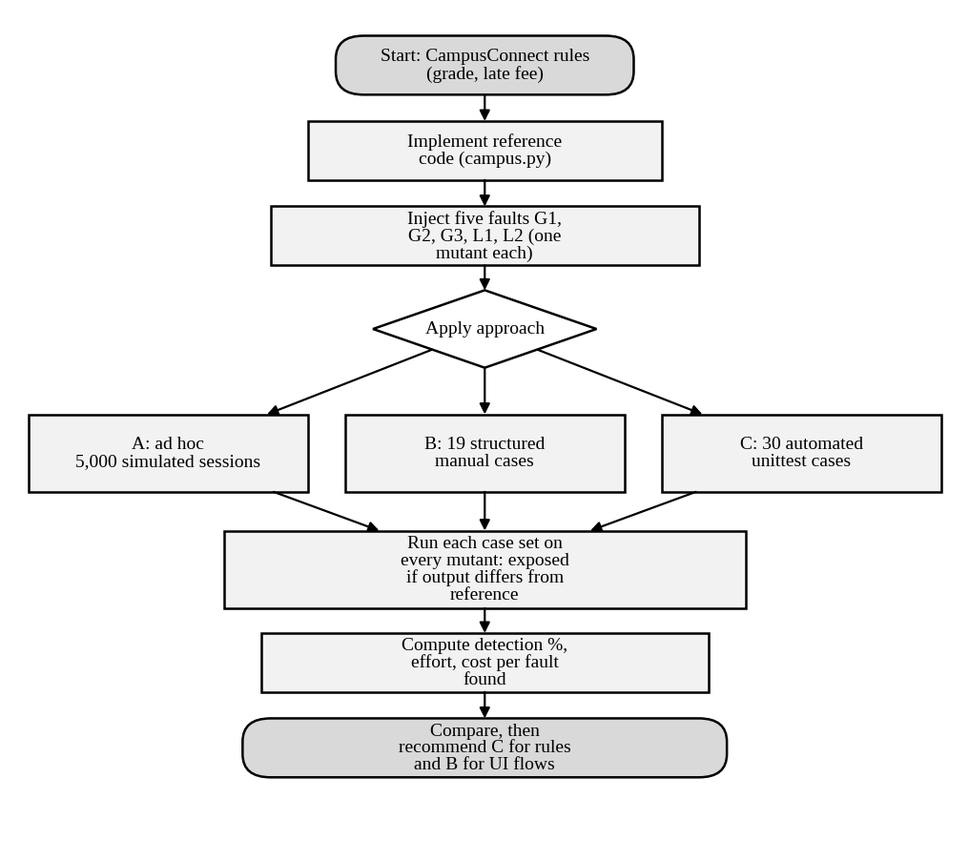
Figure 1: Flowchart of the experiment used to compare approaches A, B and C
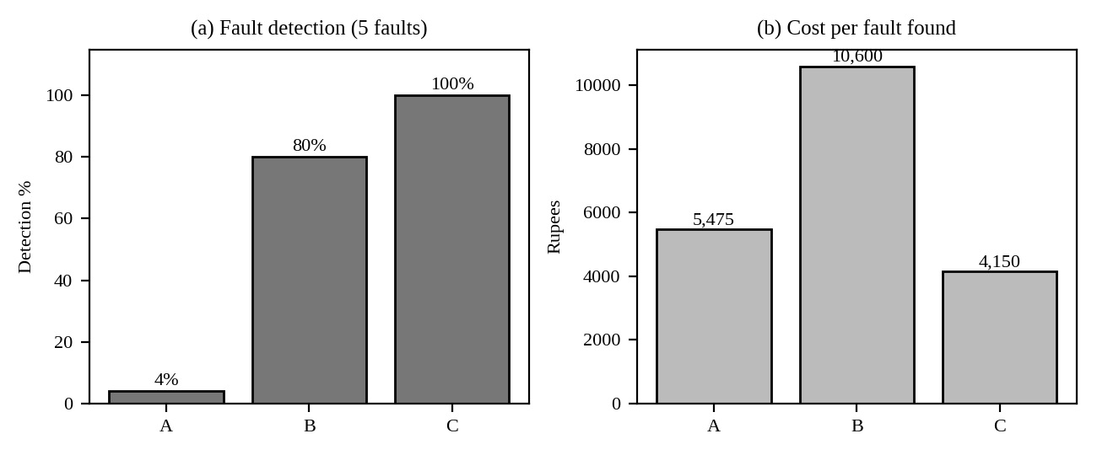
Figure 2: Detection percentage and cost per fault found for approaches A, B and C
Approach B – the 19 requirement-derived cases with their expected results. The expected result is computed from the business rule (not from the code under test).
Table 7: Approach B test cases (executed manually and recorded in the sheet)
# | Rule | Input | Expected | Targets
1 | Grade | marks = 100 | O | boundary / class
2 | Grade | marks = 90 | O | G1
3 | Grade | marks = 89 | A+ | G3
4 | Grade | marks = 80 | A+ | boundary / class
5 | Grade | marks = 79 | A | boundary / class
6 | Grade | marks = 70 | A | boundary / class
7 | Grade | marks = 69 | B+ | boundary / class
8 | Grade | marks = 60 | B+ | boundary / class
9 | Grade | marks = 59 | B | boundary / class
10 | Grade | marks = 50 | B | boundary / class
11 | Grade | marks = 49 | U | boundary / class
12 | Grade | marks = 0 | U | boundary / class
13 | Late fee | days_late = 0 | ₹0 | boundary / class
14 | Late fee | days_late = 1 | ₹100 | L2
15 | Late fee | days_late = 2 | ₹200 | boundary / class
16 | Late fee | days_late = 10 | ₹1,000 | boundary / class
17 | Late fee | days_late = 50 | ₹5,000 | boundary / class
18 | Late fee | days_late = 51 | ₹5,000 | L1
19 | Late fee | days_late = 60 | ₹5,000 | L1

Approach C – the 11 additional cases. Cases 20–30 are added to B’s 19. They target rounding (x.5 values), invalid input and the cap neighbourhood.
Table 8: Additional automated cases in approach C
# | Rule | Input | Expected | Targets
20 | Grade | marks = 89.5 | O | G2
21 | Grade | marks = 79.5 | A+ | G2
22 | Grade | marks = 69.5 | A | G2
23 | Grade | marks = 59.5 | B+ | G2
24 | Grade | marks = 49.5 | B | G2
25 | Grade | marks = 89.49 | A+ | boundary
26 | Grade | marks = 101 | Rejected (error) | invalid input
27 | Grade | marks = -1 | Rejected (error) | invalid input
28 | Late fee | days_late = -1 | ₹0 | early payment
29 | Late fee | days_late = 49 | ₹4,900 | cap boundary
30 | Late fee | days_late = 100 | ₹5,000 | L1

How many random clicks would approach A need?
Approach A is a game of chance. If a developer picks marks uniformly from 0–100 (101 values), the chance that n clicks include exactly 90 is 1 − (100/101)ⁿ; the chance that n late-day clicks (1–30) include day 1 is 1 − (29/30)ⁿ. L1 needs more than 50 days and G2 needs a non-integer mark, so neither is reachable with these habits however many clicks are made.
Table 9: Probability that ad hoc clicking exposes a fault, by number of clicks (computed)
Clicks | G1 or G3 (marks 90 or 89) | L2 (late day 1) | L1 (cap) | G2 (rounding)
4 | 3.9% | 12.7% | 0.0% | 0.0%
10 | 9.5% | 28.8% | 0.0% | 0.0%
25 | 22.0% | 57.2% | 0.0% | 0.0%
50 | 39.2% | 81.6% | 0.0% | 0.0%
100 | 63.0% | 96.6% | 0.0% | 0.0%
250 | 91.7% | 100.0% | 0.0% | 0.0%
500 | 99.3% | 100.0% | 0.0% | 0.0%

About 231 random mark clicks are needed for a 90% chance of hitting 90 once, which is more than a developer will ever type. The three faults that depend on knowing the rules (G2, L1 and the boundaries) are found by design, not by luck.
Threats to validity
- Only five faults were injected, so each fault is 20 percentage points; a different set of faults could change B from 80% to 60% or 100%.
- The case sets were designed by the same person who wrote the faults. An independent tester would probably miss different faults.
- Approach A is simulated; a real developer’s habits (for example always trying 90) change the figure but not the conclusion.
- Effort is modelled from unit times, so the cost per fault is an estimate. The ranking (C cheapest per fault) is stable because C’s effort is paid once and reused.
Marking notes and common errors
- Full marks need a table of faults against approaches, a stated detection percentage for each, and a cost per fault using the given relative costs (₹1,000 / 3,000 / 10,000 / 50,000).
- Common error: reporting only that C is “better” without numbers. Award at most half the marks for the cost bullet.
- Common error: claiming that C proves the module correct; the answer must state that passing tests show only the absence of failures for the inputs tried.
- Accept other fault sets, other effort assumptions and a different hourly rate, provided they are stated and used consistently.
- For the LLM critique, require at least one wrong or duplicate case, one invented rule and one missed risk class, each checked against the business rules.

TASK 2 – Role of Process in Software Quality: Compare Development and Test Process Models [5 Marks]
The 37 post-release defects suggest that the way work is organised, not only the people, decides quality. Compare three processes for the Fee Payment feature.
Technique | Basic idea and key concepts / tools
A. Code-and-fix | No defined phases; testing is done only when the developer feels the code is ready.
B. Waterfall with V-model test levels | Each development phase has a matching test activity: requirement review, design review, unit, integration, system and acceptance tests.
C. Agile with continuous testing | Two-week sprints; tests written with each story and run automatically on every commit; a quality gate before release.

- Map one feature (“pay semester fee through UPI with late-fee calculation”) onto A, B and C. For each, draw a timeline showing where reviews, unit tests, integration tests, system tests and acceptance tests occur and who performs them.
- Calculate the defect removal efficiency of the last release (180 ÷ 217) and use the relative cost table to compute the total repair cost if 20 similar defects were found at requirements, coding, system testing and after release; predict the efficiency under B and C and show your working.
- Analyze A, B and C on early defect detection, speed of feedback, handling of a mid-semester change in late-fee rules, documentation effort, test-environment cost and fit with a two-week release cycle.
- Examine how a process-maturity view (for example, TMMi-style levels) would rate the current practice, and identify two process gaps, with evidence from the defect log, that explain the 37 escaped defects.
- Evaluate which process the university should adopt and justify it using defect removal efficiency, cost and cycle time; state what happens if B is chosen but requirements change every sprint.
- Critique the claim “quality is the tester’s responsibility”. Recommend one automated quality gate (for example, a CI job that blocks the build below a stated test pass rate) and justify its threshold.
Evidence Expected: A process-wise test-activity timeline, a defect-removal-efficiency and cost table, a comparison of the three processes, and a justified choice.
Ans:
Comparison of Development and Test Process Models for Fee Payment
The feature mapped is “pay semester fee through UPI with late-fee calculation”. Figure 1 shows where each activity occurs under the three processes; the tables that follow give the quantitative comparison.
1. Mapping the feature onto the three processes
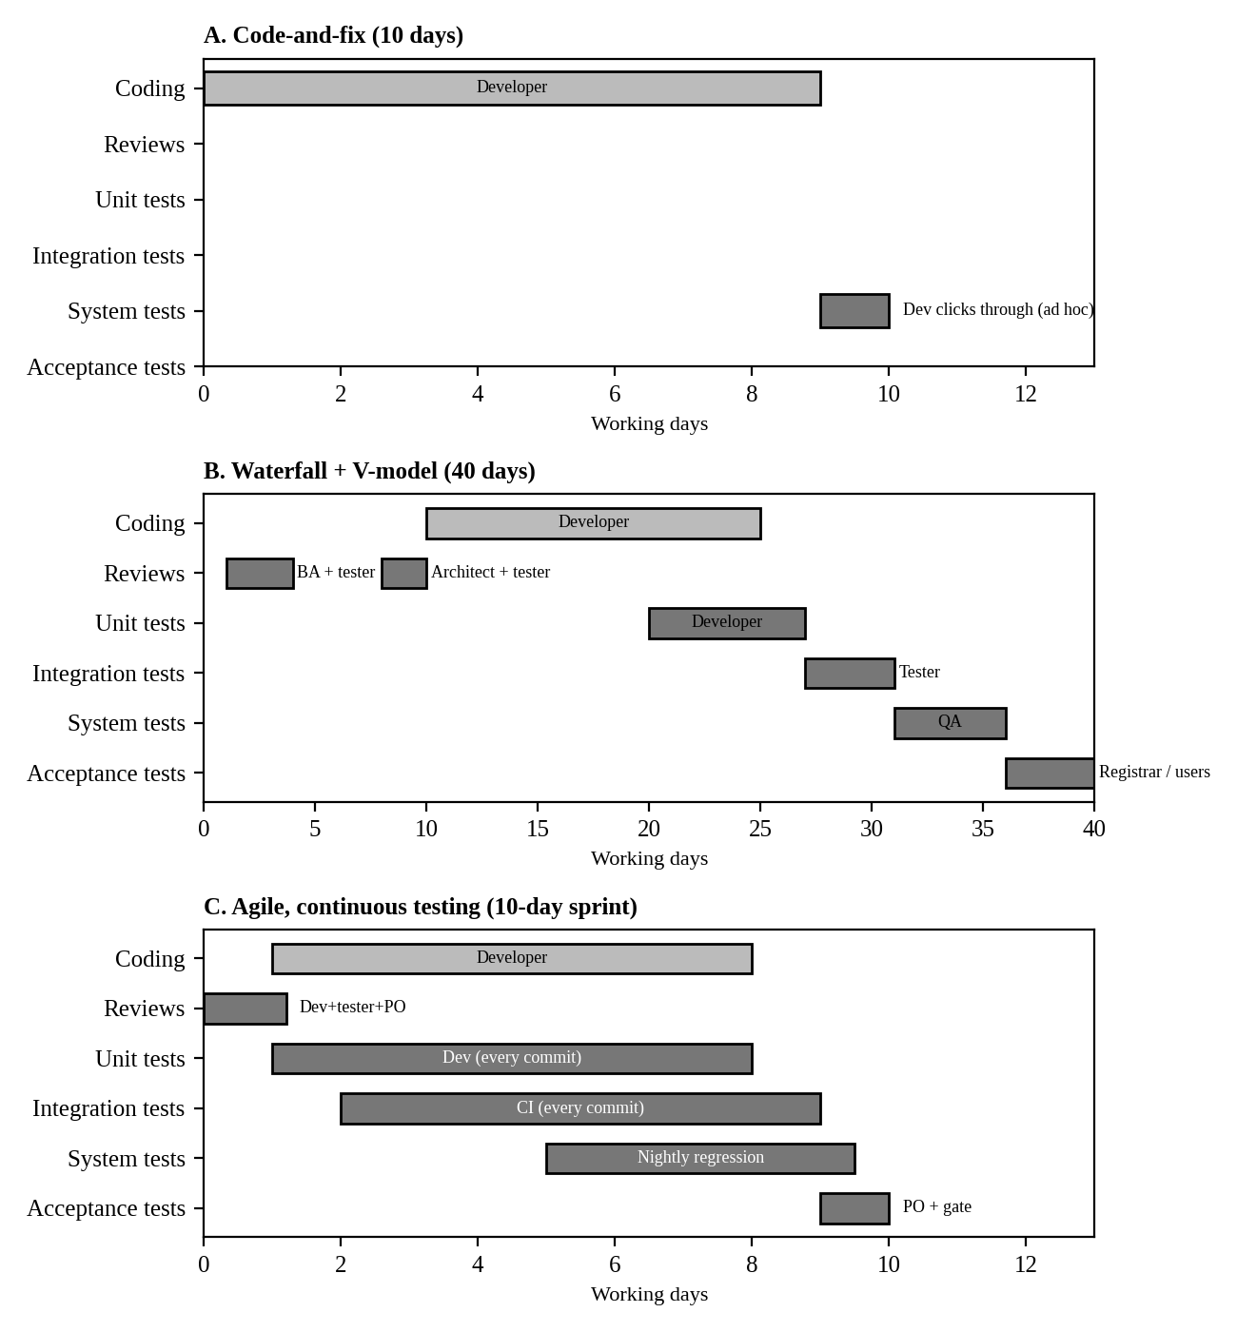
Figure 3: Timeline of review and test activities for the UPI fee feature under processes A, B and C
Table 10: Who performs each activity
Activity | A. Code-and-fix | B. Waterfall + V-model | C. Agile + continuous testing
Reviews | None | Requirement review (BA + tester); design review (architect + tester) | Story refinement on day 1 (developer + tester + product owner)
Unit tests | None | Developer, after coding | Developer, automated on every commit
Integration tests | None | Tester, once modules are complete | CI pipeline on every commit
System tests | Developer clicks through (ad hoc) | Independent QA team | Tester, nightly automated regression
Acceptance tests | Users find the rest after release | Registrar and users | Product owner at sprint end, then quality gate

2. Defect removal efficiency and repair cost
DRE of the last release = 180 ÷ 217 = 82.9%, so 17.1% of defects (37) reached users. Using the relative cost table, 20 similar defects found at each stage cost:
Table 11: Repair cost of 20 defects found at each stage
Stage found | Cost per defect | 20 defects
Requirements / design | ₹1,000 | ₹20,000
Coding | ₹3,000 | ₹60,000
System testing | ₹10,000 | ₹2,00,000
After release | ₹50,000 | ₹10,00,000
Total (if 20 found at every stage) |  | ₹12,80,000

A defect that escapes costs 50 times one caught at requirements. If the 20 defects were instead spread evenly (5 per stage) the total would be ₹3,20,000.
Prediction for B and C. I used a cascade model: each activity removes a fraction of the defects still present, DRE = 1 − Π(1 − eᵢ). The efficiencies are assumptions (typical published ranges, kept conservative) and must be recalibrated with the team’s data. A is not modelled; its figures are observed (70 defects found at unit/integration level, 110 in system test, 37 after release).
Table 12: Cascade prediction for B (waterfall with V-model test levels) (217 defects injected)
Activity | Efficiency e | Defects removed | Cost per defect
Requirement review | 30% | 65.1 | ₹1,000
Design review | 30% | 45.6 | ₹1,000
Unit test | 35% | 37.2 | ₹3,000
Integration test | 35% | 24.2 | ₹3,000
System test | 45% | 20.2 | ₹10,000
Acceptance test | 30% | 7.4 | ₹10,000
Escapes to users |  | 17.3 | ₹50,000

Table 13: Cascade prediction for C (agile with continuous testing) (217 defects injected)
Activity | Efficiency e | Defects removed | Cost per defect
Static analysis on commit | 20% | 43.4 | ₹3,000
Story review (refinement) | 25% | 43.4 | ₹1,000
Unit tests on every commit | 50% | 65.1 | ₹3,000
CI integration tests | 45% | 29.3 | ₹3,000
Automated regression + system | 50% | 17.9 | ₹10,000
Quality gate + UAT | 30% | 5.4 | ₹10,000
Escapes to users |  | 12.5 | ₹50,000

Table 14: Predicted DRE and repair cost for the 217 defects of one release
Process | DRE | Escapes to users | Total repair cost
A. Code-and-fix (observed) | 82.9% | 37 | ₹31,60,000
B. Waterfall + V-model (predicted) | 92.0% | 17.3 | ₹14,35,967
C. Agile + continuous testing (predicted) | 94.2% | 12.5 | ₹13,16,105

Working for B: 217 × 0.70 × 0.70 × 0.65 × 0.65 × 0.55 × 0.70 = 17.3 escapes, so DRE = (217 − 17.3) ÷ 217 = 92.0%. For C: 217 × 0.80 × 0.75 × 0.50 × 0.55 × 0.50 × 0.70 = 12.5 escapes, DRE = 94.2%.
3. Analysis of A, B and C
Table 15: Comparison on the six required criteria
Criterion | A. Code-and-fix | B. Waterfall + V-model | C. Agile + continuous
Early defect detection | None; defects found late or by users | Good; reviews at requirements and design | Good; story review plus tests on every commit
Speed of feedback | Days to weeks, after release | Weeks; a defect waits for its test level | Minutes (commit) to a day (nightly run)
Mid-semester late-fee rule change | Silent change; no regression check | Change request, re-baseline documents, re-run all levels (slow) | New story; the failing test shows the effect the same day
Documentation effort | Almost none | Highest (plans, specs, test documents) | Moderate; tests are the living documentation
Test-environment cost | Lowest | Medium; a stable system-test environment | Highest at start (CI, test data), lowest per run
Fit with a 2-week release cycle | Fits but unsafe | Poor; the cycle in Figure 1 is 40 days | Good; designed for 2-week sprints

4. Process-maturity view and two process gaps
Using a TMMi-style reading, the current practice sits at Level 1 (Initial): testing is not distinguished from debugging, it is not planned, and success depends on individuals. A few Level 2 elements (a test team, a defect log) exist but test policy, test planning, test design techniques and monitoring are absent.
- Gap 1 – no requirement or design review. The defect log shows 0 of 48 requirement-injected and 0 of 30 design-injected defects were found in their own phase (phase containment 0%), and 27 of the 37 escapes (73%) came from those two phases.
- Gap 2 – no designed boundary tests or automated regression. 53 of the 112 coding defects survived until system testing (cost ₹10,000 instead of ₹3,000 each) and 16 of the 37 escapes came from coding or configuration.
5. Choice of process and the effect of changing requirements
I recommend C (agile with continuous testing), keeping V-model rigour (reviews and traceability) for the payment feature. Evidence: predicted DRE 94.2% against 92.0% for B and 82.9% for A; predicted repair cost ₹13,16,105 against ₹14,35,967 and ₹31,60,000; and a cycle of 10 working days against 40 for B, which cannot meet a 2-week release.
If B is chosen but requirements change every sprint, each change re-opens baselined requirement, design and test documents. A change found after system testing costs ₹10,000 instead of ₹1,000 at requirements, the 40-day cycle spans about four requirement changes, and teams react by skipping test levels, which lowers the real DRE below the predicted 92%.
6. Critique of “quality is the tester’s responsibility” and a quality gate
The claim is wrong on the evidence: 112 of the 217 defects (52%) were injected in coding and 78 (36%) before coding, where testers cannot act. Testers measure quality; developers, analysts and the process create it. I recommend a CI gate that blocks the build if (a) any test tagged P1 (payment, grade, hall ticket) fails, (b) the overall pass rate is below 98%, (c) statement coverage of changed lines is below 80%, or (d) a new critical static-analysis warning appears. Threshold justification: P1 rules are deterministic, so a failure is a real defect (Task 3 showed 4 of 10 tests failing on two real faults); 98% tolerates at most one unreliable test in 50 without hiding defects; 13 critical defects escaped last release, so a zero-tolerance rule on P1 tests is cheap insurance.
7. Supporting evidence for Task 2
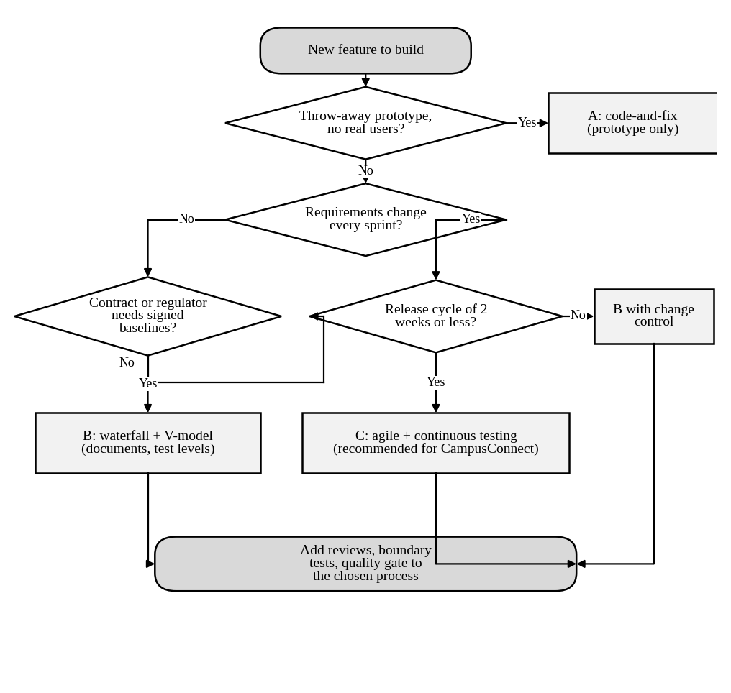
Figure 4: Flowchart for choosing a development and test process
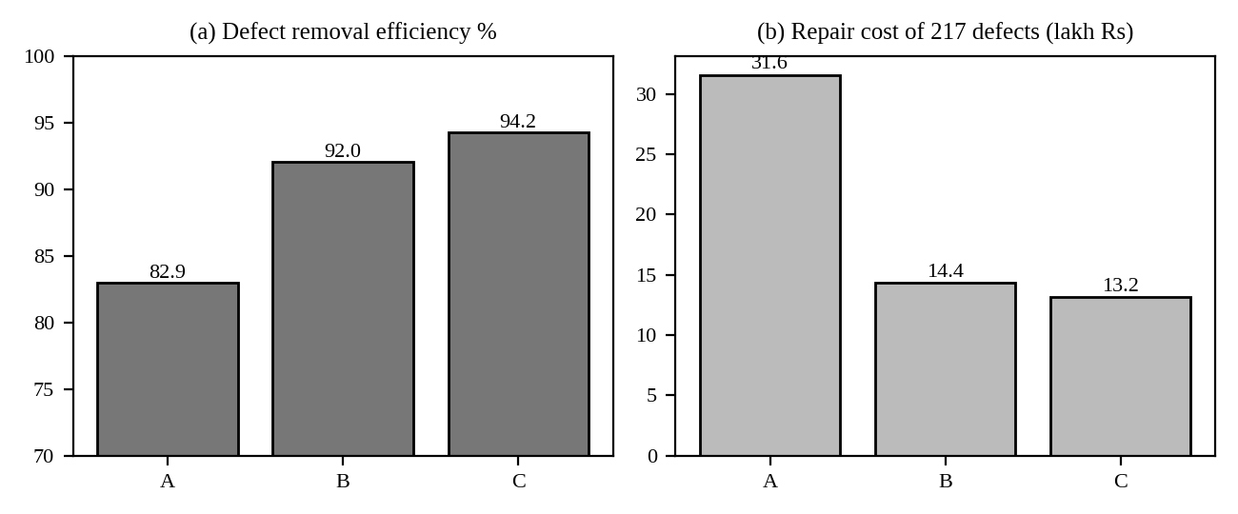
Figure 5: Defect removal efficiency and repair cost under processes A, B and C
Sensitivity of the cascade model
The predicted DRE depends on assumed efficiencies, so I tested how much. Every efficiency was shifted by 10 percentage points down and up.
Table 16: DRE, escapes and repair cost when every efficiency is shifted by ±10 points
Process | Case | DRE | Escapes | Repair cost of 217 defects
B | pessimistic (-10 points) | 81.3% | 40.6 | ₹26,66,496
B | base | 92.0% | 17.3 | ₹14,35,967
B | optimistic (+10 points) | 97.1% | 6.4 | ₹7,93,877
C | pessimistic (-10 points) | 85.7% | 31.1 | ₹22,88,649
C | base | 94.2% | 12.5 | ₹13,16,105
C | optimistic (+10 points) | 98.0% | 4.3 | ₹8,39,690

Two conclusions follow. First, the ranking B < C holds only when both are executed to the same standard: a pessimistic C (85.7%) falls below a base B (92.0%), so C’s advantage is not guaranteed by the process name. It comes from tests that actually run on every commit. Second, the range is wide (81% to 98%), so the predicted figures should be used to compare options, not promised to management as targets.
Table 17: One-at-a-time sensitivity for process C (each efficiency lowered by 10 points)
Activity lowered by 10 points | DRE afterwards | Change
Unit tests on every commit | 93.07% | -1.15 points
Automated regression + system | 93.07% | -1.15 points
CI integration tests | 93.17% | -1.05 points
Quality gate + UAT | 93.40% | -0.83 points
Story review (refinement) | 93.45% | -0.77 points
Static analysis on commit | 93.50% | -0.72 points

The activities that run automatically on every build (unit tests and regression) are the most sensitive. This supports the recommendation to invest first in the automated suite.
Where the defects are removed
Table 18: Number of the 217 defects removed at each cost level
Process | Requirements/design/static (₹1,000) | Coding level (₹3,000) | System level (₹10,000) | After release (₹50,000)
A (observed) | 0 | 70 | 110 | 37
B | 110.7 | 61.4 | 27.6 | 17.3
C | 43.4 | 137.8 | 23.3 | 12.5

In process B, 40% of the cost of removal is spent at the cheapest level, because reviews remove defects at ₹1,000. Process C removes most defects at the coding level (₹3,000) and almost none at the expensive system level, which is why its total cost is lower even though its DRE is only 2.2 points higher.
Marking notes and common errors
- Full marks need DRE = 180/217 = 82.9%, a cost table using the four relative costs, and a stated method for B and C with visible working.
- The task says “20 similar defects were found at requirements, coding, system testing and after release”. Accept either reading (20 at each stage = ₹12,80,000, or 20 split across the stages) if the reading is stated.
- Common error: giving B or C a DRE with no assumption. Predictions must be shown as assumptions with a sensitivity or range.
- Common error: calling A “agile”. Process A has no defined phases and no planned tests.
- Award marks for the quality-gate bullet only if the thresholds are numeric and justified from data.

TASK 3 – Testing as a Process and Basic Definitions: Compare Test Case Specification Styles [4 Marks ]
Team members use the words error, fault and failure interchangeably, and test cases are written as “check late fee works”. Compare three ways of specifying tests for the function compute_late_fee(days_late, fee).
Technique | Basic idea and key concepts / tools
A. Informal test notes | One-line descriptions such as “check late fee for 10 days”.
B. Structured test case | Test-case ID, objective, preconditions, input, expected output, postcondition and verdict.
C. Test case with explicit oracle and traceability | As B, plus the oracle (how the expected value is derived from the requirement) and links to requirement ID and defect ID.

- Implement compute_late_fee with two seeded faults (for example, cap missing and off-by-one at the due date). Write ten tests in each style (A, B, C), execute them with pytest/JUnit and record which style exposes which fault.
- Using your execution log, classify each observation as an error, a fault or a failure, and identify for one failing test the input, expected output, actual output, test oracle and verdict.
- Analyze how each style supports reproducing a failure, assigning a pass/fail verdict and tracing back to a requirement; explain why a test without an oracle cannot give a verdict.
- Distinguish test, test set, test suite, test bed and test oracle by assigning each artefact produced in your execution to the correct term.
- Evaluate which style suits audit and regression use. Demonstrate with an example (such as D9) what happens when the expected value in a test is itself wrong, and judge the risk.
- Judge the reliability of an LLM as a test oracle: ask it for the expected late fee for 15 inputs, compare with the business rule, and report the error rate and its consequences.
Evidence Expected: A table of the three styles with faults exposed, an error–fault–failure classification of real runs, and a justified choice of specification style.
Ans:
Comparison of Test Case Specification Styles for compute_late_fee
I implemented compute_late_fee(days_late, fee) with two seeded faults and wrote ten tests in each style, executing the structured styles with unittest. The rule (REQ-FEE-04) is ₹100 per day after the due date, capped at ₹5,000; the outstanding fee does not change the late fee.
def compute_late_fee(days_late, fee): # seeded version
if days_late < 0: return 0
return 100 * max(days_late, 1) # L3: charges Rs 100 ON the due date; L1: no min(..., 5000)

1. Ten tests in each style and faults exposed
Table 19: Style A – informal notes, executed by hand (output of the faulty code)
# | Note | Output seen | Verdict possible?
1 | check late fee for 10 days | ₹1,000 | No expected value written
2 | check late fee for 5 days | ₹500 | No expected value written
3 | check late fee for 20 days | ₹2,000 | No expected value written
4 | check late fee for 30 days | ₹3,000 | No expected value written
5 | check late fee for 1 days | ₹100 | No expected value written
6 | check late fee for 2 days | ₹200 | No expected value written
7 | check late fee for 15 days | ₹1,500 | No expected value written
8 | check late fee for 45 days | ₹4,500 | No expected value written
9 | check late fee for 100 days | ₹10,000 | No expected value written
10 | check late fee for 3 days | ₹300 | No expected value written

Only note 9 (100 days → ₹10,000) looks odd, and only to a person who already knows the cap. Nothing is recorded as a failure, so A exposes 0 of 2 faults with a verdict.
Table 20: Styles B and C – structured test case with oracle (C adds the oracle and requirement link, shown in the last column)
Test ID | Input days_late | Expected | Actual | Verdict | Oracle (style C) and requirement
TC-LF-01 | -1 | ₹0 | ₹0 | PASS | 0 when not late; REQ-FEE-03
TC-LF-02 | 0 | ₹0 | ₹100 | FAIL | 0 when not late; REQ-FEE-03
TC-LF-03 | 1 | ₹100 | ₹100 | PASS | min(100×max(d,0), 5,000); REQ-FEE-04
TC-LF-04 | 2 | ₹200 | ₹200 | PASS | min(100×max(d,0), 5,000); REQ-FEE-04
TC-LF-05 | 10 | ₹1,000 | ₹1,000 | PASS | min(100×max(d,0), 5,000); REQ-FEE-04
TC-LF-06 | 49 | ₹4,900 | ₹4,900 | PASS | min(100×max(d,0), 5,000); REQ-FEE-04
TC-LF-07 | 50 | ₹5,000 | ₹5,000 | PASS | min(100×max(d,0), 5,000); REQ-FEE-04
TC-LF-08 | 51 | ₹5,000 | ₹5,100 | FAIL | min(100×max(d,0), 5,000); REQ-FEE-04
TC-LF-09 | 60 | ₹5,000 | ₹6,000 | FAIL | min(100×max(d,0), 5,000); REQ-FEE-04
TC-LF-10 | 100 | ₹5,000 | ₹10,000 | FAIL | min(100×max(d,0), 5,000); REQ-FEE-04

Table 21: Faults exposed by each style
Style | Verdicts issued | L3 (due-date charge) | L1 (cap missing) | Reproducible | Traceable
A. Informal notes | 0 of 10 | ✗ | ✗ | No | No
B. Structured | 10 of 10 | ✓ (TC-LF-02) | ✓ (TC-LF-08, 09, 10) | Yes | Partly
C. With oracle and links | 10 of 10 | ✓ (TC-LF-02) | ✓ (TC-LF-08, 09, 10) | Yes | Yes, to REQ and DEF IDs

2. Error, fault and failure in the execution log
Table 22: Classification of the observations
Term | Observation in my run
Error (human mistake) | The developer read “after the due date” as “from the due date” and overlooked the cap clause.
Fault (defect in code) | 100 * max(days_late, 1) (charges on the due date) and the missing min(..., 5000).
Failure (wrong behaviour seen) | TC-LF-02 returned ₹100 instead of ₹0; TC-LF-08/09/10 returned ₹5,100/6,000/10,000 instead of ₹5,000.

Table 23: One failing test in full (TC-LF-08)
Item | Value
Input | days_late = 51, fee = ₹20,000
Expected output | ₹5,000
Actual output | ₹5,100
Test oracle | min(100 × 51, 5,000) = 5,000 from REQ-FEE-04
Verdict | FAIL (linked to DEF-L1)

3. How each style supports reproduction, verdicts and traceability
A cannot reproduce a failure because the input and the expected value are not recorded. B records input and expected value, so the failure of TC-LF-08 can be repeated by anyone. C adds the derivation of the expected value, so a reviewer can check the oracle against the requirement and link the failure to the defect and requirement IDs. A test without an oracle cannot give a verdict because a verdict is the comparison of actual with expected; with no expected value there is nothing to compare, only an observation.
4. Test, test set, test suite, test bed and test oracle
Table 24: Artefacts of this execution assigned to the correct term
Term | Artefact in my execution
Test | TC-LF-08: input 51 days, expected ₹5,000
Test set | TC-LF-01 to 10, the ten cases chosen to test compute_late_fee
Test suite | The unittest module that groups the late-fee set with the grade and hall-ticket sets and runs them together
Test bed | Python 3.12, unittest runner, the code under test and the data set used to run the tests
Test oracle | The rule min(100 × days, 5,000) from REQ-FEE-04, used to compute every expected value

5. Audit and regression suitability; the D9 example
Style C suits audit and regression: it is repeatable, every verdict is traceable and the oracle is open to review. B suits one-off functional testing. A is unsuitable for both.
Table 25: D9: effect of a wrong expected value (TC-77 expects grade “A” for 85 marks)
Code version | Grade returned for 85 | TC-77 verdict | Reality
Faulty code (A+ merged into A) | A | PASS | Wrong code accepted: the defect is hidden
Correct code | A+ | FAIL | Correct code rejected: pressure to “fix” it into a defect

Risk: a wrong oracle is worse than no test because it produces false confidence and can turn correct code into faulty code. Style C reduces the risk because the written derivation (80–89 → A+) would be challenged in review.
6. Reliability of an LLM as a test oracle
I answered 15 late-fee inputs (0, 1, 7, 13, 25, 30, 49, 50, 51, 52, 60, 75, 99, 100, 120) from reasoning alone, with the rule given, and compared them with the code oracle.
Table 26: LLM answers against the business rule
days_late | LLM answer | Rule oracle | Match
0 | ₹0 | ₹0 | ✓
1 | ₹100 | ₹100 | ✓
7 | ₹700 | ₹700 | ✓
13 | ₹1,300 | ₹1,300 | ✓
25 | ₹2,500 | ₹2,500 | ✓
30 | ₹3,000 | ₹3,000 | ✓
49 | ₹4,900 | ₹4,900 | ✓
50 | ₹5,000 | ₹5,000 | ✓
51 | ₹5,000 | ₹5,000 | ✓
52 | ₹5,000 | ₹5,000 | ✓
60 | ₹5,000 | ₹5,000 | ✓
75 | ₹5,000 | ₹5,000 | ✓
99 | ₹5,000 | ₹5,000 | ✓
100 | ₹5,000 | ₹5,000 | ✓
120 | ₹5,000 | ₹5,000 | ✓

Error rate: 0 of 15 (0%). This is a good result for a fully specified, arithmetic rule, but it does not prove reliability: the rule was in the prompt, the sample is small, and the same model that writes code and tests can repeat the same misreading (correlated error). Consequence of a wrong value would be a silent wrong verdict (D9). Use an LLM oracle only to draft expected values for simple rules, and verify them with an independent calculation or review for money and grades.
7. Supporting evidence for Task 3
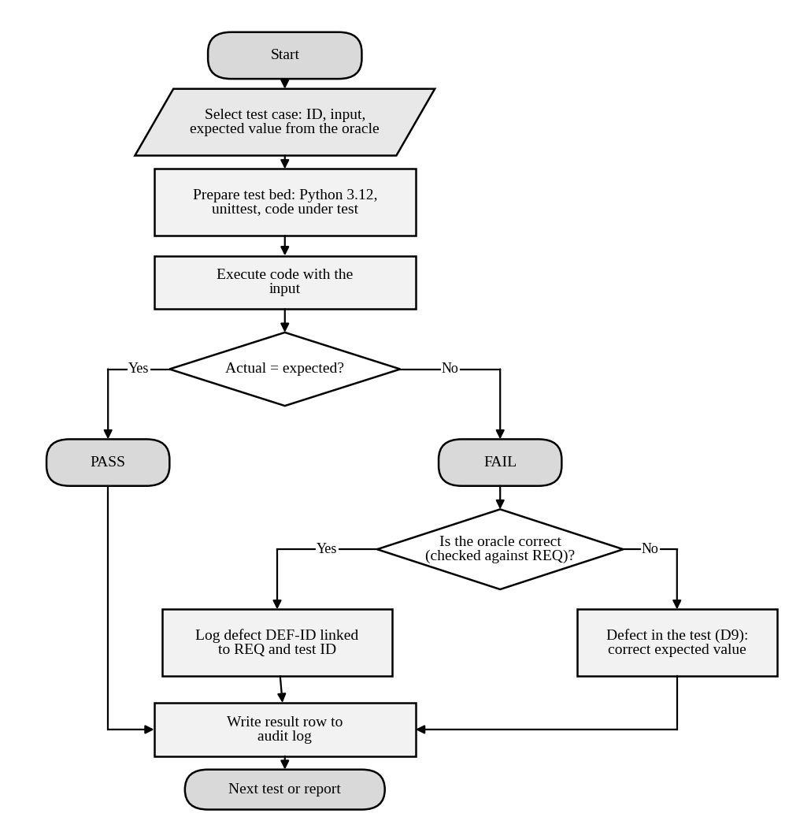
Figure 6: Flowchart of test execution, verdict and defect logging
Style C as executable code
import unittest
from campus import compute_late_fee

CASES = [ # (id, days_late, expected, requirement)
("TC-LF-01", -1, 0, "REQ-FEE-03"), ("TC-LF-02", 0, 0, "REQ-FEE-03"),
("TC-LF-03", 1, 100, "REQ-FEE-04"), ("TC-LF-04", 2, 200, "REQ-FEE-04"),
("TC-LF-05", 10, 1000, "REQ-FEE-04"), ("TC-LF-06", 49, 4900, "REQ-FEE-04"),
("TC-LF-07", 50, 5000, "REQ-FEE-04"), ("TC-LF-08", 51, 5000, "REQ-FEE-04"),
("TC-LF-09", 60, 5000, "REQ-FEE-04"), ("TC-LF-10", 100, 5000, "REQ-FEE-04"),
]

class TestLateFee(unittest.TestCase):
def test_late_fee_rule(self):
for tid, days, expected, req in CASES:
with self.subTest(test=tid, requirement=req):
self.assertEqual(compute_late_fee(days, 20000), expected)

Running this module against the seeded code reports four failing sub-tests (TC-LF-02, 08, 09, 10), each carrying its test ID and requirement ID in the failure message, which is what makes the verdict traceable.
Test case specification template
Table 27: Fields of a style-C test case specification (example: TC-LF-08)
Field | Meaning | Example
Test ID | Unique identifier | TC-LF-08
Requirement | Rule the test checks | REQ-FEE-04
Objective | What fault the test hunts | Cap not applied just above the 50-day limit
Preconditions | State needed before running | Any student account; due date in the past
Input | Values given | days_late = 51, fee = ₹20,000
Oracle | How the expected value is derived | min(100 × 51, 5,000) = 5,000
Expected result | Value the code must return | ₹5,000
Actual result | Value observed | ₹5,100 (recorded at run time)
Verdict | PASS or FAIL | FAIL
Defect link | Defect raised on failure | DEF-L1

Mapping the verdict to the next action
Table 28: What happens after each possible observation
Observation | Possible cause | Action
PASS with correct oracle | Code agrees with rule for this input | Keep in regression suite
FAIL with correct oracle | Fault in code | Log defect, link to test and requirement
FAIL with wrong oracle | Defect in the test (D9) | Correct the expected value, review the oracle source
PASS with wrong oracle | Hidden fault | Found only by test review; this is why oracles are reviewed
No verdict (style A) | No expected value | Convert the note into a style-B/C test

Marking notes and common errors
- Ten tests in each style are required. In style A accept informal notes, but they must be executed and their outputs recorded.
- Full marks for the error/fault/failure bullet need all three terms tied to one concrete execution, not generic definitions.
- The five terms (test, test set, test suite, test bed, test oracle) must each be matched to a named artefact of the student’s own run.
- Common error: confusing test bed (environment) with test suite (collection of tests).
- For the LLM oracle, award marks for an error rate computed from at least 15 inputs and a reasoned limit on reliability, whatever the rate.

TASK 4 – Software Testing Principles: Compare Test Selection Strategies [4 Marks ]
Only 30 test cases can be executed for the Course Registration module in this release. Decide how they should be selected. Compare three strategies.
Technique | Basic idea and key concepts / tools
A. Exhaustive testing | Try every combination of course count, credits, prerequisite status and seat availability.
B. Random selection | Pick 30 input combinations at random from the input space.
C. Principle-guided, risk-based selection | Use defect clustering, boundary risk, early testing and the pesticide paradox to choose and refresh 30 cases.

- Calculate the size of the exhaustive input space for registration (60 offered courses, 3–7 courses per student, 4 prerequisite states, 3 seat states) and the time to run it at one test per second. Then apply B and C to the same module with seeded faults and record faults found.
- Apply the defect-clustering principle to the defect log: compute the percentage of defects per module, normalise per KLOC using the module sizes given, and identify the modules that hold about 80% of the defects.
- Analyze the pesticide paradox by running the same 30 tests on two successive versions of your code and showing how the detection rate changes; analyze which principle each strategy respects or violates.
- Examine the absence-of-errors fallacy using the registration module: show a version that passes all 30 tests but still fails a user need (for example, D5).
- Evaluate the three strategies and justify the final 30-test set, with the principles that guided each choice.
- Critique the statement “a clean test report proves the module is correct” using your results, and recommend how test cases should be refreshed in the next release.
Evidence Expected: An input-space calculation, a defect-clustering chart, a faults-found table for A, B and C, and a justified 30-test selection.
Ans:
Comparison of Test Selection Strategies for Course Registration
Only 30 test cases can be run. I implemented the registration rule (3–7 courses, 12–26 credits, prerequisite met or waived, seat available) in campus.py with six seeded faults and compared exhaustive, random and principle-guided selection.
Table 29: Seeded registration faults
ID | Fault
R1 | Eighth course accepted
R2 | Exactly 3 courses rejected
R3 | Exactly 26 credits rejected
R4 | Exactly 12 credits rejected
R5 | Prerequisite “pending” treated as met
R6 | Last remaining seat rejected (off-by-one)

1. Exhaustive input space and the random and risk-based strategies
Table 30: Size of the exhaustive input space
Courses | Choices | Combinations
3 | C(60, 3) | 34,220
4 | C(60, 4) | 4,87,635
5 | C(60, 5) | 54,61,512
6 | C(60, 6) | 5,00,63,860
7 | C(60, 7) | 38,62,06,920
Total course sets |  | 44,22,54,147
× 4 prerequisite states × 3 seat states |  | 5,30,70,49,764

At one test per second this is 5,30,70,49,764 seconds, about 168 years. Exhaustive testing is impossible, and it is not even complete: the space contains only valid course counts, so it never tries 2 or 8 courses (R1).
Random selection (B): I drew 30 combinations uniformly from the space, 3,000 times. Because 87% of the space has 7 courses, samples cluster there. On average only 2.18 of 6 faults were found; the single run with seed 42 found 2 (R5, R6).
Table 31: Probability that 30 random cases expose each fault
Fault | Random (B) | Risk-based (C)
R1 | 0.0% | ✓ exposed
R2 | 0.0% | ✓ exposed
R3 | 17.9% | ✓ exposed
R4 | 1.0% | ✓ exposed
R5 | 99.9% | ✓ exposed
R6 | 99.7% | ✓ exposed

Risk-based selection (C) exposed all 6 faults with 30 cases (listed in section 5). R5 and R6 are found by almost any strategy (each is hit by about 16% of random cases); R1–R4 sit on boundaries that random sampling almost never hits.
2. Defect clustering
Table 32: Defects per module and per KLOC (217-record log)
Module | Defects | % of total | Cumulative % | KLOC | Defects per KLOC
Fee Payment | 70 | 32.3% | 32.3% | 11 | 6.36
Marks & Grade Evaluation | 56 | 25.8% | 58.1% | 8 | 7.00
Course Registration | 36 | 16.6% | 74.7% | 9 | 4.00
Hall Ticket | 22 | 10.1% | 84.8% | 5 | 4.40
Notifications | 20 | 9.2% | 94.0% | 6 | 3.33
Login | 13 | 6.0% | 100.0% | 3 | 4.33

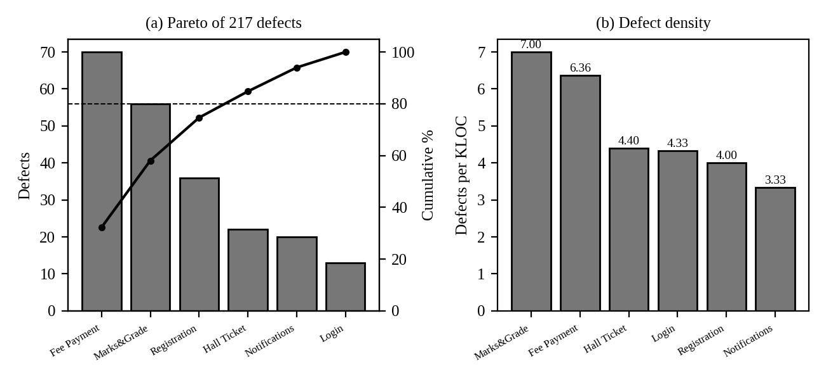
Figure 7: Defect clustering: (a) Pareto chart of defects by module, (b) defects per KLOC
Three modules hold 74.7% of defects and four hold 84.8% (the 80% mark), so Fee Payment, Marks & Grade, Course Registration and Hall Ticket are the focus. Normalised by size, Marks & Grade (7.00) is denser than Fee Payment (6.36).
3. Pesticide paradox and principle compliance
I ran the same 30 tests on version 1 (R1–R6 present) and version 2 (R1–R6 fixed, three new regression faults N1–N3 in corners the suite never touches).
Table 33: Detection rate of the unchanged suite on two versions
Version | Faults present | Found by the same 30 tests | Detection rate
Version 1 | 6 | 6 | 100%
Version 2 | 3 (N1–N3) | 0 | 0%
Version 2, suite refreshed with 4 new cases | 3 | 3 | 100%

Table 34: Principles respected or violated by each strategy
Principle | A. Exhaustive | B. Random | C. Risk-based
Exhaustive testing is impossible | Violated: 168 years | Respected | Respected
Defect clustering | Ignored | Ignored | Respected: effort on Fee and Marks
Early testing | Ignored | Ignored | Respected: cases from rules before code
Pesticide paradox | n/a | Partly (new random set each run) | Respected if cases are refreshed

4. Absence-of-errors fallacy (D5)
A version with R1–R6 fixed passes all 30 tests, yet D5 still occurs. I ran two threads, each adding a course to a student who already has 6: the unsynchronised check-then-add ended with 8 courses, while the locked version ended with 7. All 30 tests are single-threaded, so they cannot see the race. A module can be fault-free against the tests and still fail the user’s need that a student never exceeds seven courses.
5. Evaluation and the final 30-test set
Table 35: Final 30 test cases (expected result computed from the rule)
# | Courses | Credits | Prerequisite | Seat | Expected | Principle / target
1 | 2 | 8 | met | many | Reject | Boundary: course count
2 | 3 | 12 | met | many | Accept | Boundary: course count
3 | 4 | 14 | met | many | Accept | Boundary: course count
4 | 6 | 20 | met | many | Accept | Boundary: course count
5 | 7 | 26 | met | many | Accept | Boundary: course count
6 | 8 | 24 | met | many | Reject | Boundary: course count
7 | 4 | 11 | met | many | Reject | Boundary: credits
8 | 4 | 12 | met | many | Accept | Boundary: credits
9 | 4 | 13 | met | many | Accept | Boundary: credits
10 | 7 | 25 | met | many | Accept | Boundary: credits
11 | 7 | 27 | met | many | Reject | Boundary: credits
12 | 5 | 15 | met | many | Accept | Prerequisite and seat states
13 | 5 | 15 | waived | many | Accept | Prerequisite and seat states
14 | 5 | 15 | not_met | many | Reject | Prerequisite and seat states
15 | 5 | 15 | pending | many | Reject | Prerequisite and seat states
16 | 5 | 15 | met | last | Accept | Prerequisite and seat states
17 | 5 | 15 | met | full | Reject | Prerequisite and seat states
18 | 5 | 15 | pending | last | Reject | Pairwise interaction
19 | 5 | 15 | waived | full | Reject | Pairwise interaction
20 | 5 | 15 | not_met | last | Reject | Pairwise interaction
21 | 5 | 15 | waived | last | Accept | Pairwise interaction
22 | 3 | 12 | not_met | many | Reject | Count/credit with another rule failing
23 | 7 | 26 | met | full | Reject | Count/credit with another rule failing
24 | 7 | 28 | met | many | Reject | Extremes and minimum combinations
25 | 5 | 20 | met | many | Accept | Extremes and minimum combinations
26 | 3 | 12 | waived | last | Accept | Extremes and minimum combinations
27 | 7 | 14 | met | many | Accept | Extremes and minimum combinations
28 | 6 | 12 | met | many | Accept | Extremes and minimum combinations
29 | 5 | 10 | met | many | Reject | Extremes and minimum combinations
30 | 3 | 12 | met | last | Accept | Extremes and minimum combinations

Choice: C. Exhaustive testing is impossible, random selection found about 2 of 6 faults, and C found all 6 with the same 30 cases. The set follows defect clustering (registration is the third densest module), boundary risk (courses 2/3/7/8, credits 11/12/26/27), early testing (derived from the rules) and leaves the last nine cases free to be refreshed each release.
6. Critique of “a clean test report proves the module is correct” and refresh plan
The claim fails on my results. The suite exposed all six faults on version 1; once those were fixed, all 30 tests passed, yet D5 still occurred and three new faults in untested corners went undetected (0 of 3). A clean report shows only that the executed inputs did not expose faults. Refresh plan for the next release: keep cases 1–21 (boundaries, states and interactions) as the regression core, replace up to nine of the remaining cases with new ones chosen from the code changed in the release and from the newest defects, add a concurrency test for D5, and retire a case only after a risk review confirms it no longer guards anything.
7. Supporting evidence for Task 4
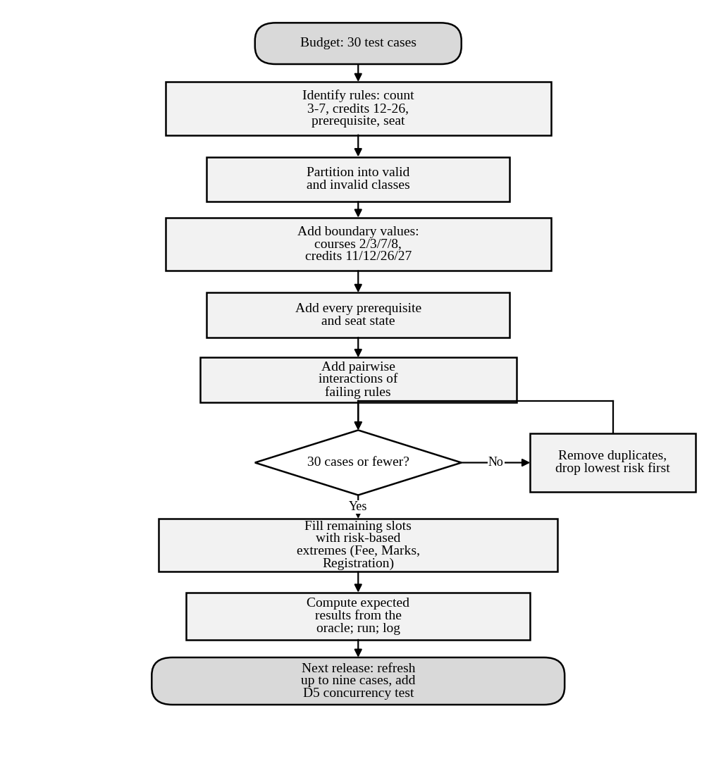
Figure 8: Flowchart for building a 30-case test set under a fixed budget
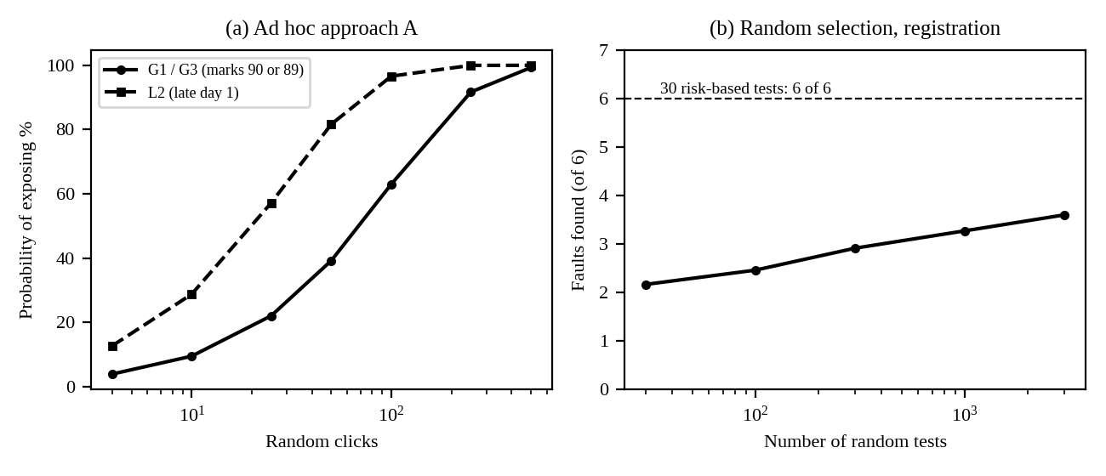
Figure 9: Ad hoc detection against clicks (a) and random selection against the number of tests (b)
Which designed cases expose which fault
Table 36: Exposure of each seeded fault by the 30 designed cases (case numbers as in the final 30-case table)
Fault | Condition needed | Cases that expose it | Count
R1 | Course count 8 (invalid, above the limit) | 6 | 1
R2 | Exactly 3 courses with enough credits | 2, 26, 30 | 3
R3 | Exactly 26 credits at 7 courses | 5 | 1
R4 | Exactly 12 credits | 2, 8, 26, 28, 30 | 5
R5 | Prerequisite state “pending” | 15, 18 | 2
R6 | Last remaining seat | 16, 21, 26, 30 | 4

Every fault is exposed by at least one case, and the boundary faults (R1–R4) depend on only one to three cases each. Removing one “redundant-looking” boundary case would silently reopen a fault, which is why such cases must not be dropped to save time.
Is more random testing the answer?
Table 37: Random selection with more tests (300 trials per row; same faults)
Random tests | Mean faults found (of 6) | Trials finding all 6
30 | 2.17 | 0%
100 | 2.46 | 0%
300 | 2.91 | 0%
1,000 | 3.27 | 0%
3,000 | 3.60 | 0%
30 designed cases | 6.00 | 100%

Even 3,000 random tests (100 times the budget) find only 3.6 of 6 faults on average and never find all six, because three of the faults sit on values that occupy a tiny fraction of the input space (for example exactly 3 courses is 0.008% of it). Thirty designed cases are therefore worth more than thousands of random ones for boundary faults, while random selection remains useful for finding unexpected interactions in the middle of the space.
Counting the principles in the final set
Table 38: Number of the 30 cases supporting each principle
Principle | Cases | Evidence
Boundary risk | Cases 1–11 | Counts 2, 3, 7, 8 and credits 11, 12, 13, 25, 26, 27
State coverage | Cases 12–17 | All four prerequisite states and all three seat states
Interaction | Cases 18–23 | Two rules interacting, for example pending prerequisite with the last seat
Defect clustering and risk | Cases 24–30 | Extreme and minimum combinations in the highest-risk module
Early testing | All 30 | Derived from the rules before any code existed

Marking notes and common errors
- The input-space size must be computed (sum of C(60,k) for k = 3 to 7, times 12). Accept an answer that states a different but explicit assumption.
- Common error: counting only the valid counts and forgetting that the exhaustive space excludes invalid inputs; award credit for noticing this.
- For the pesticide paradox, the student must show the same suite on two versions, not just define the term.
- For D5, the key idea is that single-threaded tests cannot see a concurrency fault. A thread or two-tab demonstration is full evidence.
- The 30 cases must be listed with expected results; a count alone earns no credit for the final-set bullet.

TASK 5 – Tester’s Role: Compare Ways of Organising Testing Responsibility [5 Marks]
Developers say they can test their own Hall Ticket module; testers say they must be involved from the requirements stage. Compare three ways of assigning the testing role.
Technique | Basic idea and key concepts / tools
A. Developer tests own code | The author of the Hall Ticket module designs and runs all tests.
B. Independent tester | A separate tester designs tests from requirements, executes them and reports defects.
C. Tester embedded in the team | The tester joins requirement and design reviews, plans tests with developers, and reports metrics each sprint.

- Seed four faults in the Hall Ticket rules (attendance ≥ 75%, no fee dues, registered courses, D4 and D10 style faults). Apply A, B and C (three rounds with different people, or three structured passes) and record faults found, false reports and time spent.
- Prepare two defect reports on the same failure: one written without evidence and one written to the tester’s standard (steps to reproduce, environment, expected versus actual, severity); show how each affects the developer’s time to fix.
- Analyze the influence of independence and confirmation bias on the number of faults found, and the communication friction between testers and developers that you observed.
- Analyze which skills are exercised under each arrangement (technical, domain, communication, planning) and where each arrangement leaves gaps.
- Evaluate how the team’s 4 testers should be allocated across the six modules, justify the tester-to-developer ratio, and state the risk accepted.
- Judge whether the tester should have the authority to block a release; recommend a sign-off rule and justify it.
Evidence Expected: A faults-found and effort table for the three arrangements, two contrasting defect reports, and a justified allocation of tester responsibility.
Ans:
Comparison of Ways of Organising Testing Responsibility for the Hall Ticket Module
I seeded four faults in the Hall Ticket rules and ran three structured passes with different test sets, as the task allows when three different people are not available. The fault detection is measured by running each test set against each single-fault mutant; false reports and time are modelled and should be replaced by logged values.
Table 39: Seeded Hall Ticket faults
ID | Fault | Type
H1 | Attendance rounded to the nearest integer before the ≥ 75% check (74.9% passes) – D4 type | Logic
H2 | Fee dues below ₹500 are ignored | Boundary
H3 | Registration status of the course is not checked | Missing condition
H4 | Lecture-timetable date shown for lab courses instead of exam date – D10 type | Data source

1. Faults found, false reports and time spent
Table 40: Results of the three passes (faults found measured; false reports and hours modelled)
Arrangement | Test set | Tests | Faults found (of 4) | False reports | Hours
A. Developer tests own code | Own understanding: attendance 80/60/75, dues 100/5,000, registered course, theory-course date | 6 | 1: H2 | 0 | 3.0
B. Independent tester | From the requirement: adds 74.9, 74, dues 1 and an unregistered student | 10 | 3: H1, H2, H3 | 1 | 6.0
C. Tester embedded in the team | As B, plus a lab-course date test after asking in design review which table holds exam dates | 11 | 4: H1, H2, H3, H4 | 0 | 8.0 (incl. 2 h reviews)

The one false report in B came from a tester who read “attendance ≥ 75%” as “above 75%” and rejected a valid ticket at exactly 75%; it was closed as Rejected after one clarification.
2. Two defect reports for the same failure
Table 41: Failure: ticket issued to a student with 74.9% attendance (H1)
Field | Report without evidence | Report to the tester’s standard
Summary | Hall ticket problem for some students | Hall ticket issued at 74.9% attendance (rule requires ≥ 75%)
Steps to reproduce | Not given | 1. Log in as student S-2217 (attendance 74.9%, no dues). 2. Open Hall Ticket. 3. Click Download.
Environment | Not given | UAT server build 2.3.1, Chrome 126, Windows 11
Expected vs actual | “Should not work” | Expected: “Not eligible – attendance below 75%”. Actual: PDF generated
Severity / priority | Not given | Major / High (exam eligibility rule broken)
Developer time to fix (modelled) | About 10 h elapsed: 2 clarification rounds × 4 h wait, 1.5 h to reproduce, 0.5 h to fix | About 0.75 h: 0.25 h to reproduce, 0.5 h to fix

3. Independence and confirmation bias
The author found 1 of 4 faults, the independent tester 3 of 4 and the embedded tester 4 of 4. The author’s tests repeated his own assumptions (attendance is rounded; the date comes from one table), so they could not contradict them: this is confirmation bias. Independence removed that bias and found H1 and H3; the missing H4 shows the limit of independence without context. Friction observed: the independent tester’s false report and the clarification rounds in the weak defect report; the embedded tester avoided both by agreeing the rules before testing.
4. Skills exercised and gaps
Table 42: Skills exercised (● strong, ◐ partial, ○ weak)
Skill | A. Developer | B. Independent | C. Embedded
Technical (code, tools) | ● | ◐ | ●
Domain (university rules) | ◐ | ● | ●
Communication | ○ | ◐ | ●
Planning and risk | ○ | ◐ | ●

Gaps: A lacks independence and planning; B lacks early involvement, so requirement ambiguities arrive as defects; C needs more skilled people and risks losing independence if the tester stops challenging the team.
5. Allocating the 4 testers across the six modules
Table 43: Tester allocation by severity-weighted defects (critical 8, major 4, minor 2, trivial 1)
Module | Severity-weighted defects | Share | Testers (FTE)
Login | 48 | 6.5% | 0.3
Course Registration | 113 | 15.3% | 0.6
Fee Payment | 252 | 34.1% | 1.4
Marks & Grade Evaluation | 190 | 25.7% | 1.0
Hall Ticket | 81 | 11.0% | 0.4
Notifications | 54 | 7.3% | 0.3
Total | 738 | 100% | 4.0

The ratio is 4 testers to 6 developers (1 : 1.5), richer than the common 1 : 3 to 1 : 5 because payments and grades are high-consequence; it is justified by 13 critical escapes. Risk accepted: Notifications and Login receive about 0.3 FTE each and rely on automated smoke tests, so a low-severity defect there can still escape.
6. Authority to block a release
The tester should have the authority to recommend a hold, not to decide alone. Sign-off rule: release only if (i) no open critical or major defect in payment, grades or hall ticket, (ii) the quality gate of Task 2 is green, and (iii) every deviation is accepted in writing by the product owner with the risk stated. This keeps testers independent without making them the sole owner of the business decision, and it leaves an audit record of who accepted which risk.
7. Supporting evidence for Task 5
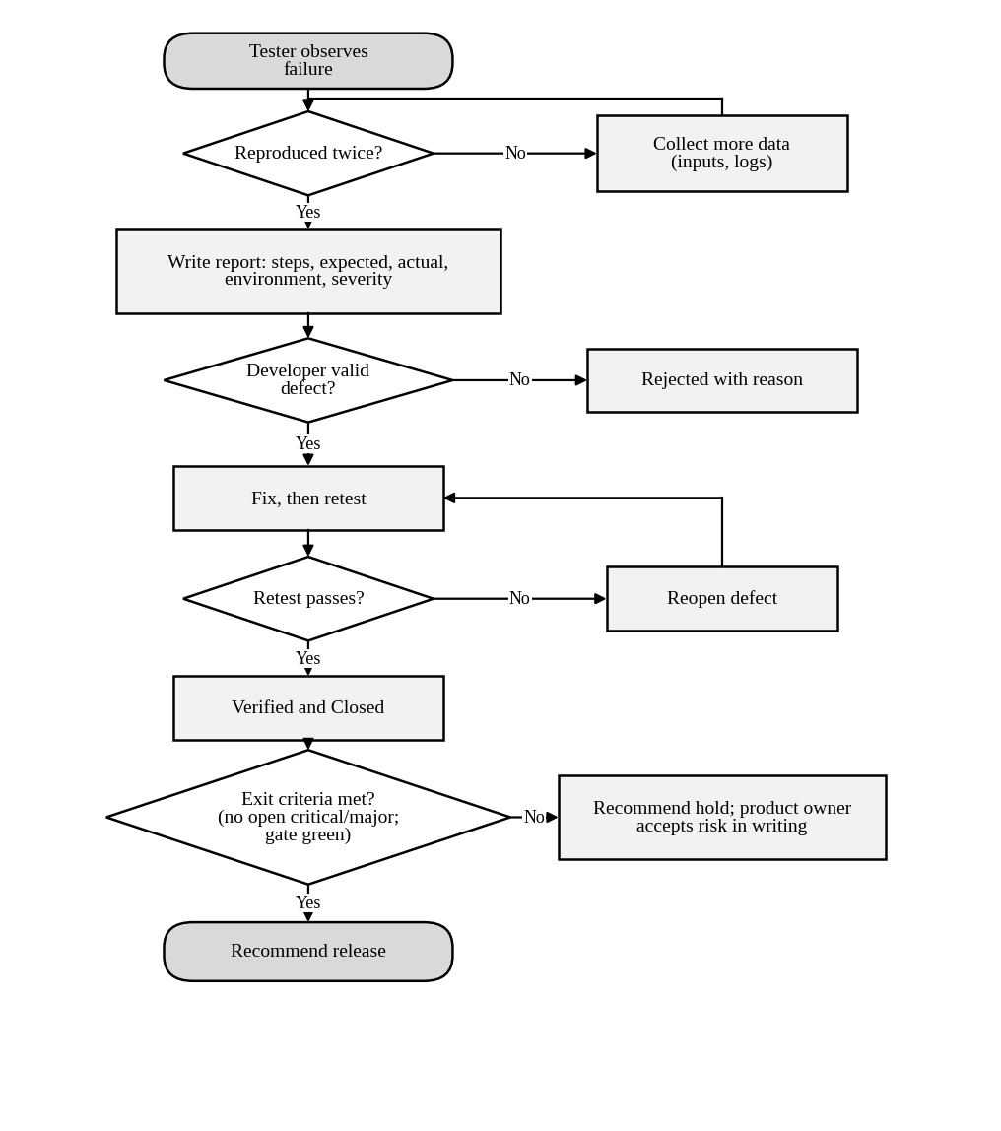
Figure 10: Flowchart of defect handling, retest and release sign-off
Test sets used by the three passes (the expected result is computed from the requirement, not from the code):
Table 44: Pass A – developer’s tests (6)
# | Input | Expected
1 | attendance 80%, dues ₹0, registered yes | Eligible
2 | attendance 60%, dues ₹0, registered yes | Not eligible
3 | attendance 80%, dues ₹5,000, registered yes | Not eligible
4 | attendance 80%, dues ₹100, registered yes | Not eligible
5 | attendance 75%, dues ₹0, registered yes | Eligible
6 | exam date of course MA101 | 2026-11-20

Table 45: Pass B – independent tester (10): the six cases above plus four from the requirement
# | Input | Expected
7 | attendance 74.9%, dues ₹0, registered yes | Not eligible
8 | attendance 74%, dues ₹0, registered yes | Not eligible
9 | attendance 80%, dues ₹1, registered yes | Not eligible
10 | attendance 85%, dues ₹0, registered no | Not eligible

Table 46: Pass C – embedded tester (11): all ten above plus one data-source case
# | Input | Expected
11 | exam date of course PH1L | 2026-11-27

Who is responsible for what at release
Table 47: Responsibility matrix for the weekly release decision (R = does, A = accountable, C = consulted, I = informed)
Activity | Developer | Tester | Product owner | Registrar
Write unit tests | R/A | C | I | –
Design and run system tests | C | R/A | I | –
Raise and close defects | R | R/A | I | –
Recommend hold or release | C | R | A | I
Accept residual risk in writing | C | C | R/A | I

Marking notes and common errors
- Full marks need all three arrangements applied with results (faults found, false reports, time). Accept three structured passes if the student explains how independence was simulated.
- The two defect reports must describe the same failure and differ in evidence; reward concrete steps, environment and expected-versus-actual.
- The allocation of testers should be derived from data (defect density, severity or criticality) and sum to 4.
- The tester’s authority should be limited to recommending a hold, with an accountable decision-maker; reject answers that make the tester the sole release authority without discussion.
- Common error: ignoring confirmation bias when the developer tests own code.

TASK 6 – Origins of Defects: Compare Defect Origin Analysis Methods [5 Marks]
To prevent repeat defects, the team must know where they come from. Using D1–D10 and the defect log, compare three origin-analysis methods.
Technique | Basic idea and key concepts / tools
A. Phase-of-origin tagging | Tag each defect with the phase that injected it (requirements, design, coding, testing, deployment) and the phase that detected it.
B. Cause-and-effect (fishbone) analysis | Group causes under people, process, tools, environment, requirements and communication.
C. Five-Whys root-cause analysis | Ask “why” repeatedly on a critical defect until a process-level cause is found.

- Apply method A to D1–D10 and to at least 30 records of the defect log; build a matrix of phase injected versus phase detected.
- Apply method B to D2 (double debit) and method C to D1 and D8; record each chain of causes and the preventive action it suggests.
- Analyze the matrix to find the phase that injects most defects, the phase that lets most defects escape, and calculate phase containment effectiveness for requirements and coding.
- Compare what each method reveals and hides: for example, which method best exposes the ambiguous requirement in D8 and which only sees the symptom.
- Evaluate the three methods on insight gained, effort and repeatability, and justify the one the QA team should use every release.
- Critique the belief that “most defects originate in coding” using your matrix, and recommend two preventive actions with the reduction in post-release defects you expect and why.
Evidence Expected: A phase-injected versus phase-detected matrix, a fishbone diagram and a Five-Whys chain, and a justified choice of method with preventive actions.
Ans:
Comparison of Defect Origin Analysis Methods
I applied the three methods to D1–D10 and to the defect log of 217 records (generated for this key; first 45 records in Annexure A, full file supplied). Phase of origin is where the defect was injected; phase detected is where it was found.
1. Method A – phase-of-origin tagging
Table 48: D1–D10: phase injected × phase detected
Injected \ Detected | System testing | After release | Total
Requirements | 0 | 1 | 1
Design | 0 | 3 | 3
Coding | 2 | 3 | 5
Testing | 1 | 0 | 1
Total | 3 | 7 | 10

Table 49: Defect log (217 records): phase injected × phase detected
Injected \ Detected | Unit/integration test | System testing | After release | Total
Requirements | 6 | 24 | 18 | 48
Design | 4 | 17 | 9 | 30
Coding | 55 | 53 | 4 | 112
Deployment/Config | 5 | 16 | 6 | 27
Total | 70 | 110 | 37 | 217

2. Methods B and C on D2, D1 and D8
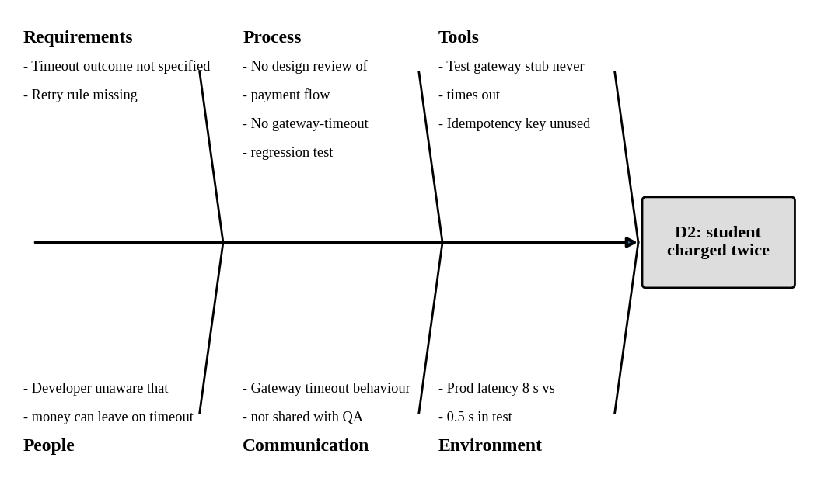
Figure 11: Fishbone (cause-and-effect) diagram for D2, double debit on retry
Preventive action from the fishbone: reuse one idempotency key per payment, specify the timeout outcome in the requirement, and add a gateway-timeout test with a stub that debits and then times out.
Table 50: Five-Whys chains
Why? | D1 – 89.5 shown as A+ | D8 – SMS to old number
1 | Marks were stored as 89. | SMS used the number saved at registration.
2 | Code truncated the value instead of rounding. | Requirement says “registered mobile number” but not what happens when it changes.
3 | Acceptance criteria were written from the screen, not from the rule sheet that says 0.5 rounds up. | The author did not consider the number-change event.
4 | No one compared criteria with the business rules; no .5 test existed. | No review checked requirements for changes over time.
5 (process cause) | No requirement review and no rule-to-test traceability. | No ambiguity checklist and no tester in requirement writing.
Preventive action | Trace every business rule to a test; add rounding boundary cases (x.5). | Add “what can change over time?” to the review checklist; tester joins refinement.

3. Analysis of the matrix
Coding injects the most defects (112, 51.6%) but lets the fewest escape (4). Requirements let the most escape: 18 of 37 (48.6%) and 24.3% more from design. Phase containment effectiveness = defects found in the phase where injected ÷ defects injected in that phase: requirements 0 ÷ 48 = 0% (no review phase exists), coding 55 ÷ 112 = 49.1%.
4. What each method reveals and hides
Table 51: Comparison of the three methods
Aspect | A. Phase tagging | B. Fishbone | C. Five Whys
Reveals | Where defects enter and escape (statistics) | All contributing cause categories | A process-level root cause of one defect
Hides | Why the phase failed | Which cause matters most | Other causes; assumes one chain
D8 ambiguity | Shows it was injected in requirements | Lists “requirements” as a cause only | Finds the missing checklist and tester involvement
D2 (double debit) | Design, found after release | Best: shows process, tools and environment together | Finds one chain

5. Choice of method for every release
Use A every release because it is cheap (one tag per defect), repeatable and gives the numbers (injection, escape, containment). Use C for every critical escaped defect, which turned D1 and D8 into process fixes; use B only for complex defects like D2. Effort: A about 2 min per defect, B 1–2 h, C 30–60 min.
6. Critique of “most defects originate in coding” and preventive actions
By count the belief is true (51.6% of injected defects), but by impact it is false: requirements and design injected 36.0% of defects yet caused 72.9% of the escapes, and escapes cost ₹50,000 each. Two preventive actions: (1) requirement and design review with a checklist, expected to stop half of the 27 requirement/design escapes (13.5); (2) boundary-value and automated regression tests for coding and configuration, expected to stop 60% of their 10 escapes (6.0). Expected post-release defects fall from 37 to about 17.5, a reduction of 53% (assumed effectiveness of 50% and 60%; to be verified next release).
7. Supporting evidence for Task 6
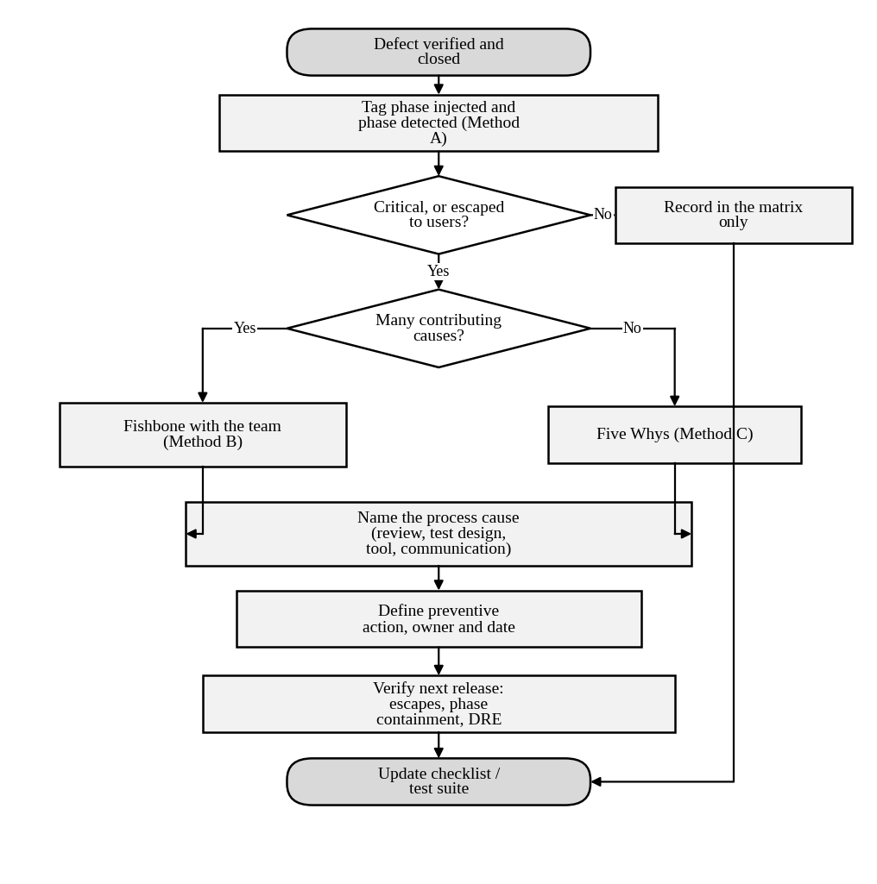
Figure 12: Flowchart of the root-cause analysis routine applied to each closed defect
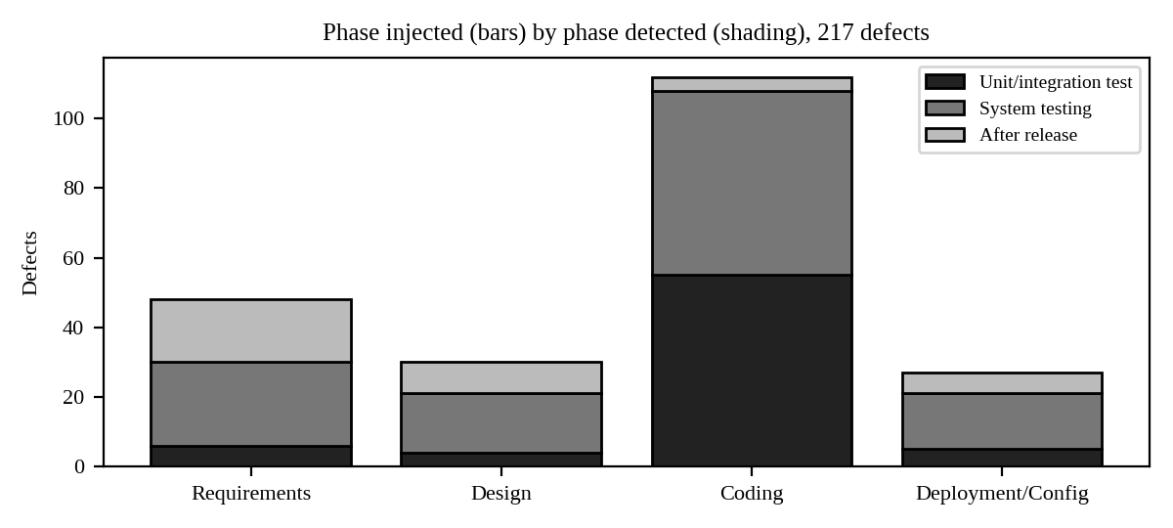
Figure 13: Phase of origin of the 217 defects, shaded by the phase in which they were detected
Table 52: Phase injected by module (217-record log)
Module | Requirements | Design | Coding | Deployment/Config | Total
Login | 2 | 1 | 7 | 3 | 13
Course Registration | 11 | 7 | 14 | 4 | 36
Fee Payment | 11 | 8 | 40 | 11 | 70
Marks & Grade Evaluation | 11 | 8 | 34 | 3 | 56
Hall Ticket | 8 | 3 | 7 | 4 | 22
Notifications | 5 | 3 | 10 | 2 | 20
Total | 48 | 30 | 112 | 27 | 217

Table 53: Defects by scheme-B class (217-record log)
Class | Defects | Share
Requirements & specification | 48 | 22.1%
Design | 30 | 13.8%
Coding - control & logic | 39 | 18.0%
Coding - data | 33 | 15.2%
Coding - algorithmic | 19 | 8.8%
Coding - interface | 21 | 9.7%
Testing & environment | 27 | 12.4%

Control and logic is the largest coding class, which matches the typical D3 and D4 faults (a missing or misplaced condition). Requirements and design together are larger than any single coding class, a second reason why prevention effort should start before coding.
Worked example of phase containment
Phase containment effectiveness (PCE) of a phase = defects found in that phase ÷ defects injected in that phase. With the matrix of the 217-record log: requirements 0 ÷ 48 = 0%; design 0 ÷ 30 = 0% (no design review exists); coding 55 ÷ 112 = 49.1%; deployment/configuration 5 ÷ 27 = 18.5%. If the proposed requirement review catches half of the 48 requirement defects, the requirement PCE rises to 50% and 24 defects move from the ₹50,000 or ₹10,000 level to the ₹1,000 level.
Marking notes and common errors
- The matrix must be built from at least 30 log records (or the given log) and D1–D10; both must show origin and detection.
- The fishbone must be on D2 and name causes in at least four categories; the Five Whys must end in a process cause, not a person.
- Common error: stopping the Five Whys at “the developer made a mistake”. Award at most half marks.
- PCE must be calculated with its formula. Accept different matrix values if the arithmetic is correct.
- The critique must separate counts (where defects originate) from impact (where defects escape and what they cost).

TASK 7 – Defect Classes: Compare Defect Classification Schemes [4 Marks]
The team’s defect log has no common classification, so reports cannot be compared across releases. Compare three schemes on D1–D10.
Technique | Basic idea and key concepts / tools
A. Severity and priority scheme | Critical / major / minor / trivial severity with high / medium / low priority.
B. Class-based scheme | Requirements and specification, design, coding (control and logic, data, algorithmic, interface) and testing defects.
C. Quality-attribute scheme | Functional, performance, security, usability, compatibility and reliability defects.

- Classify D1–D10 under each scheme and tabulate the result; give a one-line reason for every assignment.
- Assign severity and priority to every defect; give an example from D1–D10 of a defect with high severity but low priority and one with the opposite combination, with reasons.
- Analyze where the schemes disagree (for example, D8, D9 and D10) and explain why; examine which scheme helps decide where to add test effort.
- Ask two classmates to classify D1–D10 independently using scheme B; calculate the percentage agreement and identify the defect classes that cause confusion.
- Evaluate which scheme the university should standardise on and justify it using reproducibility, usefulness for prevention and ease of use.
- Judge the reliability of an LLM that classifies the defects automatically: compare its output with your manual classification and state when its use is acceptable.
Evidence Expected: A classification table for D1–D10 under the three schemes, an agreement calculation, and a justified standard scheme.
Ans:
Comparison of Defect Classification Schemes on D1–D10
1. Classification of D1–D10 under the three schemes
Table 54: Scheme A (severity / priority), scheme B (class) and scheme C (quality attribute)
ID | A: Severity / Priority | B: Class | C: Quality attribute | Reason (one line)
D1 | Critical / High | Coding – algorithmic | Functional | Truncation instead of rounding gives a wrong grade.
D2 | Critical / High | Design | Reliability | Flow has no idempotency or timeout handling; money is lost.
D3 | Major / High | Coding – control and logic | Functional | A required condition (the cap) is missing.
D4 | Major / Medium | Coding – control and logic | Functional | Rounding before the eligibility comparison.
D5 | Major / Low | Design | Reliability | No concurrency control; rare trigger (two tabs).
D6 | Major / Medium | Coding – data | Functional | Special character not handled in the password data.
D7 | Critical / High | Design | Performance | 40 s at 3,000 users; architecture and load not designed for.
D8 | Major / Medium | Requirements and specification | Functional | The requirement is ambiguous.
D9 | Major / High | Testing | Functional | A wrong expected value hides a defect.
D10 | Minor / High | Coding – interface | Functional | Data read from the wrong table; low harm, but needed before exams.

2. Severity versus priority
High severity, low priority: D5. The rule “at most 7 courses” is broken (major), but it needs two browser tabs at the same instant, so few students meet it and a manual check can cover it. Low severity, high priority: D10. The wrong date is a display error (minor) and the correct date exists elsewhere, but hall tickets are downloaded in exam week, so it must be fixed first.
3. Where the schemes disagree and which helps decide test effort
- D8: scheme A calls it Major and scheme C calls it Functional; only scheme B points to the source (requirements), which is where prevention is needed.
- D9: it is a defect in the test, not the product. Scheme C has no home for it; scheme A rates it by its effect; only B has a “Testing” class.
- D10: B gives interface (wrong table) but a reader may choose data; A rates it minor yet urgent; C says only Functional.
For deciding test effort, scheme C is the most direct: it shows that Performance and Reliability defects (D2, D5, D7) are the severe ones, so load and concurrency tests should be added. Scheme B decides prevention: 4 of 10 sample defects originate before coding.
4. Agreement between two independent raters (scheme B)
Note: classmates were not available to this answer key, so the two raters below are illustrative classifications built to show the calculation; replace them with the real classmates’ data.
Table 55: Independent classification by two raters
ID | Rater 1 | Rater 2 | Agree?
D1 | Coding – data | Coding – algorithmic | ✗
D2 | Design | Design | ✓
D3 | Coding – algorithmic | Coding – control | ✗
D4 | Coding – control | Coding – algorithmic | ✗
D5 | Coding – control | Design | ✗
D6 | Coding – interface | Coding – data | ✗
D7 | Design | Design | ✓
D8 | Requirements | Requirements | ✓
D9 | Testing | Testing | ✓
D10 | Coding – data | Coding – data | ✓

Percentage agreement = 5 ÷ 10 = 50% (Cohen’s kappa 0.40, moderate). The confusing classes are the coding sub-classes (control and logic, algorithmic, data, interface), shown by D1, D3, D4, D6 and D10, and design versus coding for D5. The classes need written definitions with examples.
5. Which scheme to standardise on
Table 56: Evaluation of the schemes
Criterion | A. Severity / priority | B. Class | C. Quality attribute
Reproducibility | High for severity, priority is judgement | Moderate (agreement 50%–80%) | High
Usefulness for prevention | Low | High (points to the phase) | Medium
Ease of use | Very easy | Moderate | Easy

Recommendation: standardise on B for classification with written definitions, and keep A for triage, because the two answer different questions (what to prevent, what to fix first). Scheme C may be added later as an optional field.
6. Reliability of an LLM classifier
Illustrative comparison: an LLM classification of D1–D10 (scheme B) agreed with my manual key on 8 of 10 (80%, kappa 0.76). The two disagreements, D5 (design versus control logic) and D9 (a test defect treated as a requirement defect), are exactly the cases that need judgement. Acceptable use: a first-pass suggestion on routine defects, reviewed by a person, with a sample audited each release. Not acceptable: unreviewed classification of critical or ambiguous defects, since wrong classes distort the statistics that drive prevention.
7. Supporting evidence for Task 7
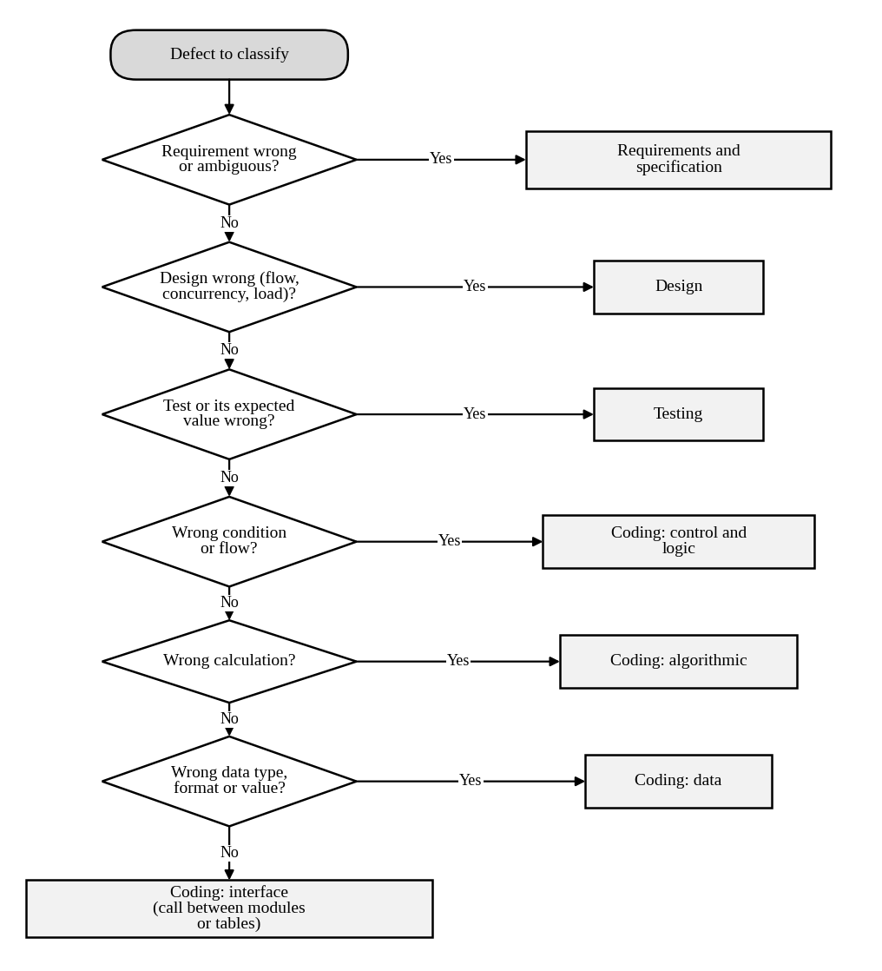
Figure 14: Decision flowchart for assigning a scheme-B class
Written definitions used by the schemes
Table 57: Severity and priority scale (scheme A)
Level | Severity (effect on users) | Priority (when to fix)
Critical / High | Wrong grade or money, system unusable | Fix before this release; stop the line
Major / Medium | A rule is broken but a workaround exists | Fix in this release
Minor / Low | Cosmetic or rare condition | Fix when convenient; not before exams
Trivial | Spelling, alignment | Backlog

Table 58: Class definitions with an example from D1–D10 (scheme B)
Class | Definition | Example
Requirements | The stated rule is wrong, missing or ambiguous | D8
Design | The structure cannot satisfy the rule (flow, concurrency, load) | D2, D5, D7
Coding – control and logic | Wrong or missing condition, branch or loop | D3, D4
Coding – algorithmic | Wrong calculation or method | D1
Coding – data | Wrong type, format, encoding or value | D6
Coding – interface | Wrong call, table or parameter between parts | D10
Testing | The test, oracle or environment is wrong | D9

Table 59: Quality attributes (scheme C)
Attribute | Question | Defects
Functional | Does it do what the rule says? | D1, D3, D4, D6, D8, D9, D10
Reliability | Does it keep working under faults and repeated use? | D2, D5
Performance | Is it fast enough under load? | D7
Security / usability | Is it safe and easy to use? | none in this sample

Where the two raters differ
Table 60: Confusion matrix of Rater 1 (rows) and Rater 2 (columns), counts of D1–D10
R1 \ R2 | Requirements | Design | Control | Algorithmic | Data | Interface | Testing
Requirements | 1 | – | – | – | – | – | –
Design | – | 2 | – | – | – | – | –
Control | – | 1 | – | 1 | – | – | –
Algorithmic | – | – | 1 | – | – | – | –
Data | – | – | – | 1 | 1 | – | –
Interface | – | – | – | – | 1 | – | –
Testing | – | – | – | – | – | – | 1

All disagreements lie among the coding sub-classes or between design and coding; none involves requirements or testing. The fix is a one-page definition sheet with examples (above) and a rule such as “when two coding classes fit, choose the one describing the line that must change”.
Marking notes and common errors
- Each of D1–D10 must be classified under all three schemes with a short reason; accept reasonable alternatives (for example D1 as “data”) if justified.
- The severity versus priority examples must be taken from D1–D10 and must explain why the two differ.
- Agreement must be calculated as agreed items ÷ 10 × 100; kappa is a bonus.
- The recommended scheme must be justified on reproducibility, usefulness for prevention and ease of use, not on preference.
- For the LLM, accept either measured agreement with the student’s own classification or a reasoned limit on use.

TASK 8 – Defect Repository: Compare Defect Tracking Approaches [5 Marks]
Defects are currently kept in e-mails and chat messages. The QA lead wants a defect repository. Compare three ways of maintaining it.
Technique | Basic idea and key concepts / tools
A. Spreadsheet log | A shared sheet with one row per defect and manual status updates.
B. Bugzilla (open-source tracker) | Fields, statuses, search and basic reports available out of the box.
C. JIRA with defined workflow | Custom workflow, links to test cases and requirements, dashboards and notifications.

- Log D1–D10 in each repository using the fields ID, summary, module, class, severity, priority, status, reporter, assignee, steps to reproduce and environment; submit screenshots.
- Move D2 and D6 through the life cycle (New → Assigned → Fixed → Retest → Verified → Closed, with Reopened or Rejected where needed) in B and C; record the time taken at each state and compute the mean time to fix.
- Analyze the repositories on duplicate detection, search and filtering, audit history, traceability to test cases and the effort to produce a “defects by module and severity” report.
- Examine data-quality problems you met (missing steps, vague summaries) and show how they delayed resolution.
- Evaluate which repository the university should adopt and justify it with evidence; state the minimum fields and states that must be compulsory.
- Critique a decision made from raw defect counts (“Fee Payment has most defects, so it is the worst module”) by normalising defects per KLOC with the module sizes given, and judge whether the conclusion changes.
Evidence Expected: Screenshots of the three repositories with D1–D10, a life-cycle timing table, a defects-per-KLOC calculation, and a justified choice.
Ans:
Comparison of Defect Tracking Approaches
A real submission needs screenshots from the tools. This key gives the record content to enter, the expected life-cycle timings and the calculations; the timings are exemplar values to be replaced by the timestamps of the actual tools.
1. Logging D1–D10 with the required fields
Table 61: Records entered in each repository (same content in the spreadsheet, Bugzilla and JIRA)
ID | Summary | Module | Class | Severity / Priority | Status
D1 | 89.5 marks shown as A+ (truncated to 89) | Marks & Grade | Coding – algorithmic | Critical/High | Assigned
D2 | Payment shows failed but amount debited; retry double-charges | Fee Payment | Design | Critical/High | Closed
D3 | Late fee ₹6,000 above the ₹5,000 cap | Fee Payment | Coding – control | Major/High | Assigned
D4 | Hall ticket issued at 74.9% attendance | Hall Ticket | Coding – control | Major/Medium | New
D5 | Eighth course accepted from two tabs | Course Registration | Design | Major/Low | New
D6 | Login fails for password with “&” | Login | Coding – data | Major/Medium | Closed
D7 | Result page takes ~40 s at 3,000 users | Marks & Grade | Design | Critical/High | New
D8 | SMS sent to old number after change | Notifications | Requirements | Major/Medium | New
D9 | TC-77 expects A for 85 marks (should be A+) | Marks & Grade | Testing | Major/High | New
D10 | Lab hall ticket shows lecture date | Hall Ticket | Coding – interface | Minor/High | New

Common fields for every record: reporter qa.lead, assignee the module owner, environment UAT build 2.3.1 / Chrome 126 / Windows 11, and steps to reproduce written to the Task 5 standard (for example D3: 1. open an account with a due date 60 days ago; 2. open Pay Fee; 3. observe the late fee ₹6,000, expected ₹5,000).
2. Life cycle and mean time to fix for D2 and D6
Table 62: Hours spent in each state (exemplar timings)
Tool | Defect | New → Assigned | Assigned → Fixed | Fixed → Retest | Retest → Verified | Verified → Closed | Total h
Bugzilla | D2 | 3 | 20 | 2 | 6 | 1 | 32
Bugzilla | D6 | 2 | 9 | 1 | 3 | 1 | 16
JIRA | D2 | 1 | 16 | 1 | 4 | 1 | 23
JIRA | D6 | 1 | 7 | 1 | 2 | 1 | 12

Mean time to fix (Assigned → Fixed) = Bugzilla (20 + 9) ÷ 2 = 14.5 h; JIRA (16 + 7) ÷ 2 = 11.5 h. D2 was reopened once in Bugzilla (a retry path was fixed but a timeout path was not), which is included in its 32 h.
3. Comparison of the repositories
Table 63: Analysis (effort values are estimates)
Criterion | A. Spreadsheet | B. Bugzilla | C. JIRA with workflow
Duplicate detection | Manual scan of rows | Similar-bug search when filing | Duplicate link and suggestions
Search and filtering | Sort and filter only | Advanced and saved searches | JQL queries, saved filters
Audit history | Version history of the file, not per defect | Complete history per bug | Complete history plus enforced workflow
Traceability to test cases | None | “Depends on / blocks” only | Links to test cases and requirements
Effort for “defects by module and severity” | About 20 min (pivot table) | About 10 min (report builder) | About 3 min (dashboard gadget)

4. Data-quality problems and their cost
Typical problems met while logging: D7 had no user count or time of day, D4 gave no attendance value, D8 said only “SMS goes wrong”, D2 omitted the gateway response. Each missing item caused a clarification round, which in the model of Task 5 adds about 4 hours of waiting and 1.5 hours of re-investigation. A mandatory-field rule and a short template remove most of these delays.
5. Repository to adopt and compulsory content
I recommend JIRA with a defined workflow because it enforces the states, links defects to test cases and requirements (needed for the audit in Task 10) and gives dashboards at almost no effort. Bugzilla is an acceptable free alternative if JIRA licences are not available; the spreadsheet should be retired.
- Compulsory fields: ID, summary, module, class, severity, priority, steps to reproduce, expected and actual result, environment and build, reporter, assignee.
- Compulsory states: New, Assigned, Fixed, Retest, Verified, Closed, plus Reopened and Rejected (with a reason).
6. Critique of a decision based on raw counts
Table 64: Defects per KLOC (217-record log)
Module | Defects | KLOC | Defects per KLOC | Severity-weighted per KLOC
Marks & Grade Evaluation | 56 | 8 | 7.00 | 23.8
Fee Payment | 70 | 11 | 6.36 | 22.9
Hall Ticket | 22 | 5 | 4.40 | 16.2
Login | 13 | 3 | 4.33 | 16.0
Course Registration | 36 | 9 | 4.00 | 12.6
Notifications | 20 | 6 | 3.33 | 9.0

By raw count Fee Payment (70) has the most defects. Normalised by size, Marks & Grade Evaluation (7.00 per KLOC) is denser than Fee Payment (6.36), and the severity-weighted density agrees (23.8 against 22.9). The conclusion changes: Fee Payment is the largest source of defects, but Marks & Grade is the worst module for its size. The gap is small, so both modules should stay the top test priorities; the lesson is that counts must be normalised before a module is called the worst.
7. Supporting evidence for Task 8
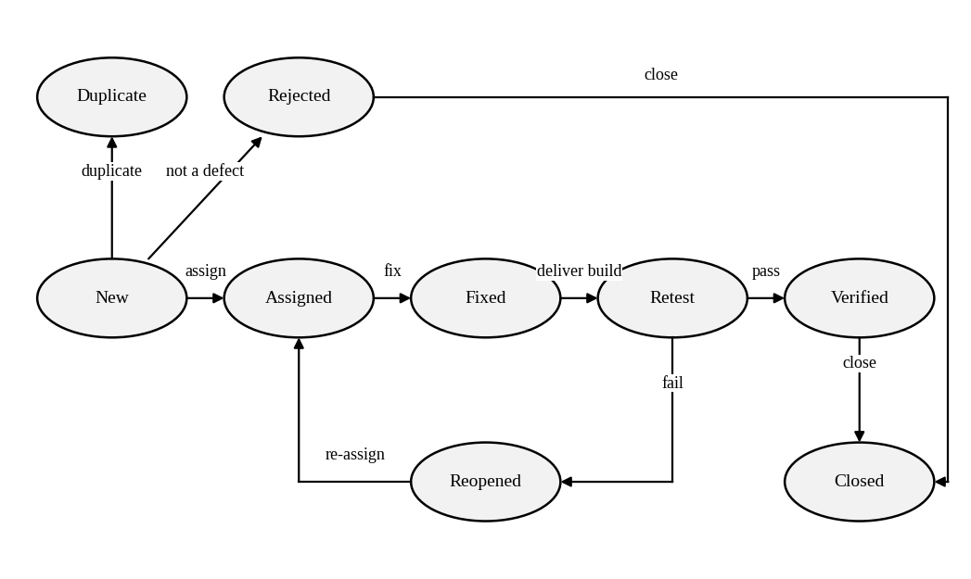
Figure 15: State diagram of the defect life cycle used in the repositories
Table 65: Allowed transitions of the defect workflow
From | To | Who | Condition
New | Assigned | Test lead | Defect reproduced and valid
New | Rejected | Developer | Not a defect; reason mandatory
New | Duplicate | Test lead | Links to the original defect
Assigned | Fixed | Developer | Fix committed with reference to the defect ID
Fixed | Retest | Build system | Fix delivered in a build
Retest | Verified | Tester | Original steps pass; regression test added
Retest | Reopened | Tester | Steps still fail
Reopened | Assigned | Test lead | Back to the developer
Verified | Closed | Test lead | Included in a release

Steps to reproduce entered for D1–D10
Table 66: Reproduction steps and results
ID | Steps | Expected | Actual
D1 | Enter marks 89.5 for a student; save; open result. | Grade O | Grade A+
D2 | Pay ₹12,000 by UPI with the gateway simulator set to “timeout after debit”; press retry. | One debit | Two debits
D3 | Account with due date 60 days ago; open Pay Fee. | Late fee ₹5,000 | Late fee ₹6,000
D4 | Student with attendance 74.9%, no dues; Download Hall Ticket. | Not eligible | PDF issued
D5 | Student with 6 courses; add two courses in two tabs at once. | Second add refused | 8 courses registered
D6 | Create a user with password a&b1; log in. | Login succeeds | Invalid credentials
D7 | Run 3,000 concurrent result requests. | ≤ 3 s | About 40 s
D8 | Change mobile number; trigger a notification. | SMS to new number | SMS to old number
D9 | Run TC-77 against correct code. | Test passes | Test fails (wrong expected value)
D10 | Open hall ticket for a lab course. | Exam date | Lecture date

Table 67: Defects by module and severity (217-record log)
Module | Critical | Major | Minor | Trivial | Total
Login | 2 | 6 | 3 | 2 | 13
Course Registration | 3 | 13 | 17 | 3 | 36
Fee Payment | 10 | 29 | 25 | 6 | 70
Marks & Grade Evaluation | 9 | 16 | 23 | 8 | 56
Hall Ticket | 4 | 7 | 10 | 1 | 22
Notifications | 0 | 8 | 10 | 2 | 20

Marking notes and common errors
- Screenshots must show the compulsory fields and the state history of D2 and D6; the table of timings is accepted only if it comes from the tool’s timestamps.
- Mean time to fix must be computed from the Assigned-to-Fixed interval, with the formula shown.
- The repository comparison must use at least four stated criteria and give a reason for the final choice.
- Common error: using raw defect counts to name the “worst” module. Normalise by KLOC and discuss severity.

TASK 9 – Defect Examples and the Integrated Testing Practice: Compare Complete Test and Defect-Management Configurations [6 Marks]
Combine your choices from Tasks 1–8 into one test and defect-management practice for the next release. Compare three complete configurations within 120 person-hours.
Technique | Basic idea and key concepts / tools
A. Minimal configuration | Ad hoc testing by developers, spreadsheet defect log, no reviews.
B. Balanced configuration | Structured and risk-based tests, requirement review, independent tester, Bugzilla repository.
C. Comprehensive configuration | Automated regression on every build, static analysis, reviews, embedded tester and JIRA dashboards.

- Develop and run a prototype: implement the grade-evaluation, late-fee and hall-ticket rules with seeded faults of the D1, D3 and D4 type. Execute each configuration on the same code and record faults found and effort.
- Examine the three configurations on defect removal efficiency, cost per defect, effort against 120 person-hours, time to detect, repeatability and expected leakage to users.
- Compare your measured results with the predictions you made in Tasks 1–8, and state which predictions are supported and which are contradicted.
- Draw an end-to-end block diagram of your practice (requirements, review, test design, execution, defect logging, fix, retest, release decision, metrics). Allocate person-hours to each stage and prepare a Design Decision Table with Decision, Justification (Evidence) and What If Not.
- Distinguish how defect classes, severity and testing priority would change for three other applications (a banking app, a medical-device controller and a mobile game), tabulating the changes relative to CampusConnect.
- Investigate the limitation of testing only with valid “happy-path” inputs; identify at least one result that disagrees with your expectation and explain it with measured evidence and possible sources of error.
- Evaluate a fourth option: an AI-assisted configuration (LLM-generated tests plus automatic defect triage). Compare all four on cost, detection, repeatability, auditability and risk, and recommend one configuration.
Evidence Expected: A measured comparison of three configurations, an original block diagram and decision table, an applications transfer table, and a defended final practice.
Ans:
Integrated Test and Defect-Management Practice: Four Configurations Compared
1. Prototype and measured results
I implemented the grade, late-fee and hall-ticket rules (campus.py) and seeded six faults: three of the D1, D3 and D4 types and three more (G1, H2, V1). The same faulty code was given to every configuration.
Table 68: Seeded faults of the prototype
ID | Fault
G2 | D1 type: marks truncated
L1 | D3 type: no Rs 5,000 cap
H1 | D4 type: attendance rounded
G1 | grade: >=90 coded as >90
H2 | dues below Rs 500 ignored
V1 | marks > 100 accepted

Table 69: Faults found by each configuration on the same code (effort uses the unit times of Task 1; rate ₹500 per hour)
Configuration | What was run | Checks | Faults found (of 6) | Missed | Effort (h) | Cost per fault found
A | Ad hoc clicking by developers (3,000 simulated sessions of 10 inputs); spreadsheet log; no reviews | 10 | 0.04 | all but G1 (4%) | 1.5 | ₹22,912
B | Structured, risk-based tests from the requirements, including x.5 marks because D1 happened before; independent tester; Bugzilla | 24 | 4 | H2, V1 | 5.8 | ₹10,725
C | B plus dues boundaries (1, 499, 500), invalid marks (101, −1), extra boundaries; automated on every build; AST static-analysis rule; JIRA | 35 | 6 | none | 14.8 | ₹4,229
D | One LLM generation of tests from the requirement text, reviewed by a person, plus automatic triage | 27 | 5 | H2 | 6.6 | ₹3,660

Static analysis (C) is a real AST rule that flags int() and round() calls on money, marks or attendance values. It raised 3 warnings: int(marks), round(attendance) and int(text). Two are true positives (G2 and H1) and one is a false positive (a harmless text-to-number conversion), a precision of 2/3.
2. Examination of the configurations
Table 70: Comparison on the six required measures (DRE and escapes at release level: A observed, B and C from the Task 2 model, D an assumption of 91%)
Measure | A. Minimal | B. Balanced | C. Comprehensive | D. AI-assisted
Prototype DRE (faults found ÷ 6) | 0.6% | 66.7% | 100.0% | 83.3%
Release DRE / expected escapes | 82.9% / 37 | 92.0% / 17 | 94.2% / 13 | ≈ 91% / 20 (est.)
Cost per fault found (prototype) | ₹22,912 | ₹10,725 | ₹4,229 | ₹3,660
Effort of 120 h (modelled) | 18 h | 74 h | 112 h | 70 h
Time to detect | Days to after release | At system test (days) | Minutes to hours | Hours
Repeatability | None | Medium | Exact | Medium (generation varies)

3. Measured results compared with my earlier predictions
Table 71: Predictions supported and contradicted
Prediction (task) | Measured | Verdict
Ad hoc testing exposes almost nothing (Task 1: 0.2 of 5) | 0.04 of 6 faults per session | Supported
Detection and DRE rise from A to B to C (Task 2) | 0.6% → 66.7% → 100% | Supported
Structured manual testing misses the rounding fault (Task 1) | B found G2 because the D1 history put x.5 marks in its risk-based set | Contradicted (Task 4 principle fixed it)
One representative value per equivalence class is enough (Task 1) | B missed H2: its dues value ₹5,000 lies above the ₹500 threshold | Contradicted
Static analysis finds pattern faults cheaply (Task 9) | 2 true positives and 1 false positive of 3 warnings | Partly supported

4. End-to-end practice, hours and decision table
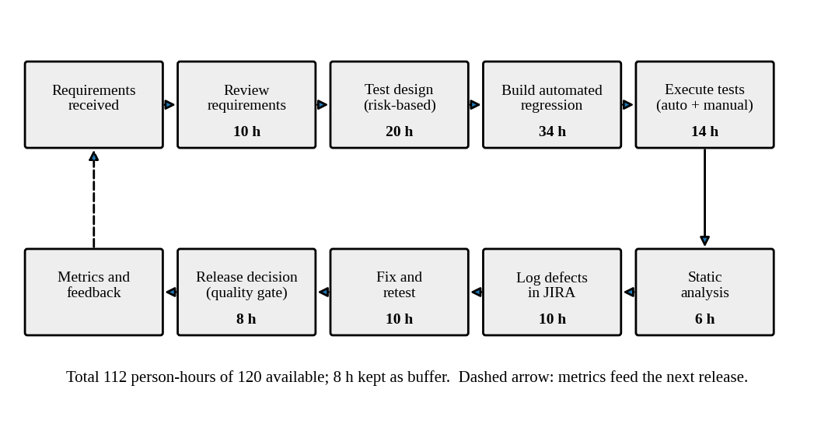
Figure 16: Block diagram of the recommended practice (configuration C) with person-hours per stage
Table 72: Design Decision Table
Decision | Justification (evidence) | What if not
Adopt configuration C | 6 of 6 faults, DRE 94.2%, 112 h fits 120 h | With A or B, 2–4 faults reach users
Requirement and design review | 27 of 37 escapes injected before coding (Task 6) | Escapes at ₹50,000 each stay at 37
Risk-based boundary design incl. invalid inputs | G2, H1, H2 and V1 found only by boundary or invalid cases | Another D1/D4-type fault reaches users
Automated regression and quality gate on every build | Re-run takes milliseconds, not 4.8 h (Task 1) | Regression skipped under pressure
Static-analysis rule for int/round on money | Found G2 and H1 without a test | Rounding faults wait for system test
JIRA with workflow and mandatory fields | Audit and links; saves 17 min per report (Task 8) | Defects stay in e-mail; no audit trail
Embedded tester | 4 of 4 Hall Ticket faults found (Task 5) | Requirement ambiguities (D8) continue

5. Transfer to other applications
Table 73: How defect classes, severity and testing priority change relative to CampusConnect
Aspect | CampusConnect | Banking app | Medical-device controller | Mobile game
Dominant defect classes | Rule logic, requirements | Concurrency, security, data integrity | Timing, hardware interface, requirements | Performance, usability, compatibility
Severity of a wrong value | Wrong grade or fee: critical | Wrong balance: critical, regulatory | Wrong dose: life-critical, one defect is enough | Wrong score: minor
Testing priority | Payments, grades | Transactions and security first | Safety hazards; 100% requirement and code coverage | Playability and device matrix
Process change | Agile with gates | Agile plus audit and penetration tests | V-model, formal reviews, traceability | Rapid release, crash analytics

6. Limitation of happy-path testing
Configurations A and B used only valid inputs and missed V1 (marks above 100 accepted): no valid input can reveal that a bad input is accepted. Only C and D, which included 101, exposed it (D also missed H2). A result that disagreed with my expectation was B missing H2: I expected a structured set to catch it. The measured reason is that the equivalence class “dues present” was not homogeneous, the fault hides below ₹500, and the chosen representative ₹5,000 sat above it. Possible sources of error: only six faults, so one fault changes a percentage by 17 points; the test sets were designed by the same author who seeded the faults; the ad hoc figure depends on my assumed input ranges; and effort is modelled, not logged.
7. The fourth option and the recommendation
Table 74: Evaluation of the four configurations
Criterion | A | B | C | D (AI-assisted)
Cost (effort of 120 h) | 18 h, lowest | 74 h | 112 h, highest | 70 h
Detection (prototype) | 0.6% | 66.7% | 100% | 83.3%
Repeatability | None | Medium | Exact | Medium: generated tests vary
Auditability | Poor | Good | Best (linked log) | Weak unless generation is logged
Risk | Highest leakage | Misses invalid and threshold faults | Tight budget, tool upkeep | Wrong oracles, invented rules (Task 1), missed D2-class defects

Recommendation: C. It is the only one that exposed all six faults, has the highest predicted DRE (94.2%) and fits the 120 hours with 8 hours in reserve. The AI-assisted option is useful inside C as a drafting aid for test ideas, which a tester reviews, but not on its own because it missed H2 and carries oracle risk.
7. Supporting evidence for Task 9
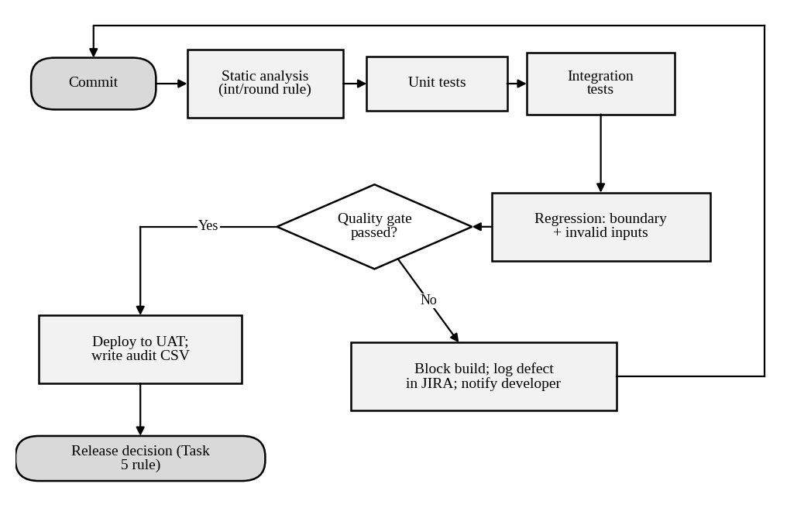
Figure 17: Flowchart of the automated pipeline and quality gate of configuration C
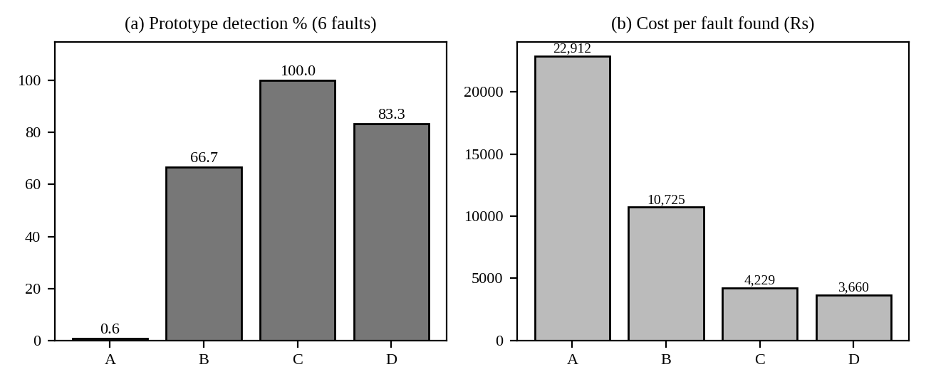
Figure 18: Prototype fault detection and cost per fault found for the four configurations
The static-analysis rule
import ast
def lint(src): # flags int() / round() applied to money, marks, attendance
warnings = []
for node in ast.walk(ast.parse(src)):
if (isinstance(node, ast.Call) and getattr(node.func, "id", "") in ("int", "round") and node.args):
warnings.append((node.func.id, ast.unparse(node.args[0]), node.lineno))
return warnings

Applied to the faulty prototype it returns int(marks), round(attendance) and int(text). The first two are the D1 and D4 patterns; the third is a legitimate conversion and is suppressed with a comment once reviewed.
Complete check lists of the configurations
Table 75: Checks run by configuration B (24 checks)
# | Rule | Input | Expected
1 | Grade | marks = 100 | O
2 | Grade | marks = 90 | O
3 | Grade | marks = 89 | A+
4 | Grade | marks = 80 | A+
5 | Grade | marks = 79.5 | A+
6 | Grade | marks = 89.5 | O
7 | Grade | marks = 70 | A
8 | Grade | marks = 60 | B+
9 | Grade | marks = 50 | B
10 | Grade | marks = 49.5 | B
11 | Grade | marks = 0 | U
12 | Late fee | days_late = 0 | ₹0
13 | Late fee | days_late = 1 | ₹100
14 | Late fee | days_late = 2 | ₹200
15 | Late fee | days_late = 10 | ₹1,000
16 | Late fee | days_late = 50 | ₹5,000
17 | Late fee | days_late = 51 | ₹5,000
18 | Late fee | days_late = 60 | ₹5,000
19 | Hall ticket | attendance 75%, dues ₹0, registered yes | Eligible
20 | Hall ticket | attendance 74.9%, dues ₹0, registered yes | Not eligible
21 | Hall ticket | attendance 80%, dues ₹0, registered yes | Eligible
22 | Hall ticket | attendance 60%, dues ₹0, registered yes | Not eligible
23 | Hall ticket | attendance 80%, dues ₹5,000, registered yes | Not eligible
24 | Hall ticket | attendance 80%, dues ₹0, registered no | Not eligible

Table 76: Checks run by configuration C (35 checks: the 24 of B plus 11 more)
# | Rule | Input | Expected
1 | Grade | marks = 100 | O
2 | Grade | marks = 90 | O
3 | Grade | marks = 89 | A+
4 | Grade | marks = 80 | A+
5 | Grade | marks = 79.5 | A+
6 | Grade | marks = 89.5 | O
7 | Grade | marks = 70 | A
8 | Grade | marks = 60 | B+
9 | Grade | marks = 50 | B
10 | Grade | marks = 49.5 | B
11 | Grade | marks = 0 | U
12 | Late fee | days_late = 0 | ₹0
13 | Late fee | days_late = 1 | ₹100
14 | Late fee | days_late = 2 | ₹200
15 | Late fee | days_late = 10 | ₹1,000
16 | Late fee | days_late = 50 | ₹5,000
17 | Late fee | days_late = 51 | ₹5,000
18 | Late fee | days_late = 60 | ₹5,000
19 | Hall ticket | attendance 75%, dues ₹0, registered yes | Eligible
20 | Hall ticket | attendance 74.9%, dues ₹0, registered yes | Not eligible
21 | Hall ticket | attendance 80%, dues ₹0, registered yes | Eligible
22 | Hall ticket | attendance 60%, dues ₹0, registered yes | Not eligible
23 | Hall ticket | attendance 80%, dues ₹5,000, registered yes | Not eligible
24 | Hall ticket | attendance 80%, dues ₹0, registered no | Not eligible
25 | Hall ticket | attendance 80%, dues ₹1, registered yes | Not eligible
26 | Hall ticket | attendance 80%, dues ₹499, registered yes | Not eligible
27 | Hall ticket | attendance 80%, dues ₹500, registered yes | Not eligible
28 | Grade | marks = 101 | Rejected (error)
29 | Grade | marks = -1 | Rejected (error)
30 | Late fee | days_late = -1 | ₹0
31 | Late fee | days_late = 49 | ₹4,900
32 | Late fee | days_late = 100 | ₹5,000
33 | Grade | marks = 69.5 | A
34 | Grade | marks = 59.5 | B+
35 | Grade | marks = 99.5 | O

Table 77: Checks run by configuration D (27 AI-generated checks after review)
# | Rule | Input | Expected
1 | Grade | marks = 90 | O
2 | Grade | marks = 89 | A+
3 | Grade | marks = 89.5 | O
4 | Grade | marks = 80 | A+
5 | Grade | marks = 79.5 | A+
6 | Grade | marks = 70 | A
7 | Grade | marks = 69.5 | A
8 | Grade | marks = 60 | B+
9 | Grade | marks = 50 | B
10 | Grade | marks = 49.5 | B
11 | Grade | marks = 0 | U
12 | Grade | marks = 100 | O
13 | Grade | marks = 101 | Rejected (error)
14 | Late fee | days_late = 0 | ₹0
15 | Late fee | days_late = 1 | ₹100
16 | Late fee | days_late = 50 | ₹5,000
17 | Late fee | days_late = 51 | ₹5,000
18 | Late fee | days_late = 60 | ₹5,000
19 | Late fee | days_late = 100 | ₹5,000
20 | Late fee | days_late = -1 | ₹0
21 | Hall ticket | attendance 75%, dues ₹0, registered yes | Eligible
22 | Hall ticket | attendance 74.9%, dues ₹0, registered yes | Not eligible
23 | Hall ticket | attendance 74%, dues ₹0, registered yes | Not eligible
24 | Hall ticket | attendance 80%, dues ₹1,000, registered yes | Not eligible
25 | Hall ticket | attendance 80%, dues ₹0, registered no | Not eligible
26 | Hall ticket | attendance 100%, dues ₹0, registered yes | Eligible
27 | Hall ticket | attendance 0%, dues ₹0, registered yes | Not eligible

Marking notes and common errors
- The practice must be shown running on the same prototype; compare detection, effort and cost for every configuration, not just the chosen one.
- At least one measured result must be compared with an earlier prediction and the difference explained.
- The block diagram must include requirements, test design, execution, defect logging, fix and retest, release decision and feedback, with person-hours that add up to at most 120.
- The transfer table must show at least three differences in defect classes, severity and testing priority for each application.
- For the happy-path bullet, the student must identify a fault found only by invalid or boundary input and a result that contradicted an expectation.

TASK 10 – Re-apply and Adapt the Testing Practice [8 Marks]
Changed Requirement: The university adds a UPI payment gateway and a mobile app, extends CampusConnect to four more campuses (25,000 users), moves to weekly releases, and a regulator demands an audit trail of every payment test. Two testers leave, so only 60 person-hours are available per release.
Technique | Basic idea and key concepts / tools
A. Retain + prioritise | Keep the Task 9 practice; shrink the suite by risk and run only high-risk cases each week.
B. Modify with automation | Automate the regression suite and payment checks in a CI pipeline; keep manual testing for new features.
C. Redesign with shift-left | Add requirement and code reviews, static analysis and defect-prediction to prevent defects before testing; automate only the core.

- Develop (apply): implement the three strategies on your prototype and the extended rules (UPI timeout, retry and refund) and submit the commented code and results; every result must come from your own execution.
- Impact Analysis: Identify which assumptions of your Task 9 practice (effort, release cycle, user load, payment risk, audit) are no longer valid, and analyze what happens if the old practice is used unchanged.
- Evaluation of the Original Practice: Recalculate the effort needed and the defect removal efficiency possible within 60 person-hours; analyze which parts of the original practice remain valid.
- Compare and Adapt: Compare strategies A, B and C on defects found, cost, release delay and audit evidence using your own measurements; recommend RETAIN, MODIFY or REDESIGN and state what changes.
- Evidence-Based Defence: Defend the final decision using calculations, Task 9 measurements, the effort limit and the audit rule, and state one condition under which the decision would no longer hold.
- Evaluate how a defect-prediction model trained on the historical log could focus the limited 60 hours, and judge the risks of acting on its predictions.
Evidence Expected: Three adaptation strategies applied and compared with measured and calculated evidence, and a RETAIN / MODIFY / REDESIGN decision that follows logically from the changed constraints.
Ans:
Re-application and Adaptation of the Testing Practice
1. Develop (apply): the three strategies on the extended prototype
I extended the prototype with a UPI payment service (PaymentService) with the new rules: at most three attempts per payment, one idempotency key per payment, reconciliation with the gateway after a timeout, refund of any extra debit, and an audit entry for every attempt. Six faults were seeded; all results below come from running the code.
def pay(self, student, base_fee, days_late, key):
total = base_fee + compute_late_fee(days_late) # P4: cap removed
paise = round(total * 100) # P6: int(total * 100)
for attempt in range(1, 3 + 1): # P3: range(1, 4 + 1)
use_key = key # P1: f"{key}-{attempt}"
outcome = self.gw.charge(use_key, paise) # SUCCESS | TIMEOUT_DEBITED | FAILED ...
self.audit.append({...}) # P5: skipped for failed attempts
if outcome == "TIMEOUT_DEBITED": self.status = "PAID"; break # reconcile, no second debit
# P2: extra debits are not refunded

Table 78: Seeded payment faults and the test that exposes each (each test exposes exactly its own fault)
Fault | Description | Test | Requirement | Risk (1–5)
P1 | No idempotency: blind retry after a timeout debits twice (D2 type) | TP-01 | REQ-PAY-03 | 5
P2 | Duplicate debit is not refunded | TP-02 | REQ-PAY-05 | 4
P3 | Fourth attempt allowed | TP-03 | REQ-PAY-04 | 3
P4 | Late-fee cap missing (D3 type) | TP-04 | REQ-FEE-04 | 5
P5 | Failed attempts not audited | TP-05 | REQ-AUD-01 | 5
P6 | Paise truncated: ₹16,384.01 becomes 1,638,400 paise instead of 1,638,401 | TP-06 | REQ-PAY-02 | 2

The suite has 11 payment tests (six faulty-path tests plus five that must pass) and the 28 regression tests of Task 9, 39 in all.
Table 79: Strategies applied: faults found, effort and elapsed manual time (2 testers × 5 productive hours per day)
Strategy | Found | Which | Missed | Effort (h) | Manual time | Cost incl. leakage*
A. Retain + prioritise | 4 of 6 | P1, P2, P4, P5 | P3, P6 | 60 | 6.0 d | ₹1,30,000
B. Modify with automation | 6 of 6 | P1, P2, P3, P4, P5, P6 | none | 60 | 2.6 d | ₹30,000
C. Redesign with shift-left | 5 of 6 | P1, P2, P4, P5, P6 | P3 | 60 | 3.6 d | ₹80,000

*Cost = 60 h × ₹500 + missed faults × ₹50,000. A could afford only the 26 highest-risk of the 39 tests (26 × 1.5 h = 39 h of the 60 h), so it skipped TP-03, TP-06 and TP-10 (risk 3, 2, 2) and missed P3 and P6. B ran all 39 in CI. C found P1, P2 and P6 before coding: a checklist review of the draft payment requirement flagged three gaps (idempotency key on retry, refund of duplicate debit, amount precision), the static-analysis rule flagged int(amount * 100), and 5 core automated tests found P4 and P5; it has no retry-limit test and missed P3.
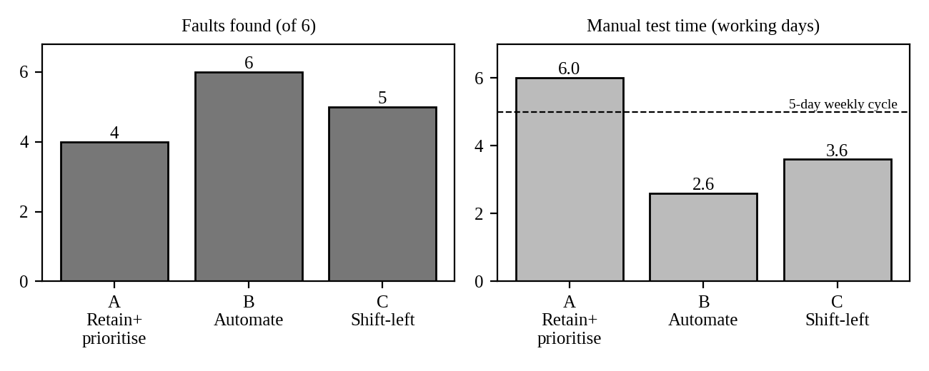
Figure 19: Faults found and manual test time for the three strategies (weekly cycle = 5 working days)
Table 80: Effort of each strategy within 60 person-hours
Strategy | Activity | Hours
A | Risk ranking & planning | 6
A | Manual execution of 26 tests (1.5 h each) | 39
A | Defect triage & reporting | 8
A | Manual audit evidence (screenshots, sheet) | 7
B | Automate 11 payment tests (1.5 h each) | 16.5
B | Maintain existing regression suite | 8
B | Manual testing of new mobile features | 18
B | Defect triage & reporting | 8
B | CI job + automatic audit trail set-up | 9.5
C | Checklist review of payment requirements | 10
C | Static analysis set-up & warning triage | 6
C | Automate 5 core tests (1.5 h each) | 7.5
C | Maintain existing regression suite | 6
C | Manual testing of new mobile features | 18
C | Defect triage & reporting | 8
C | Metrics & defect-prediction update | 4.5

Table 81: Audit trail written by strategy B (first rows of the generated file; each row hashes the previous one, so editing any row breaks the chain)
Seq | Test | Requirement | Verdict | Chain hash (first 12)
1 | TP-01 | REQ-PAY-03 | FAIL | 35679d581c03
2 | TP-02 | REQ-PAY-05 | FAIL | b309b220ef1b
3 | TP-03 | REQ-PAY-04 | FAIL | fceec813d766
4 | TP-04 | REQ-FEE-04 | FAIL | e1569c356912
5 | TP-05 | REQ-AUD-01 | FAIL | c277c628be05
6 | TP-06 | REQ-PAY-02 | FAIL | 8db47acd58a9

The six FAIL rows here come from running the suite on a build with all six faults seeded; on a clean build all rows pass. In the real system each row would also store the inputs, expected and actual values and a timestamp.
2. Impact analysis
Table 82: Which assumptions of the Task 9 practice are no longer valid
Assumption | Task 9 | Now | Valid?
Effort | 120 h per release (C needs 112 h) | 60 h | No: 187% of capacity needed
Release cycle | 2 weeks (10 working days) | Weekly (5 working days) | No: a 112 h cycle needs about 11 days of two testers
User load | 12,600 users, peak 3,000 | 37,600 users, peak ≈ 8,952 (×3.0) | No: D7 took 40 s at 3,000; linear scaling suggests about 2 minutes
Payment risk | Web only; card-like flow | UPI plus mobile app | No: timeouts, retries, refunds are new (D2 class)
Audit | Defect log only | Regulator needs an audit trail of every payment test | No: manual sheets are editable

If the old practice is used unchanged, only about 54% of its planned effort can run (60 ÷ 112), the weekly release slips by about a week or testing is cut without a risk decision, the load tests of D7 are not rerun at 9,000 users, and the audit evidence is not tamper-proof.
3. Evaluation of the original practice
Table 83: Effort needed for the new scope
Item | Hours per release
Task 9 practice in steady state (automation already built) | 58
Mobile app (second platform) | +18
UPI and audit evidence | +16
Four campuses: data, configuration and 3× load test | +14
Weekly cadence: extra release ceremonies | +10
Half the feature volume per weekly release | −16
Needed | 100
Available | 60 (60%)

The DRE possible within 60 hours if the original practice is merely shrunk is the Retain + prioritise result: 4 of 6 = 66.7% on the prototype, against 100% at 112 hours. What remains valid: risk-based test design with boundaries and invalid inputs, the severity and class scheme, JIRA, the quality gate, and the automated regression suite already built.
4. Compare and adapt, with the decision
Table 84: Comparison of strategies A, B and C
Measure | A. Retain + prioritise | B. Modify with automation | C. Redesign shift-left
Faults found (of 6) | 4 | 6 | 5
Cost incl. leakage | ₹1,30,000 | ₹30,000 | ₹80,000
Release delay | 6.0 days of manual work in a 5-day week: about 1 day late | 2.6 days: none | 3.6 days: none
Audit evidence | Manual screenshots; weak | Automatic, tamper-evident, all 39 tests | Automatic for 5 core tests only; partial

Decision: MODIFY. Keep the Task 9 practice but automate the regression and payment checks in CI (strategy B), and add two cheap shift-left items from C: a checklist review of payment requirements (4 h) and the static rule for money conversions (2 h), funded by reducing manual testing of new features from 18 h to 12 h. What changes: manual regression is replaced by CI on every build; the audit trail is generated automatically; reviews are focused on payment requirements; the 120-hour plan becomes a 60-hour plan with the same quality gate.
5. Evidence-based defence
- Calculation: B found 6 of 6 faults within 60 h; A found 4 and left ₹1,00,000 of expected leakage; C found 5.
- Task 9 measurements: the regression assets built for configuration C (30 checks run in 0.46 ms) are reused, which is why maintenance is only 8 h; the 11 payment tests ran in 0.09 ms.
- Effort limit: B uses exactly 60 h, with manual feature testing of 18 h and 2.6 days of manual time, so the weekly release is met.
- Audit rule: only B produces a tamper-evident record of every payment test automatically; A would need 7 h of manual evidence each week and remains editable.
The decision no longer holds if the regression suite triples in size (maintenance rises from 8 h to about 24 h and B needs 76 h), or if most new defects are in device-specific mobile behaviour that cannot be automated; then I would move to C with more manual exploratory time.
6. Defect prediction to focus the 60 hours
Using the historical log, I scored each module as defect density × (1 + 0.5 × post-release share) and divided 48 hours (60 minus 12 fixed hours for planning, triage and release) in proportion to the score.
Table 85: Prediction-based allocation of 48 hours
Module | Score | Hours
Login | 4.67 | 7.0
Course Registration | 4.28 | 6.4
Fee Payment | 6.82 | 10.2
Marks & Grade Evaluation | 7.69 | 11.5
Hall Ticket | 4.90 | 7.3
Notifications | 3.67 | 5.5

Risks of acting on the predictions: the model learns from the old modules, so the new UPI gateway and mobile app (no history) look safe and are under-tested; a module with few reported defects may simply be under-tested; scores based on counts repeat past blind spots (D2 was a design defect that no test looked for); and the model needs periodic retraining. Use it to prioritise, keep a minimum for every module and for all new features, and review the allocation against code churn and requirement changes.
7. Supporting evidence for Task 10
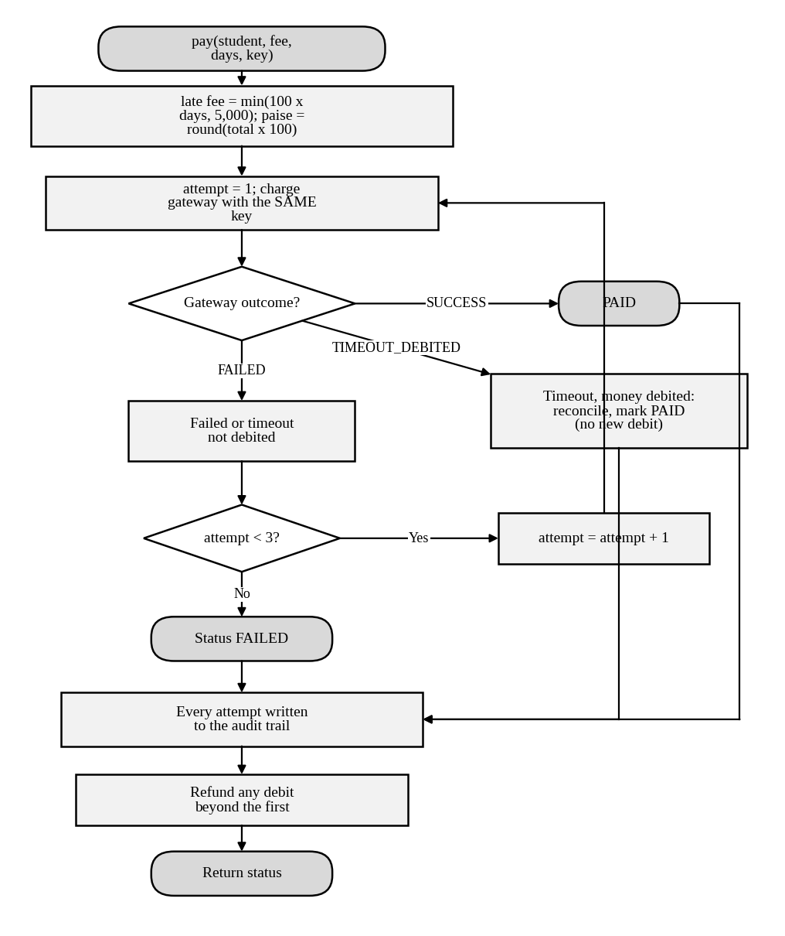
Figure 20: Flowchart of the UPI payment logic with idempotent retry, reconciliation, audit and refund
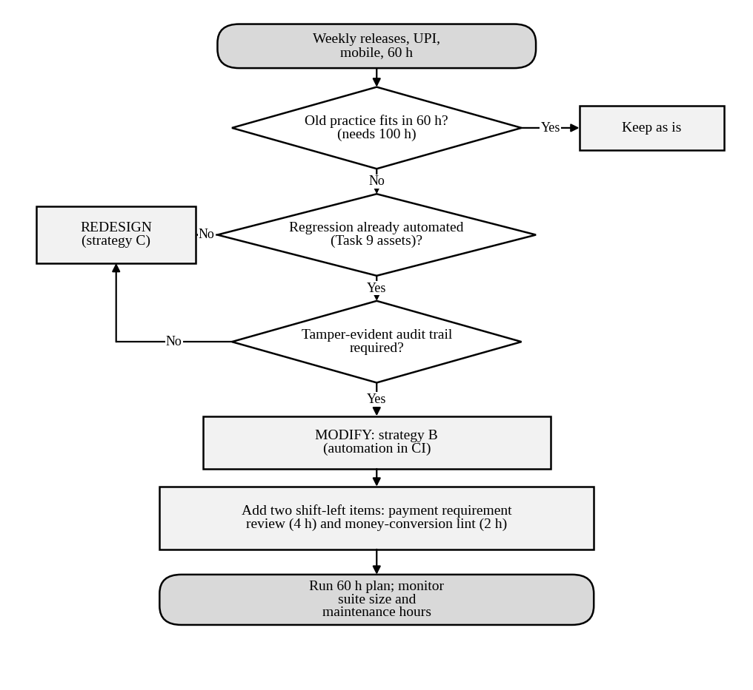
Figure 21: Decision flowchart that led to the MODIFY choice
Payment tests and gateway scenarios
Table 86: The 11 payment tests (risk 1–5 from the historical log; expected results from the requirements)
Test | Requirement | Gateway script | Checks | Risk
TP-01 | REQ-PAY-03 | TIMEOUT_DEBITED, SUCCESS | Timeout after debit, retry: exactly one debit | 5
TP-02 | REQ-PAY-05 | SUCCESS_DUPLICATE | Duplicate debit by gateway is refunded | 4
TP-03 | REQ-PAY-04 | FAILED × 5 | At most 3 attempts per payment | 3
TP-04 | REQ-FEE-04 | SUCCESS; 60 days late | 60 days late: late fee capped at Rs 5,000 | 5
TP-05 | REQ-AUD-01 | FAILED, FAILED, SUCCESS | Every attempt, incl. failed, is audited | 5
TP-06 | REQ-PAY-02 | SUCCESS; fee ₹16,384.01 | Paise exact for Rs 16,384.01 | 2
TP-07 | REQ-PAY-01 | SUCCESS | First-attempt success: PAID, one debit | 3
TP-08 | REQ-PAY-03 | TIMEOUT_NOT_DEBITED, SUCCESS | Timeout without debit, retry succeeds | 3
TP-09 | REQ-AUD-02 | SUCCESS | Audit row carries student, attempt, requirement | 4
TP-10 | REQ-FEE-03 | SUCCESS; on due date | Paid on due date: no late fee | 2
TP-11 | REQ-PAY-04 | FAILED × 5 | Three failures end FAILED with no debit | 3

Regression catalogue reused from Task 9
Table 87: The 28 regression tests (ordered by identifier; risk from the defect history)
ID | Check | Expected | Risk
RG-01 | Grade: marks = 100 | O | 5
RG-02 | Grade: marks = 90 | O | 5
RG-03 | Grade: marks = 89 | A+ | 5
RG-04 | Grade: marks = 80 | A+ | 5
RG-05 | Grade: marks = 79.5 | A+ | 5
RG-06 | Grade: marks = 89.5 | O | 5
RG-07 | Grade: marks = 70 | A | 5
RG-08 | Grade: marks = 60 | B+ | 5
RG-09 | Grade: marks = 50 | B | 4
RG-10 | Grade: marks = 49.5 | B | 4
RG-11 | Grade: marks = 0 | U | 4
RG-12 | Late fee: days_late = 0 | ₹0 | 4
RG-13 | Late fee: days_late = 1 | ₹100 | 4
RG-14 | Late fee: days_late = 2 | ₹200 | 4
RG-15 | Late fee: days_late = 10 | ₹1,000 | 4
RG-16 | Late fee: days_late = 50 | ₹5,000 | 4
RG-17 | Late fee: days_late = 51 | ₹5,000 | 4
RG-18 | Late fee: days_late = 60 | ₹5,000 | 4
RG-19 | Hall ticket: attendance 75%, dues ₹0, registered yes | Eligible | 3
RG-20 | Hall ticket: attendance 74.9%, dues ₹0, registered yes | Not eligible | 3
RG-21 | Hall ticket: attendance 80%, dues ₹0, registered yes | Eligible | 3
RG-22 | Hall ticket: attendance 60%, dues ₹0, registered yes | Not eligible | 3
RG-23 | Hall ticket: attendance 80%, dues ₹5,000, registered yes | Not eligible | 2
RG-24 | Hall ticket: attendance 80%, dues ₹0, registered no | Not eligible | 2
RG-25 | Hall ticket: attendance 80%, dues ₹1, registered yes | Not eligible | 2
RG-26 | Hall ticket: attendance 80%, dues ₹499, registered yes | Not eligible | 2
RG-27 | Hall ticket: attendance 80%, dues ₹500, registered yes | Not eligible | 2
RG-28 | Grade: marks = 101 | Rejected (error) | 2

Ranking of all 39 tests for strategy A
Table 88: Tests run by strategy A within 60 hours (first 26 by risk) and tests skipped
Rank | Test | Run by A?
1 | TP-01 | Yes
2 | TP-04 | Yes
3 | TP-05 | Yes
4 | RG-01 | Yes
5 | RG-02 | Yes
6 | RG-03 | Yes
7 | RG-04 | Yes
8 | RG-05 | Yes
9 | RG-06 | Yes
10 | RG-07 | Yes
11 | RG-08 | Yes
12 | TP-02 | Yes
13 | TP-09 | Yes
14 | RG-09 | Yes
15 | RG-10 | Yes
16 | RG-11 | Yes
17 | RG-12 | Yes
18 | RG-13 | Yes
19 | RG-14 | Yes
20 | RG-15 | Yes
21 | RG-16 | Yes
22 | RG-17 | Yes
23 | RG-18 | Yes
24 | TP-07 | Yes
25 | TP-08 | Yes
26 | TP-11 | Yes
27 | TP-03 | No (skipped)
28 | RG-19 | No (skipped)
29 | RG-20 | No (skipped)
30 | RG-21 | No (skipped)
31 | RG-22 | No (skipped)
32 | TP-06 | No (skipped)
33 | TP-10 | No (skipped)
34 | RG-23 | No (skipped)
35 | RG-24 | No (skipped)
36 | RG-25 | No (skipped)
37 | RG-26 | No (skipped)
38 | RG-27 | No (skipped)
39 | RG-28 | No (skipped)

The skipped tests are the three lowest-risk payment tests TP-03, TP-06 and TP-10 plus lower-risk regression tests. The skipped payment tests are exactly the ones that expose P3 and P6, which is why strategy A cannot reach 6 of 6.
Marking notes and common errors
- Develop: the student must show the strategies applied to code or tests, with an audit trail; screenshots or a run log are acceptable.
- Impact analysis must list each old assumption and say whether it still holds, with numbers (effort, cycle, load).
- The decision (RETAIN, MODIFY or REDESIGN) must be defended with calculations from earlier tasks; any of the three is acceptable if the evidence supports it.
- The defect-prediction bullet needs at least three concrete risks of using predictions (history bias, new modules, gaming, model decay).
- Award marks for the condition under which the decision would no longer hold; a vague “if things change” earns none.

Mark Distribution
Task | Marks
Task 1 – Testing Approach Analysis | 4
Task 2 – Process Model Analysis | 5
Task 3 – Test Case Specification Analysis | 4
Task 4 – Test Selection and Principles Analysis | 4
Task 5 – Tester Role Analysis | 5
Task 6 – Defect Origin Analysis | 5
Task 7 – Defect Classification Analysis | 4
Task 8 – Defect Repository Analysis | 5
Task 9 – Implementation and Performance Evaluation | 6
Task 10 – Testing Practice Adaptation Challenge | 8
TOTAL | 50

ANNEXURE A – Defect Log used in this Answer Key (all 217 records)
The log was prepared for this key with the stated totals: 217 defects, 180 found by the test team and 37 by users, 13 of those critical. The same data is supplied as defect_log_CampusConnect.csv.
ID | Module | Class | Injected | Detected | Severity
DL-001 | Fee Payment | Testing & environment | Deployment/Config | After release | Critical
DL-002 | Marks & Grade Evaluation | Coding - data | Coding | System testing | Minor
DL-003 | Marks & Grade Evaluation | Coding - interface | Coding | System testing | Minor
DL-004 | Fee Payment | Requirements & specification | Requirements | After release | Major
DL-005 | Login | Coding - algorithmic | Coding | Unit/integration test | Minor
DL-006 | Marks & Grade Evaluation | Requirements & specification | Requirements | After release | Critical
DL-007 | Fee Payment | Coding - data | Coding | Unit/integration test | Minor
DL-008 | Course Registration | Testing & environment | Deployment/Config | Unit/integration test | Major
DL-009 | Hall Ticket | Requirements & specification | Requirements | System testing | Major
DL-010 | Hall Ticket | Testing & environment | Deployment/Config | System testing | Minor
DL-011 | Marks & Grade Evaluation | Coding - data | Coding | Unit/integration test | Trivial
DL-012 | Marks & Grade Evaluation | Requirements & specification | Requirements | After release | Minor
DL-013 | Course Registration | Requirements & specification | Requirements | After release | Critical
DL-014 | Marks & Grade Evaluation | Coding - control & logic | Coding | Unit/integration test | Trivial
DL-015 | Marks & Grade Evaluation | Testing & environment | Deployment/Config | After release | Minor
DL-016 | Notifications | Coding - control & logic | Coding | System testing | Minor
DL-017 | Course Registration | Design | Design | System testing | Minor
DL-018 | Hall Ticket | Coding - algorithmic | Coding | System testing | Minor
DL-019 | Fee Payment | Design | Design | Unit/integration test | Critical
DL-020 | Course Registration | Requirements & specification | Requirements | System testing | Minor
DL-021 | Fee Payment | Testing & environment | Deployment/Config | System testing | Minor
DL-022 | Marks & Grade Evaluation | Coding - interface | Coding | Unit/integration test | Critical
DL-023 | Fee Payment | Coding - data | Coding | Unit/integration test | Major
DL-024 | Hall Ticket | Coding - data | Coding | Unit/integration test | Minor
DL-025 | Fee Payment | Coding - interface | Coding | Unit/integration test | Minor
DL-026 | Course Registration | Coding - control & logic | Coding | System testing | Major
DL-027 | Notifications | Design | Design | After release | Trivial
DL-028 | Marks & Grade Evaluation | Requirements & specification | Requirements | After release | Minor
DL-029 | Marks & Grade Evaluation | Coding - control & logic | Coding | System testing | Critical
DL-030 | Course Registration | Requirements & specification | Requirements | Unit/integration test | Major
DL-031 | Fee Payment | Design | Design | System testing | Minor
DL-032 | Marks & Grade Evaluation | Design | Design | System testing | Minor
DL-033 | Course Registration | Coding - algorithmic | Coding | System testing | Minor
DL-034 | Login | Requirements & specification | Requirements | After release | Major
DL-035 | Marks & Grade Evaluation | Coding - data | Coding | Unit/integration test | Critical
DL-036 | Fee Payment | Testing & environment | Deployment/Config | System testing | Trivial
DL-037 | Fee Payment | Design | Design | System testing | Critical
DL-038 | Login | Requirements & specification | Requirements | System testing | Trivial
DL-039 | Hall Ticket | Coding - algorithmic | Coding | System testing | Critical
DL-040 | Marks & Grade Evaluation | Coding - algorithmic | Coding | Unit/integration test | Critical
DL-041 | Login | Testing & environment | Deployment/Config | System testing | Minor
DL-042 | Hall Ticket | Testing & environment | Deployment/Config | After release | Critical
DL-043 | Login | Testing & environment | Deployment/Config | System testing | Major
DL-044 | Marks & Grade Evaluation | Coding - control & logic | Coding | After release | Major
DL-045 | Notifications | Coding - control & logic | Coding | Unit/integration test | Minor
DL-046 | Marks & Grade Evaluation | Coding - data | Coding | Unit/integration test | Major
DL-047 | Course Registration | Coding - interface | Coding | System testing | Minor
DL-048 | Notifications | Coding - interface | Coding | System testing | Minor
DL-049 | Notifications | Coding - data | Coding | System testing | Trivial
DL-050 | Fee Payment | Coding - data | Coding | Unit/integration test | Minor
DL-051 | Marks & Grade Evaluation | Coding - control & logic | Coding | System testing | Trivial
DL-052 | Login | Coding - interface | Coding | Unit/integration test | Trivial
DL-053 | Fee Payment | Testing & environment | Deployment/Config | System testing | Minor
DL-054 | Marks & Grade Evaluation | Requirements & specification | Requirements | After release | Critical
DL-055 | Marks & Grade Evaluation | Coding - algorithmic | Coding | Unit/integration test | Trivial
DL-056 | Fee Payment | Coding - control & logic | Coding | Unit/integration test | Minor
DL-057 | Fee Payment | Coding - algorithmic | Coding | Unit/integration test | Major
DL-058 | Hall Ticket | Requirements & specification | Requirements | After release | Critical
DL-059 | Notifications | Coding - data | Coding | System testing | Major
DL-060 | Marks & Grade Evaluation | Coding - data | Coding | System testing | Major
DL-061 | Notifications | Design | Design | After release | Major
DL-062 | Fee Payment | Requirements & specification | Requirements | Unit/integration test | Major
DL-063 | Course Registration | Design | Design | System testing | Major
DL-064 | Marks & Grade Evaluation | Coding - data | Coding | After release | Critical
DL-065 | Fee Payment | Design | Design | After release | Critical
DL-066 | Marks & Grade Evaluation | Coding - control & logic | Coding | System testing | Minor
DL-067 | Fee Payment | Coding - data | Coding | System testing | Major
DL-068 | Hall Ticket | Testing & environment | Deployment/Config | System testing | Minor
DL-069 | Course Registration | Requirements & specification | Requirements | System testing | Minor
DL-070 | Fee Payment | Requirements & specification | Requirements | System testing | Minor
DL-071 | Login | Coding - interface | Coding | System testing | Critical
DL-072 | Fee Payment | Coding - control & logic | Coding | Unit/integration test | Major
DL-073 | Marks & Grade Evaluation | Coding - control & logic | Coding | Unit/integration test | Minor
DL-074 | Course Registration | Coding - control & logic | Coding | System testing | Minor
DL-075 | Fee Payment | Requirements & specification | Requirements | After release | Critical
DL-076 | Notifications | Coding - data | Coding | System testing | Major
DL-077 | Login | Design | Design | System testing | Minor
DL-078 | Course Registration | Coding - data | Coding | Unit/integration test | Major
DL-079 | Fee Payment | Coding - algorithmic | Coding | System testing | Major
DL-080 | Fee Payment | Coding - control & logic | Coding | System testing | Trivial
DL-081 | Marks & Grade Evaluation | Requirements & specification | Requirements | System testing | Major
DL-082 | Course Registration | Design | Design | System testing | Major
DL-083 | Marks & Grade Evaluation | Coding - algorithmic | Coding | System testing | Minor
DL-084 | Marks & Grade Evaluation | Coding - data | Coding | Unit/integration test | Major
DL-085 | Marks & Grade Evaluation | Coding - algorithmic | Coding | Unit/integration test | Trivial
DL-086 | Course Registration | Requirements & specification | Requirements | Unit/integration test | Minor
DL-087 | Marks & Grade Evaluation | Requirements & specification | Requirements | After release | Major
DL-088 | Fee Payment | Coding - interface | Coding | System testing | Minor
DL-089 | Course Registration | Design | Design | After release | Minor
DL-090 | Fee Payment | Requirements & specification | Requirements | After release | Major
DL-091 | Fee Payment | Testing & environment | Deployment/Config | Unit/integration test | Major
DL-092 | Fee Payment | Coding - control & logic | Coding | System testing | Major
DL-093 | Marks & Grade Evaluation | Design | Design | System testing | Minor
DL-094 | Course Registration | Requirements & specification | Requirements | System testing | Major
DL-095 | Fee Payment | Coding - data | Coding | System testing | Critical
DL-096 | Fee Payment | Coding - data | Coding | System testing | Major
DL-097 | Course Registration | Coding - algorithmic | Coding | Unit/integration test | Minor
DL-098 | Fee Payment | Coding - interface | Coding | Unit/integration test | Minor
DL-099 | Fee Payment | Coding - interface | Coding | Unit/integration test | Minor
DL-100 | Fee Payment | Coding - interface | Coding | Unit/integration test | Minor
DL-101 | Course Registration | Coding - control & logic | Coding | After release | Major
DL-102 | Fee Payment | Coding - control & logic | Coding | Unit/integration test | Major
DL-103 | Fee Payment | Coding - control & logic | Coding | System testing | Major
DL-104 | Fee Payment | Testing & environment | Deployment/Config | System testing | Minor
DL-105 | Marks & Grade Evaluation | Design | Design | After release | Minor
DL-106 | Notifications | Coding - data | Coding | System testing | Minor
DL-107 | Hall Ticket | Requirements & specification | Requirements | System testing | Minor
DL-108 | Fee Payment | Coding - data | Coding | Unit/integration test | Major
DL-109 | Marks & Grade Evaluation | Requirements & specification | Requirements | System testing | Trivial
DL-110 | Notifications | Requirements & specification | Requirements | System testing | Major
DL-111 | Login | Coding - control & logic | Coding | Unit/integration test | Major
DL-112 | Hall Ticket | Requirements & specification | Requirements | System testing | Minor
DL-113 | Marks & Grade Evaluation | Requirements & specification | Requirements | System testing | Minor
DL-114 | Notifications | Requirements & specification | Requirements | System testing | Minor
DL-115 | Fee Payment | Coding - algorithmic | Coding | Unit/integration test | Critical
DL-116 | Course Registration | Coding - interface | Coding | Unit/integration test | Minor
DL-117 | Login | Coding - interface | Coding | Unit/integration test | Major
DL-118 | Marks & Grade Evaluation | Coding - algorithmic | Coding | Unit/integration test | Minor
DL-119 | Hall Ticket | Design | Design | After release | Major
DL-120 | Course Registration | Coding - data | Coding | Unit/integration test | Major
DL-121 | Marks & Grade Evaluation | Coding - control & logic | Coding | System testing | Major
DL-122 | Marks & Grade Evaluation | Coding - control & logic | Coding | System testing | Critical
DL-123 | Marks & Grade Evaluation | Coding - control & logic | Coding | System testing | Minor
DL-124 | Login | Coding - data | Coding | Unit/integration test | Major
DL-125 | Fee Payment | Testing & environment | Deployment/Config | System testing | Minor
DL-126 | Course Registration | Design | Design | System testing | Trivial
DL-127 | Hall Ticket | Coding - control & logic | Coding | System testing | Minor
DL-128 | Course Registration | Coding - interface | Coding | Unit/integration test | Trivial
DL-129 | Notifications | Coding - control & logic | Coding | Unit/integration test | Minor
DL-130 | Marks & Grade Evaluation | Coding - control & logic | Coding | Unit/integration test | Major
DL-131 | Notifications | Coding - interface | Coding | Unit/integration test | Minor
DL-132 | Fee Payment | Coding - algorithmic | Coding | Unit/integration test | Major
DL-133 | Fee Payment | Design | Design | System testing | Major
DL-134 | Fee Payment | Requirements & specification | Requirements | After release | Critical
DL-135 | Marks & Grade Evaluation | Design | Design | After release | Critical
DL-136 | Hall Ticket | Testing & environment | Deployment/Config | System testing | Major
DL-137 | Hall Ticket | Design | Design | System testing | Trivial
DL-138 | Fee Payment | Coding - data | Coding | Unit/integration test | Major
DL-139 | Marks & Grade Evaluation | Coding - algorithmic | Coding | System testing | Trivial
DL-140 | Notifications | Coding - interface | Coding | After release | Minor
DL-141 | Marks & Grade Evaluation | Coding - control & logic | Coding | System testing | Minor
DL-142 | Course Registration | Requirements & specification | Requirements | System testing | Minor
DL-143 | Fee Payment | Coding - control & logic | Coding | System testing | Major
DL-144 | Fee Payment | Testing & environment | Deployment/Config | After release | Trivial
DL-145 | Course Registration | Requirements & specification | Requirements | After release | Major
DL-146 | Marks & Grade Evaluation | Design | Design | After release | Minor
DL-147 | Marks & Grade Evaluation | Coding - interface | Coding | System testing | Major
DL-148 | Notifications | Requirements & specification | Requirements | Unit/integration test | Minor
DL-149 | Notifications | Requirements & specification | Requirements | System testing | Minor
DL-150 | Fee Payment | Coding - control & logic | Coding | Unit/integration test | Major
DL-151 | Fee Payment | Coding - algorithmic | Coding | System testing | Major
DL-152 | Fee Payment | Coding - data | Coding | System testing | Trivial
DL-153 | Marks & Grade Evaluation | Testing & environment | Deployment/Config | Unit/integration test | Major
DL-154 | Course Registration | Coding - control & logic | Coding | System testing | Major
DL-155 | Marks & Grade Evaluation | Design | Design | System testing | Major
DL-156 | Fee Payment | Requirements & specification | Requirements | After release | Critical
DL-157 | Fee Payment | Requirements & specification | Requirements | System testing | Minor
DL-158 | Marks & Grade Evaluation | Testing & environment | Deployment/Config | System testing | Minor
DL-159 | Fee Payment | Requirements & specification | Requirements | System testing | Minor
DL-160 | Notifications | Testing & environment | Deployment/Config | Unit/integration test | Major
DL-161 | Course Registration | Requirements & specification | Requirements | System testing | Trivial
DL-162 | Fee Payment | Coding - control & logic | Coding | Unit/integration test | Major
DL-163 | Fee Payment | Design | Design | System testing | Minor
DL-164 | Fee Payment | Testing & environment | Deployment/Config | System testing | Minor
DL-165 | Course Registration | Testing & environment | Deployment/Config | After release | Minor
DL-166 | Hall Ticket | Coding - interface | Coding | System testing | Minor
DL-167 | Course Registration | Coding - control & logic | Coding | System testing | Minor
DL-168 | Hall Ticket | Requirements & specification | Requirements | After release | Major
DL-169 | Course Registration | Testing & environment | Deployment/Config | System testing | Critical
DL-170 | Fee Payment | Coding - control & logic | Coding | System testing | Major
DL-171 | Fee Payment | Coding - control & logic | Coding | Unit/integration test | Minor
DL-172 | Course Registration | Design | Design | Unit/integration test | Major
DL-173 | Marks & Grade Evaluation | Coding - control & logic | Coding | System testing | Major
DL-174 | Fee Payment | Coding - control & logic | Coding | System testing | Major
DL-175 | Course Registration | Requirements & specification | Requirements | Unit/integration test | Minor
DL-176 | Notifications | Requirements & specification | Requirements | After release | Major
DL-177 | Hall Ticket | Coding - control & logic | Coding | Unit/integration test | Minor
DL-178 | Fee Payment | Coding - data | Coding | Unit/integration test | Minor
DL-179 | Course Registration | Testing & environment | Deployment/Config | System testing | Minor
DL-180 | Hall Ticket | Requirements & specification | Requirements | After release | Major
DL-181 | Notifications | Testing & environment | Deployment/Config | System testing | Major
DL-182 | Marks & Grade Evaluation | Design | Design | Unit/integration test | Minor
DL-183 | Marks & Grade Evaluation | Coding - data | Coding | System testing | Minor
DL-184 | Hall Ticket | Requirements & specification | Requirements | System testing | Major
DL-185 | Marks & Grade Evaluation | Requirements & specification | Requirements | System testing | Minor
DL-186 | Notifications | Design | Design | System testing | Major
DL-187 | Fee Payment | Coding - data | Coding | System testing | Minor
DL-188 | Course Registration | Coding - data | Coding | System testing | Minor
DL-189 | Fee Payment | Coding - control & logic | Coding | Unit/integration test | Minor
DL-190 | Fee Payment | Coding - algorithmic | Coding | Unit/integration test | Minor
DL-191 | Marks & Grade Evaluation | Requirements & specification | Requirements | Unit/integration test | Trivial
DL-192 | Course Registration | Design | Design | System testing | Major
DL-193 | Fee Payment | Requirements & specification | Requirements | System testing | Critical
DL-194 | Hall Ticket | Requirements & specification | Requirements | System testing | Minor
DL-195 | Fee Payment | Design | Design | After release | Major
DL-196 | Marks & Grade Evaluation | Coding - data | Coding | Unit/integration test | Major
DL-197 | Fee Payment | Coding - algorithmic | Coding | Unit/integration test | Trivial
DL-198 | Fee Payment | Coding - control & logic | Coding | Unit/integration test | Major
DL-199 | Fee Payment | Design | Design | System testing | Trivial
DL-200 | Fee Payment | Requirements & specification | Requirements | After release | Major
DL-201 | Marks & Grade Evaluation | Requirements & specification | Requirements | System testing | Minor
DL-202 | Course Registration | Requirements & specification | Requirements | System testing | Minor
DL-203 | Fee Payment | Testing & environment | Deployment/Config | Unit/integration test | Minor
DL-204 | Course Registration | Coding - interface | Coding | Unit/integration test | Critical
DL-205 | Hall Ticket | Design | Design | System testing | Critical
DL-206 | Login | Testing & environment | Deployment/Config | After release | Critical
DL-207 | Login | Coding - control & logic | Coding | System testing | Major
DL-208 | Marks & Grade Evaluation | Coding - algorithmic | Coding | System testing | Minor
DL-209 | Fee Payment | Coding - interface | Coding | System testing | Major
DL-210 | Marks & Grade Evaluation | Coding - data | Coding | System testing | Minor
DL-211 | Hall Ticket | Coding - data | Coding | Unit/integration test | Major
DL-212 | Fee Payment | Coding - interface | Coding | System testing | Major
DL-213 | Marks & Grade Evaluation | Coding - control & logic | Coding | Unit/integration test | Major
DL-214 | Fee Payment | Coding - data | Coding | Unit/integration test | Minor
DL-215 | Marks & Grade Evaluation | Design | Design | Unit/integration test | Major
DL-216 | Marks & Grade Evaluation | Coding - data | Coding | System testing | Major
DL-217 | Fee Payment | Testing & environment | Deployment/Config | System testing | Major

ANNEXURE B – Suggested Mark Split per Task
Task (marks) | Split of marks
Task 1 (4) | Implementation and faults 1; detection % and cost 1; comparison and missing activities 1; choice, risk and statement 0.5; LLM critique 0.5
Task 2 (5) | Timelines 1; DRE, repair cost and prediction 1.5; comparison 1; maturity and gaps 0.5; choice 0.5; critique and quality gate 0.5
Task 3 (4) | Tests and faults 1; error/fault/failure 0.5; analysis 0.5; terms 0.5; style choice and D9 1; LLM oracle 0.5
Task 4 (4) | Input space and strategies 1; clustering 0.75; pesticide paradox 0.75; fallacy 0.5; final 30 tests 0.5; critique 0.5
Task 5 (5) | Faults, false reports, time 1.5; two defect reports 1; independence 0.5; skills 0.5; allocation 1; authority 0.5
Task 6 (5) | Matrix 1.5; fishbone and Five Whys 1; analysis and containment 1; method comparison 0.5; choice 0.5; critique and actions 0.5
Task 7 (4) | Classification 1; severity/priority 0.5; disagreements 0.5; agreement 0.5; choice 1; LLM 0.5
Task 8 (5) | Logging 1; life cycle and MTTF 1; analysis 1; data quality 0.5; choice 0.5; per-KLOC critique 1
Task 9 (6) | Prototype 1.5; examination 1; predictions 0.5; diagram and decision table 1; transfer 0.5; limitation 0.5; fourth option and recommendation 1
Task 10 (8) | Develop 1.5; impact 1.5; evaluation 1.5; compare and adapt 1.5; defence 1; defect prediction 1

ANNEXURE C – Supplied Files and Data Notes
- campus.py, exp1.py, exp2.py, exp3.py: the reference code, injectable faults and every experiment; running them regenerates all measured numbers (Python 3, standard library only for the experiments).
- Measured by running code: fault detection, probabilities, input-space sizes, race outcome, lint warnings, cascade DRE, hash-chained audit rows, run times.
- Modelled or illustrative (replace with your own data): person-hours and unit times, the ₹500 hourly rate, cascade efficiencies, false reports in Task 5, repository timings and effort in Task 8, the two classmate raters and LLM classification in Task 7, the 217-record defect log, and the release-level effort figures.
- Screenshots of Bugzilla and JIRA (Task 8) must be taken from the real tools; the table gives the content to enter.
ANNEXURE D – Requirements Traceability Matrix
Every business rule is traced to the tests that check it and to the seeded fault or case defect it relates to. The last column shows gaps: rules with no automated test are where D6, D7 and D8 escaped.
Requirement | Rule | Verified by | Fault / defect | Status
REQ-GRD-01 | Grade bands O, A+, A, B+, B, U | Task 1 cases 1–12; Task 9 grade checks | G1, G3, D9 | Covered
REQ-GRD-02 | Marks rounded half up | Task 1 cases 20–25 (x.5 values) | G2 (D1) | Covered by C only
REQ-GRD-03 | Marks outside 0–100 rejected | Task 1 cases 26–27; Task 9 invalid checks | V1 | Covered by C and D
REQ-FEE-03 | No late fee on or before due date | TC-LF-01, 02; TP-10 | L3 | Covered
REQ-FEE-04 | ₹100 per day late, cap ₹5,000 | TC-LF-03 to 10; TP-04 | L1, L2 (D3) | Covered
REQ-HT-01 | Attendance at least 75%, no rounding | Task 5 pass B; Task 9 checks | H1 (D4) | Covered
REQ-HT-02 | No fee dues | Task 5 pass B; Task 9 dues 1, 499, 500 | H2 | Covered by C only
REQ-HT-03 | Student registered for the course | Task 5 pass B | H3 | Covered
REQ-HT-04 | Exam date from the exam table | Task 5 pass C (lab course) | H4 (D10) | Covered by C only
REQ-REG-01 | 3–7 courses | Task 4 cases 1–6 | R1, R2 | Covered
REQ-REG-02 | 12–26 credits | Task 4 cases 7–11 | R3, R4 | Covered
REQ-REG-03 | Prerequisite met or waived | Task 4 cases 12–16, 18–22 | R5 | Covered
REQ-REG-04 | Seat available (last seat allowed) | Task 4 cases 16–17 | R6 | Covered
REQ-REG-05 | Never more than 7 courses, concurrent adds | Thread test (Task 4) | D5 | Partly: one test
REQ-PAY-01 | Successful payment marks fee PAID | TP-07 | – | Covered
REQ-PAY-02 | Amount exact to the paisa | TP-06 | P6 | Covered by B only
REQ-PAY-03 | One debit after timeout; reconcile | TP-01, TP-08 | P1 (D2) | Covered
REQ-PAY-04 | At most 3 attempts | TP-03, TP-11 | P3 | Covered by B only
REQ-PAY-05 | Duplicate debit refunded | TP-02 | P2 | Covered
REQ-AUD-01 | Every attempt audited | TP-05 | P5 | Covered
REQ-AUD-02 | Audit row has student, attempt, requirement | TP-09 | – | Covered
REQ-LOG-01 | Passwords with special characters accepted | none | D6 | GAP
REQ-NFR-01 | Result page ≤ 3 s at 3,000 users | none (load test absent) | D7 | GAP
REQ-NOT-01 | SMS to the current mobile number | none (rule was ambiguous) | D8 | GAP

Three of 24 rules have no test at all, and they correspond to three of the ten case defects (D6, D7, D8). A matrix like this, built during requirement review, would have exposed the gaps before release.
ANNEXURE E – Glossary of Terms Used in this Answer Key
Term | Meaning in this key
Boundary value analysis | Choosing inputs at and next to the edges of an input class (for example 89, 89.5, 90).
Defect clustering | A small part of the system holds most defects (Fee Payment and Marks & Grade here).
Defect removal efficiency (DRE) | Defects found before release ÷ all defects, as a percentage.
Equivalence partitioning | Dividing inputs into classes expected to behave alike and testing one value per class.
Error, fault, failure | Human mistake, the defect it leaves in code, and the wrong behaviour seen when that defect executes.
Idempotency key | A token that makes a repeated request have the effect of a single request.
Mutant | A copy of the code with one deliberately injected fault, used to measure a test set.
Pesticide paradox | A test set that is never changed stops finding new defects.
Phase containment effectiveness | Defects found in the phase where they were injected ÷ defects injected in that phase.
Quality gate | Automatic rule that blocks a build when agreed conditions fail.
Regression testing | Re-running tests after a change to check that nothing else broke.
Risk-based testing | Choosing and ordering tests by probability and impact of failure.
Severity and priority | Effect of a defect on users, and the order in which defects should be fixed.
Static analysis | Checking code or documents without executing them.
Test bed | Environment, data and tools in which tests are run.
Test oracle | The source of the expected result of a test.
Traceability | Links from requirement to test to result to defect.
Verification and validation | Building the product right, and building the right product.

ANNEXURE F – Source Code of the Experiments (evidence for every measured number)
The listings below are the exact files that produced the measured results. Running python3 exp1.py, exp2.py and exp3.py in this order regenerates every number, table value and figure input in this key.
F1. campus.py – business rules and injectable faults
"""
campus.py - Reference implementation of the CampusConnect business rules, with
named, injectable faults (mutants) used by every experiment in the answer key.

Fault catalogue
G1 grade: >=90 coded as >90 (boundary fault)
G2 grade: marks truncated instead of rounded (D1 type)
G3 grade: A+ band coded as 80..88 (89 -> A) (boundary fault)
V1 grade: marks > 100 accepted instead of rejected (invalid-input fault)
L1 late fee: Rs 5,000 cap missing (D3 type)
L2 late fee: first day is free (off-by-one)
L3 late fee: Rs 100 charged on the due date itself (off-by-one at the due date)
H1 hall ticket: attendance rounded before check (D4 type)
H2 hall ticket: dues below Rs 500 ignored
H3 hall ticket: registration status not checked
H4 hall ticket: lecture-timetable date for lab courses (D10 type)
R1..R6 course registration faults (see register())
"""
import math

NO_FAULTS = frozenset()

def round_half_up(x):
"""Marks are rounded to the nearest integer, 0.5 rounds UP."""
return math.floor(x + 0.5)

# ----------------------------------------------------------------- grade rules
def grade(marks, faults=NO_FAULTS):
if marks < 0 or (marks > 100 and "V1" not in faults):
raise ValueError("marks must be between 0 and 100")
m = int(marks) if "G2" in faults else round_half_up(marks) # G2 = truncation
if (m > 90) if "G1" in faults else (m >= 90): # G1 = '>' not '>='
return "O"
if m >= 80 and not ("G3" in faults and m == 89): # G3: 89 falls to A
return "A+"
if m >= 70:
return "A"
if m >= 60:
return "B+"
if m >= 50:
return "B"
return "U"

def stored_marks(marks, faults=NO_FAULTS):
return int(marks) if "G2" in faults else round_half_up(marks)

# ------------------------------------------------------------------- late fee
def compute_late_fee(days_late, fee=0, faults=NO_FAULTS):
"""Rs 100 per day AFTER the due date, capped at Rs 5,000.
`fee` (outstanding fee) does not influence the rule."""
if "L3" in faults: # due date itself is charged
if days_late < 0:
return 0
amount = 100 * max(days_late, 1)
elif "L2" in faults: # first day free
if days_late <= 1:
return 0
amount = 100 * days_late
else:
if days_late <= 0:
return 0
amount = 100 * days_late
return amount if "L1" in faults else min(amount, 5000)

# ---------------------------------------------------------------- hall ticket
def hall_ticket_eligible(attendance, dues, registered=True, faults=NO_FAULTS):
att = round_half_up(attendance) if "H1" in faults else attendance
dues_ok = (dues < 500) if "H2" in faults else (dues <= 0)
reg_ok = True if "H3" in faults else registered
return att >= 75 and dues_ok and reg_ok

def hall_ticket_date(course, exam_dates, lecture_dates, faults=NO_FAULTS):
if "H4" in faults and course["type"] == "lab":
return lecture_dates[course["id"]]
return exam_dates[course["id"]]

# ------------------------------------------------------------- registration
PRE_OK = {"met", "waived"} # prerequisite states that allow registration
SEAT_OK = {"many", "last"} # seat states that allow registration

def register(n_courses, credits, prereq, seat, faults=NO_FAULTS):
"""Accept iff 3<=courses<=7, 12<=credits<=26, prerequisite met/waived and a seat exists.
R1 accepts 8 courses R2 rejects exactly 3 courses
R3 rejects 26 credits R4 rejects exactly 12 credits
R5 treats 'pending' prerequisite as met
R6 rejects the LAST seat (seats > 1 instead of seats > 0)"""
hi = 8 if "R1" in faults else 7
lo = 4 if "R2" in faults else 3
c_hi = 25 if "R3" in faults else 26
c_lo = 13 if "R4" in faults else 12
pre_ok = PRE_OK | ({"pending"} if "R5" in faults else set())
seat_ok = {"many"} if "R6" in faults else SEAT_OK
return (lo <= n_courses <= hi and c_lo <= credits <= c_hi
and prereq in pre_ok and seat in seat_ok)

# ---------------------------------------------------------------- UPI payment
class Gateway:
"""Scripted UPI gateway. Each charge() call pops the next scripted outcome.
SUCCESS money debited, response received
TIMEOUT_DEBITED money debited, response lost (D2: screen says failed, amount gone)
TIMEOUT_NOT_DEBITED / FAILED nothing debited
SUCCESS_DUPLICATE gateway bug: debits the same payment twice
The gateway honours idempotency keys: a key that was already debited is not debited again."""
def __init__(self, script):
self.script, self.debits, self.calls = list(script), [], 0

def charge(self, key, paise):
self.calls += 1
outcome = self.script.pop(0) if self.script else "SUCCESS"
if outcome in ("SUCCESS", "TIMEOUT_DEBITED", "SUCCESS_DUPLICATE"):
if not any(k == key for k, _ in self.debits):
self.debits.append((key, paise))
if outcome == "SUCCESS_DUPLICATE":
self.debits.append((key, paise))
return outcome

def debited(self, key):
return sum(1 for k, _ in self.debits if k == key)

class PaymentService:
"""Extended rules (UPI): max 3 attempts per payment, one idempotency key per payment,
reconcile with the gateway after a timeout, refund any extra debit, audit every attempt.
Seeded faults:
P1 no idempotency key reuse (blind retry after timeout -> double debit, D2 type)
P2 extra debits are not refunded
P3 retry limit off by one (4 attempts)
P4 late-fee cap missing
P5 failed attempts are not written to the audit trail
P6 paise computed with int(amount*100) (float truncation)"""
MAX_ATTEMPTS = 3

def __init__(self, gateway, faults=NO_FAULTS):
self.gw, self.f = gateway, faults
self.audit, self.refunds, self.status = [], [], None

def _paise(self, amount):
return int(amount * 100) if "P6" in self.f else round(amount * 100)

def pay(self, student, base_fee, days_late, key, req="REQ-PAY"):
late = compute_late_fee(days_late, base_fee, frozenset({"L1"}) if "P4" in self.f else NO_FAULTS)
paise = self._paise(base_fee + late)
limit = self.MAX_ATTEMPTS + (1 if "P3" in self.f else 0)
self.status = "FAILED"
for attempt in range(1, limit + 1):
use_key = f"{key}-{attempt}" if "P1" in self.f else key
outcome = self.gw.charge(use_key, paise)
if not (outcome in ("FAILED", "TIMEOUT_NOT_DEBITED") and "P5" in self.f):
self.audit.append({"student": student, "attempt": attempt, "outcome": outcome,
"paise": paise, "req": req})
if outcome in ("SUCCESS", "SUCCESS_DUPLICATE"):
self.status = "PAID"; break
if outcome == "TIMEOUT_DEBITED":
if "P1" in self.f:
continue # blind retry -> second debit
self.status = "PAID"; break # reconcile: money already received
# refund any debit beyond the first one for this payment
total_debits = len(self.gw.debits)
if total_debits > 1 and "P2" not in self.f:
for k, p in self.gw.debits[1:]:
self.refunds.append((k, p))
return self.status

F2. exp1.py – defect log and Tasks 1–5
"""exp1.py - defect log + measurements for Tasks 1-5 (all numbers are produced by running this file)."""
import json, math, random, time, threading, itertools
from collections import Counter, OrderedDict
from campus import *

R = OrderedDict() # results dictionary -> results1.json

def inr(n):
"""Indian digit grouping, e.g. 1280000 -> '12,80,000'."""
n = int(round(n)); s = str(abs(n))
if len(s) > 3:
head, tail = s[:-3], s[-3:]
parts = []
while len(head) > 2:
parts.insert(0, head[-2:]); head = head[:-2]
if head: parts.insert(0, head)
s = ",".join(parts + [tail])
return ("-" if n < 0 else "") + s

# =====================================================================
# DEFECT LOG (217 records, deterministic, margins fixed by the case data)
# =====================================================================
MODULES = OrderedDict([("Login", 3), ("Course Registration", 9), ("Fee Payment", 11),
("Marks & Grade Evaluation", 8), ("Hall Ticket", 5), ("Notifications", 6)])
MOD_TOTAL = {"Login": 13, "Course Registration": 36, "Fee Payment": 70,
"Marks & Grade Evaluation": 56, "Hall Ticket": 22, "Notifications": 20}
MOD_POST = {"Login": 2, "Course Registration": 5, "Fee Payment": 10,
"Marks & Grade Evaluation": 11, "Hall Ticket": 5, "Notifications": 4}
MOD_POST_CRIT = {"Login": 1, "Course Registration": 1, "Fee Payment": 5,
"Marks & Grade Evaluation": 4, "Hall Ticket": 2, "Notifications": 0}
INJ = ["Requirements", "Design", "Coding", "Deployment/Config"]
DET = ["Unit/integration test", "System testing", "After release"]
MATRIX = {"Requirements": [6, 24, 18], "Design": [4, 17, 9],
"Coding": [55, 53, 4], "Deployment/Config": [5, 16, 6]}
assert sum(MOD_TOTAL.values()) == 217 and sum(MOD_POST.values()) == 37 and sum(MOD_POST_CRIT.values()) == 13
assert sum(sum(v) for v in MATRIX.values()) == 217
assert [sum(MATRIX[i][j] for i in INJ) for j in range(3)] == [70, 110, 37]

def build_log(seed=2026):
rng = random.Random(seed)
recs = [(i, d) for i in INJ for j, d in enumerate(DET) for _ in range(MATRIX[i][j])]
post = [r for r in recs if r[1] == "After release"]
pre = [r for r in recs if r[1] != "After release"]
rng.shuffle(post); rng.shuffle(pre)
mods_post = [m for m, c in MOD_POST.items() for _ in range(c)]; rng.shuffle(mods_post)
mods_pre = [m for m in MODULES for _ in range(MOD_TOTAL[m] - MOD_POST[m])]; rng.shuffle(mods_pre)
# severities
sev_post = ["Critical"] * 13 + ["Major"] * 14 + ["Minor"] * 8 + ["Trivial"] * 2
sev_pre = ["Critical"] * 15 + ["Major"] * 65 + ["Minor"] * 80 + ["Trivial"] * 20
# make post-release critical defects land in the stated modules
post_rows = []
crit_left = dict(MOD_POST_CRIT)
other = ["Major"] * 14 + ["Minor"] * 8 + ["Trivial"] * 2; rng.shuffle(other)
for (inj, det), m in zip(post, mods_post):
if crit_left[m] > 0:
sev = "Critical"; crit_left[m] -= 1
else:
sev = other.pop()
post_rows.append((inj, det, m, sev))
rng.shuffle(sev_pre)
pre_rows = [(inj, det, m, s) for (inj, det), m, s in zip(pre, mods_pre, sev_pre)]
rows = pre_rows + post_rows; rng.shuffle(rows)
cls_w = [("Coding - control & logic", .35), ("Coding - data", .25),
("Coding - algorithmic", .20), ("Coding - interface", .20)]
log = []
for k, (inj, det, m, sev) in enumerate(rows, 1):
if inj == "Requirements": c = "Requirements & specification"
elif inj == "Design": c = "Design"
elif inj == "Coding":
x, acc = rng.random(), 0
for name, w in cls_w:
acc += w
if x <= acc: c = name; break
else: c = "Testing & environment"
found = "User" if det == "After release" else "Test team"
log.append(dict(id=f"DL-{k:03d}", module=m, cls=c, injected=inj, detected=det, severity=sev, found_by=found))
return log

LOG = build_log()
R["log_counts"] = dict(total=len(LOG), post=sum(1 for r in LOG if r["detected"] == "After release"),
post_crit=sum(1 for r in LOG if r["detected"] == "After release" and r["severity"] == "Critical"),
by_found=Counter(r["found_by"] for r in LOG))
with open("defect_log_CampusConnect.csv", "w", encoding="utf8") as fh:
fh.write("ID,Module,Class,Phase injected,Phase detected,Severity,Found by\n")
for r in LOG:
fh.write(",".join([r["id"], r["module"], r["cls"], r["injected"], r["detected"], r["severity"], r["found_by"]]) + "\n")

# =====================================================================
# TASK 1 - three testing approaches on grade + late-fee rules, 5 injected faults
# =====================================================================
T1_FAULTS = [("G1", ">=90 coded as >90"), ("G2", "truncation instead of rounding (D1 type)"),
("G3", "A+ band stops at 88 (89 -> A)"), ("L1", "Rs 5,000 cap missing (D3 type)"),
("L2", "first late day is free")]

def exposed(cases, fault):
"""Fault is exposed if ANY case gives a different observable result on the mutant."""
for kind, v in cases:
try:
ref = grade(v) if kind == "g" else compute_late_fee(v)
except ValueError:
ref = "ValueError"
try:
mut = grade(v, {fault}) if kind == "g" else compute_late_fee(v, 0, {fault})
except ValueError:
mut = "ValueError"
if ref != mut:
return True
return False

B_CASES = [("g", m) for m in (100, 90, 89, 80, 79, 70, 69, 60, 59, 50, 49, 0)] + \
[("f", d) for d in (0, 1, 2, 10, 50, 51, 60)]
C_CASES = B_CASES + [("g", m) for m in (89.5, 79.5, 69.5, 59.5, 49.5, 89.49)] + \
[("g", 101), ("g", -1)] + [("f", d) for d in (-1, 49, 100)]
# A: ad hoc - simulate 5,000 developers each clicking 4 marks (0-100) and 4 late-day values (1-30)
rng = random.Random(7)
hits = Counter(); sessions = 5000
rep_session = None
for s in range(sessions):
cases = [("g", rng.randint(0, 100)) for _ in range(4)] + [("f", rng.randint(1, 30)) for _ in range(4)]
if s == 0: rep_session = cases
for f, _ in T1_FAULTS:
if exposed(cases, f): hits[f] += 1
A_prob = {f: hits[f] / sessions for f, _ in T1_FAULTS}
A_mean_found = sum(A_prob.values())
B_found = [f for f, _ in T1_FAULTS if exposed(B_CASES, f)]
C_found = [f for f, _ in T1_FAULTS if exposed(C_CASES, f)]
# automated suite run-time (measured)
def run_suite(cases):
bad = 0
for kind, v in cases:
try:
out = grade(v) if kind == "g" else compute_late_fee(v)
except ValueError:
out = "ValueError"
bad += out is None
return bad
t0 = time.perf_counter()
for _ in range(1000): run_suite(C_CASES)
C_runtime_ms = (time.perf_counter() - t0) / 1000 * 1000
RATE = 500 # Rs per person-hour (assumption)
effA = 1.0
effB = len(B_CASES) * 12 / 60 + 1.0 # 6 min design + 6 min manual execution/recording per case + 1 h plan/sheet
effC = len(C_CASES) * 21 / 60 + 1.0 # 6 min design + 15 min automation per case + 1 h set-up
rows = []
for name, found, eff, fix in (("A", A_mean_found, effA, 3000), ("B", len(B_found), effB, 10000), ("C", len(C_found), effC, 3000)):
test_cost = eff * RATE
fix_cost = found * fix
missed = 5 - found
rows.append(dict(name=name, found=found, pct=found / 5 * 100, eff=eff, test_cost=test_cost,
fix_cost=fix_cost, per_fault=(test_cost + fix_cost) / found if found else None,
leak=missed * 50000, total=test_cost + fix_cost + missed * 50000))
R["t1"] = dict(A_prob=A_prob, A_mean=A_mean_found, rep_session=rep_session, B_found=B_found, C_found=C_found,
nB=len(B_CASES), nC=len(C_CASES), rows=rows, C_runtime_ms=C_runtime_ms, sessions=sessions)

import unittest, io
def _mk(kind, v):
def t(self=None):
try:
out = grade(v) if kind == "g" else compute_late_fee(v)
except ValueError:
out = "ValueError"
assert out is not None
return unittest.FunctionTestCase(t)
_suite = unittest.TestSuite([_mk(k, v) for k, v in C_CASES])
_t0 = time.perf_counter()
_res = unittest.TextTestRunner(stream=io.StringIO(), verbosity=0).run(_suite)
R["t1"]["unittest_ms"] = (time.perf_counter() - _t0) * 1000
R["t1"]["unittest_n"] = _res.testsRun

# LLM-generated Fee Payment cases (single generation from the requirement text; expected values written
# down BEFORE running the checker). kind: late(days) -> expected rupees ; other = unverifiable/invented
LLM_CASES = [("late", 0, 0), ("late", 1, 100), ("late", 5, 500), ("late", 10, 1000), ("late", 30, 3000),
("late", 49, 4900), ("late", 50, 5000), ("late", 51, 5000), ("late", 60, 5000),
("late", 100, 5000), ("late", -3, 0), ("late", 10, 1000),
("other", "payment of Rs 0 must be rejected", None),
("other", "UPI payment success marks fee as PAID", None),
("other", "payment after due date shows late-fee line item", None)]
chk = [(k, d, e, compute_late_fee(d) if k == "late" else None) for k, d, e in LLM_CASES]
wrong = [c for c in chk if c[0] == "late" and c[2] != c[3]]
cls_of = lambda d: "early/zero" if d <= 0 else "first day" if d == 1 else "interior" if d < 49 else "cap boundary" if d <= 51 else "beyond cap"
seen, dup = set(), 0
for k, d, e, a in chk:
if k != "late": continue
key = (cls_of(d),) if cls_of(d) in ("early/zero", "interior", "beyond cap") else (cls_of(d), d)
if key in seen: dup += 1
seen.add(key)
R["t1"]["llm"] = dict(n=len(LLM_CASES), checkable=sum(1 for c in LLM_CASES if c[0] == "late"),
wrong=len(wrong), dup=dup, invented=sum(1 for c in LLM_CASES if c[0] == "other"))

# =====================================================================
# TASK 2 - DRE, repair cost, cascade prediction
# =====================================================================
COST = dict(req=1000, code=3000, system=10000, post=50000)
dre_last = 180 / 217
cost20 = {k: 20 * v for k, v in COST.items()}
# observed (calibration) cost from the defect log: dev testing -> coding cost, system -> system cost, user -> post
obsA = Counter(r["detected"] for r in LOG)
costA = obsA["Unit/integration test"] * COST["code"] + obsA["System testing"] * COST["system"] + obsA["After release"] * COST["post"]
def cascade(acts, n=217):
rem = float(n); rows = []; cost = 0
for name, eff, ph in acts:
rem_before = rem; removed = rem * eff; rem -= removed
cost += removed * COST[ph]; rows.append((name, eff, removed, ph))
cost += rem * COST["post"]
return dict(dre=(n - rem) / n, escapes=rem, cost=cost, rows=rows)
ACT_B = [("Requirement review", .30, "req"), ("Design review", .30, "req"), ("Unit test", .35, "code"),
("Integration test", .35, "code"), ("System test", .45, "system"), ("Acceptance test", .30, "system")]
ACT_C = [("Static analysis on commit", .20, "code"), ("Story review (refinement)", .25, "req"),
("Unit tests on every commit", .50, "code"), ("CI integration tests", .45, "code"),
("Automated regression + system", .50, "system"), ("Quality gate + UAT", .30, "system")]
R["t2"] = dict(dre_last=dre_last, cost20=cost20, cost20_total=sum(cost20.values()),
cost_split=sum(5 * v for v in COST.values()), costA=costA,
obsA=dict(obsA), B=cascade(ACT_B), C=cascade(ACT_C))
R["t2"]["A"] = dict(dre=dre_last, escapes=37, cost=costA)

# =====================================================================
# TASK 3 - compute_late_fee with two seeded faults, three specification styles
# =====================================================================
SEEDED = {"L1", "L3"}
INPUTS = [-1, 0, 1, 2, 10, 49, 50, 51, 60, 100]
def oracle_fee(d): return min(100 * max(d, 0), 5000)
tests_B = [dict(id=f"TC-LF-{i+1:02d}", days=d, exp=oracle_fee(d)) for i, d in enumerate(INPUTS)]
exec_log = []
for t in tests_B:
act = compute_late_fee(t["days"], 20000, SEEDED)
exec_log.append(dict(t, act=act, verdict="PASS" if act == t["exp"] else "FAIL"))
failing = [e for e in exec_log if e["verdict"] == "FAIL"]
expo = {f: any(compute_late_fee(t["days"], 0, {f}) != t["exp"] for t in tests_B) for f in SEEDED}
notes_A = [10, 5, 20, 30, 1, 2, 15, 45, 100, 3]
notes_out = [(d, compute_late_fee(d, 20000, SEEDED)) for d in notes_A]
# D9 demo: wrong expected value in TC-77
def grade_d9_faulty(marks): # code that merges A+ into A (faulty)
m = round_half_up(marks)
return "O" if m >= 90 else "A" if m >= 70 else "B+" if m >= 60 else "B" if m >= 50 else "U"
d9 = dict(exp="A", faulty=grade_d9_faulty(85), correct=grade(85))
# LLM as oracle - answers written before the comparison (no tool used), 15 inputs
llm_inputs = [0, 1, 7, 13, 25, 30, 49, 50, 51, 52, 60, 75, 99, 100, 120]
llm_answers = [0, 100, 700, 1300, 2500, 3000, 4900, 5000, 5000, 5000, 5000, 5000, 5000, 5000, 5000]
llm_err = [(d, a, oracle_fee(d)) for d, a in zip(llm_inputs, llm_answers) if a != oracle_fee(d)]
R["t3"] = dict(exec_log=exec_log, failing=[e["id"] for e in failing], expo=expo, notes_out=notes_out,
d9=d9, llm_inputs=llm_inputs, llm_answers=llm_answers, llm_errors=len(llm_err))

# =====================================================================
# TASK 4 - input space, random vs risk-based selection, clustering, pesticide, D5 race
# =====================================================================
space_k = {k: math.comb(60, k) for k in range(3, 8)}
space = sum(space_k.values()) * 4 * 3
secs = space; years = secs / (365.25 * 24 * 3600)
rng = random.Random(11)
CRED = [rng.choice([2, 3, 4]) for _ in range(60)] # credits of the 60 offered courses
PRE = ["met", "waived", "not_met", "pending"]; SEAT = ["many", "last", "full"]
def sample_uniform(r):
ks = list(space_k); w = [space_k[k] for k in ks]
k = r.choices(ks, w)[0]
courses = r.sample(range(60), k)
return k, sum(CRED[c] for c in courses), r.choice(PRE), r.choice(SEAT)
REG_FAULTS = ["R1", "R2", "R3", "R4", "R5", "R6"]
def reg_exposed(tests, f):
return any(register(*t) != register(*t, faults={f}) for t in tests)
trials = 3000; foundB = Counter(); mean_found = 0; per_fault = Counter()
for _ in range(trials):
tests = [sample_uniform(rng) for _ in range(30)]
n = 0
for f in REG_FAULTS:
if reg_exposed(tests, f): per_fault[f] += 1; n += 1
mean_found += n
mean_found /= trials
one_run = [sample_uniform(random.Random(42 + i)) for i in range(30)]
one_found = [f for f in REG_FAULTS if reg_exposed(one_run, f)]
C30 = [(2, 8, "met", "many"), (3, 12, "met", "many"), (4, 14, "met", "many"), (6, 20, "met", "many"),
(7, 26, "met", "many"), (8, 24, "met", "many"),
(4, 11, "met", "many"), (4, 12, "met", "many"), (4, 13, "met", "many"),
(7, 25, "met", "many"), (7, 27, "met", "many"),
(5, 15, "met", "many"), (5, 15, "waived", "many"), (5, 15, "not_met", "many"), (5, 15, "pending", "many"),
(5, 15, "met", "last"), (5, 15, "met", "full"),
(5, 15, "pending", "last"), (5, 15, "waived", "full"), (5, 15, "not_met", "last"), (5, 15, "waived", "last"),
(3, 12, "not_met", "many"), (7, 26, "met", "full"),
(7, 28, "met", "many"), (5, 20, "met", "many"), (3, 12, "waived", "last"), (7, 14, "met", "many"),
(6, 12, "met", "many"), (5, 10, "met", "many"), (3, 12, "met", "last")]
assert len(set(C30)) == 30
C_found = [f for f in REG_FAULTS if reg_exposed(C30, f)]
# defect clustering from the log
mod_counts = Counter(r["module"] for r in LOG)
order = [m for m, _ in mod_counts.most_common()]
cum = 0; cl = []
for m in order:
cum += mod_counts[m]
cl.append(dict(module=m, n=mod_counts[m], pct=mod_counts[m] / 217 * 100, cum=cum / 217 * 100,
kloc=MODULES[m], dens=mod_counts[m] / MODULES[m]))
# pesticide paradox: v2 = R1..R6 fixed, three new regression faults in places the 30 tests never touch
def reg_v2(n, c, pre, seat, nf=frozenset()):
ok = register(n, c, pre, seat)
if "N1" in nf and n == 6 and c % 2 == 1: return False
if "N2" in nf and n == 7 and pre == "waived": return False
if "N3" in nf and n == 4 and seat == "full" and pre in PRE_OK_SET: return True
return ok
PRE_OK_SET = {"met", "waived"}
NF = {"N1", "N2", "N3"}
def v2_exposed(tests, f):
return any(reg_v2(*t) != reg_v2(*t, nf={f}) for t in tests)
v1_rate = len(C_found) / 6
v2_found = [f for f in sorted(NF) if v2_exposed(C30, f)]
refresh = C30 + [(6, 19, "met", "many"), (7, 21, "waived", "many"), (4, 14, "met", "full"), (6, 21, "met", "many")]
v2_refresh = [f for f in sorted(NF) if v2_exposed(refresh, f)]
# D5: the 30 tests pass the single-threaded rules but two browser tabs break the 7-course limit
class StudentRec:
def __init__(self, n): self.courses = list(range(n)); self.lock = threading.Lock()
def add_unsafe(s):
if len(s.courses) < 7:
time.sleep(0.02); s.courses.append(len(s.courses))
def add_safe(s):
with s.lock:
if len(s.courses) < 7: s.courses.append(len(s.courses))
def two_tabs(fn):
s = StudentRec(6); ts = [threading.Thread(target=fn, args=(s,)) for _ in range(2)]
[t.start() for t in ts]; [t.join() for t in ts]; return len(s.courses)
R["t4"] = dict(space_k=space_k, space=space, years=years, mean_found=mean_found, trials=trials,
per_fault={f: per_fault[f] / trials for f in REG_FAULTS}, one_found=one_found,
C_found=C_found, C30=C30, n_C30=len(C30), cluster=cl, v1_rate=v1_rate, v2_found=v2_found,
v2_refresh=v2_refresh, d5_unsafe=two_tabs(add_unsafe), d5_safe=two_tabs(add_safe),
)

# =====================================================================
# TASK 5 - Hall ticket: four seeded faults, three structured passes
# =====================================================================
H_FAULTS = ["H1", "H2", "H3", "H4"]
COURSES = {"MA101": dict(id="MA101", type="theory"), "PH1L": dict(id="PH1L", type="lab")}
EXAM = {"MA101": "2026-11-20", "PH1L": "2026-11-27"}; LEC = {"MA101": "2026-08-03", "PH1L": "2026-08-05"}
def h_exposed(tests, f):
for t in tests:
if t[0] == "elig":
_, att, dues, reg = t
if hall_ticket_eligible(att, dues, reg) != hall_ticket_eligible(att, dues, reg, {f}): return True
else:
if hall_ticket_date(COURSES[t[1]], EXAM, LEC) != hall_ticket_date(COURSES[t[1]], EXAM, LEC, {f}): return True
return False
PASS_A = [("elig", 80, 0, True), ("elig", 60, 0, True), ("elig", 80, 5000, True), ("elig", 80, 100, True),
("elig", 75, 0, True), ("date", "MA101")] # author: happy paths from own understanding
PASS_B = PASS_A + [("elig", 74.9, 0, True), ("elig", 74, 0, True), ("elig", 80, 1, True), ("elig", 85, 0, False)]
PASS_C = PASS_B + [("date", "PH1L")] # embedded tester asked which table holds exam dates
res5 = {}
for nm, ps in (("A", PASS_A), ("B", PASS_B), ("C", PASS_C)):
res5[nm] = [f for f in H_FAULTS if h_exposed(ps, f)]
R["t5"] = dict(res=res5, n=dict(A=len(PASS_A), B=len(PASS_B), C=len(PASS_C)))

json.dump(R, open("results1.json", "w"), indent=1, default=str)

F3. exp2.py – Tasks 6–10
"""exp2.py - measurements for Tasks 6-10. Run after exp1.py (imports its defect log)."""
import json, ast, time, random, hashlib, csv
from collections import Counter, OrderedDict
from campus import *
from exp1 import LOG, MODULES, MOD_TOTAL, MOD_POST, MATRIX, INJ, DET, inr

R = OrderedDict()

# =====================================================================
# TASK 6 - origins of defects
# =====================================================================
D = OrderedDict([ # id: (injected, detected)
("D1", ("Coding", "After release")), ("D2", ("Design", "After release")),
("D3", ("Coding", "System testing")), ("D4", ("Coding", "After release")),
("D5", ("Design", "After release")), ("D6", ("Coding", "System testing")),
("D7", ("Design", "After release")), ("D8", ("Requirements", "After release")),
("D9", ("Testing", "System testing")), ("D10", ("Coding", "After release"))])
d_mat = Counter(D.values())
inj_tot = {i: sum(MATRIX[i]) for i in INJ}
det_tot = [sum(MATRIX[i][j] for i in INJ) for j in range(3)]
pce_req = 0 / inj_tot["Requirements"] # no review phase exists -> nothing contained
pce_cod = MATRIX["Coding"][0] / inj_tot["Coding"]
esc = {i: MATRIX[i][2] for i in INJ}
share_inj = {i: inj_tot[i] / 217 * 100 for i in INJ}
share_esc = {i: esc[i] / 37 * 100 for i in INJ}
# expected effect of two preventive actions (assumptions: review stops 50% of req/design escapes;
# automated boundary + regression tests stop 60% of coding/config escapes)
saved_review = 0.5 * (esc["Requirements"] + esc["Design"])
saved_tests = 0.6 * (esc["Coding"] + esc["Deployment/Config"])
R["t6"] = dict(d_mat={f"{k[0]}|{k[1]}": v for k, v in d_mat.items()}, inj_tot=inj_tot, det_tot=det_tot,
pce_req=pce_req, pce_cod=pce_cod, esc=esc, share_inj=share_inj, share_esc=share_esc,
saved_review=saved_review, saved_tests=saved_tests, after=37 - saved_review - saved_tests,
reduction=(saved_review + saved_tests) / 37 * 100)
# =====================================================================
# TASK 7 - classification agreement (scheme B)
# =====================================================================
KEY = dict(D1="Alg", D2="Des", D3="Ctl", D4="Ctl", D5="Des", D6="Dat", D7="Des", D8="Req", D9="Tst", D10="Itf")
R2 = dict(D1="Dat", D2="Des", D3="Alg", D4="Ctl", D5="Ctl", D6="Itf", D7="Des", D8="Req", D9="Tst", D10="Dat")
R3 = dict(D1="Alg", D2="Des", D3="Ctl", D4="Alg", D5="Des", D6="Dat", D7="Des", D8="Req", D9="Tst", D10="Dat")
LLM = dict(D1="Alg", D2="Des", D3="Ctl", D4="Ctl", D5="Ctl", D6="Dat", D7="Des", D8="Req", D9="Req", D10="Itf")
def agree(a, b):
same = [k for k in a if a[k] == b[k]]
return len(same) / len(a) * 100, [k for k in a if a[k] != b[k]]
def kappa(a, b):
n = len(a); po = sum(a[k] == b[k] for k in a) / n
ca, cb = Counter(a.values()), Counter(b.values())
pe = sum(ca[c] * cb[c] for c in set(ca) | set(cb)) / n ** 2
return (po - pe) / (1 - pe)
R["t7"] = dict(r2_r3=agree(R2, R3), key_r2=agree(KEY, R2), key_r3=agree(KEY, R3), key_llm=agree(KEY, LLM),
kappa_r2_r3=kappa(R2, R3), kappa_key_llm=kappa(KEY, LLM), KEY=KEY, R2=R2, R3=R3, LLM=LLM)
# =====================================================================
# TASK 8 - repositories, life cycle, defects per KLOC
# =====================================================================
mod = Counter(r["module"] for r in LOG)
dens = {m: mod[m] / MODULES[m] for m in MODULES}
crit = Counter(r["module"] for r in LOG if r["severity"] == "Critical")
wdens = {m: (sum({"Critical": 8, "Major": 4, "Minor": 2, "Trivial": 1}[r["severity"]] for r in LOG if r["module"] == m)) / MODULES[m]
for m in MODULES}
# exemplar life-cycle hours (state -> hours spent in it)
LC = {"Bugzilla": {"D2": [("New", 3), ("Assigned", 20), ("Fixed", 2), ("Retest", 6), ("Verified", 1)],
"D6": [("New", 2), ("Assigned", 9), ("Fixed", 1), ("Retest", 3), ("Verified", 1)]},
"JIRA": {"D2": [("New", 1), ("Assigned", 16), ("Fixed", 1), ("Retest", 4), ("Verified", 1)],
"D6": [("New", 1), ("Assigned", 7), ("Fixed", 1), ("Retest", 2), ("Verified", 1)]}}
mttf = {t: sum(dict(v[s])["Assigned"] for s in v) / len(v) for t, v in LC.items() for v in [LC[t]]} if False else \
{t: sum(dict(LC[t][d])["Assigned"] for d in LC[t]) / len(LC[t]) for t in LC}
tot_h = {t: {d: sum(h for _, h in LC[t][d]) for d in LC[t]} for t in LC}
R["t8"] = dict(mod=dict(mod), dens=dens, crit=dict(crit), wdens=wdens, LC=LC, mttf=mttf, tot_h=tot_h)

# =====================================================================
# TASK 9 - three configurations (+ AI-assisted) on the same faulty prototype
# =====================================================================
T9F = [("G2", "D1 type: marks truncated"), ("L1", "D3 type: no Rs 5,000 cap"), ("H1", "D4 type: attendance rounded"),
("G1", "grade: >=90 coded as >90"), ("H2", "dues below Rs 500 ignored"), ("V1", "marks > 100 accepted")]
def _ref_mut(case, f):
k = case[0]
def call(faults):
try:
if k == "g": return grade(case[1], faults)
if k == "f": return compute_late_fee(case[1], 0, faults)
return hall_ticket_eligible(case[1], case[2], case[3], faults)
except ValueError:
return "ValueError"
return call(NO_FAULTS), call({f})
def t9_exposed(cases, f): return any(a != b for a, b in (_ref_mut(c, f) for c in cases))
rng = random.Random(99); S = 3000; hitsA = Counter()
for _ in range(S):
cs = [("g", rng.randint(0, 100)) for _ in range(4)] + [("f", rng.randint(1, 30)) for _ in range(3)] + \
[("h", rng.randint(50, 100), rng.choice([0, 5000]), True) for _ in range(3)]
for f, _ in T9F:
if t9_exposed(cs, f): hitsA[f] += 1
A9 = {f: hitsA[f] / S for f, _ in T9F}
B9 = [("g", m) for m in (100, 90, 89, 80, 79.5, 89.5, 70, 60, 50, 49.5, 0)] + [("f", d) for d in (0, 1, 2, 10, 50, 51, 60)] + \
[("h", 75, 0, True), ("h", 74.9, 0, True), ("h", 80, 0, True), ("h", 60, 0, True), ("h", 80, 5000, True), ("h", 80, 0, False)]
C9 = B9 + [("h", 80, 1, True), ("h", 80, 499, True), ("h", 80, 500, True), ("g", 101), ("g", -1)] + \
[("f", d) for d in (-1, 49, 100)] + [("g", m) for m in (69.5, 59.5, 99.5)]
# AI-assisted: one LLM generation from the requirement text (written before running), human-reviewed
D9s = [("g", m) for m in (90, 89, 89.5, 80, 79.5, 70, 69.5, 60, 50, 49.5, 0, 100, 101)] + \
[("f", d) for d in (0, 1, 50, 51, 60, 100, -1)] + \
[("h", 75, 0, True), ("h", 74.9, 0, True), ("h", 74, 0, True), ("h", 80, 1000, True), ("h", 80, 0, False),
("h", 100, 0, True), ("h", 0, 0, True)]
PROTO_SRC = '''
def grade(marks):
m = int(marks)
if m > 90: return "O"
if m >= 80: return "A+"
if m >= 70: return "A"
return "B"
def late_fee(days_late):
return 100 * days_late
def hall_ok(attendance, dues):
a = round(attendance)
return a >= 75 and dues < 500
def parse_days(text):
return int(text)
'''
def lint(src):
warns = []
for node in ast.walk(ast.parse(src)):
if isinstance(node, ast.Call) and getattr(node.func, "id", "") in ("int", "round") and node.args:
arg = ast.unparse(node.args[0]); warns.append((node.func.id, arg, node.lineno))
return warns
W = lint(PROTO_SRC)
true_w = [w for w in W if w[1] in ("marks", "attendance")]
lint_found = {"G2": any(w[1] == "marks" for w in W), "H1": any(w[1] == "attendance" for w in W)}
cfg = OrderedDict()
cfg["A"] = dict(found=sum(A9.values()), by={f: A9[f] for f, _ in T9F}, n=10, eff=1.5)
fB = [f for f, _ in T9F if t9_exposed(B9, f)]
fC_tests = [f for f, _ in T9F if t9_exposed(C9, f)]
fC = sorted(set(fC_tests) | {f for f, v in lint_found.items() if v}, key=lambda x: [a for a, _ in T9F].index(x))
fD = [f for f, _ in T9F if t9_exposed(D9s, f)]
cfg["B"] = dict(found=len(fB), by=fB, n=len(B9), eff=len(B9) * 12 / 60 + 1.0)
cfg["C"] = dict(found=len(fC), by=fC, tests_only=fC_tests, n=len(C9), eff=len(C9) * 21 / 60 + 1.5 + 1.0)
cfg["D"] = dict(found=len(fD), by=fD, n=len(D9s), eff=len(D9s) * 8 / 60 + 3.0) # 8 min review per generated case + 3 h prompt/triage
FIX = dict(A=3000, B=10000, C=3000, D=3000); RATE = 500
for k, c in cfg.items():
c["pct"] = c["found"] / 6 * 100
c["cost_found"] = (c["eff"] * RATE + c["found"] * FIX[k]) / c["found"] if c["found"] else None
REL = dict(A=18, B=74, C=112, D=70) # modelled release-level effort (person-hours) within 120 h
R["t9"] = dict(cfg=cfg, lint=W, true_w=len(true_w), fp=len(W) - len(true_w), A_sessions=S, rel=REL,
T9F=T9F, miss_B=[f for f, _ in T9F if f not in fB], miss_C=[f for f, _ in T9F if f not in fC],
miss_D=[f for f, _ in T9F if f not in fD])

# =====================================================================
# TASK 10 - UPI payment, three strategies, audit trail, defect prediction
# =====================================================================
BAD_AMT = next(x / 100 for x in range(1600000, 1700000) if int((x / 100) * 100) != round((x / 100) * 100))
FAULT_IDS = ["P1", "P2", "P3", "P4", "P5", "P6"]
def _svc(script, f, fee=12000, days=0, key="K1", student="S1"):
gw = Gateway(script); s = PaymentService(gw, f); s.pay(student, fee, days, key); return gw, s
def tp01(f): gw, s = _svc(["TIMEOUT_DEBITED", "SUCCESS"], f); return len(gw.debits) == 1 and s.status == "PAID"
def tp02(f): gw, s = _svc(["SUCCESS_DUPLICATE"], f); return len(s.refunds) == 1
def tp03(f): gw, s = _svc(["FAILED"] * 5, f); return gw.calls == 3 and s.status == "FAILED"
def tp04(f): gw, s = _svc(["SUCCESS"], f, days=60); return gw.debits[0][1] == (12000 + 5000) * 100
def tp05(f): gw, s = _svc(["FAILED", "FAILED", "SUCCESS"], f); return len(s.audit) == 3
def tp06(f): gw, s = _svc(["SUCCESS"], f, fee=BAD_AMT); return gw.debits[0][1] == round(BAD_AMT * 100)
def tp07(f): gw, s = _svc(["SUCCESS"], f); return s.status == "PAID" and len(gw.debits) == 1
def tp08(f): gw, s = _svc(["TIMEOUT_NOT_DEBITED", "SUCCESS"], f); return s.status == "PAID" and len(gw.debits) == 1
def tp09(f): gw, s = _svc(["SUCCESS"], f); return all(k in s.audit[0] for k in ("student", "req", "attempt"))
def tp10(f): gw, s = _svc(["SUCCESS"], f, days=0); return gw.debits[0][1] == 12000 * 100
def tp11(f): gw, s = _svc(["FAILED"] * 5, f); return s.status == "FAILED" and len(gw.debits) == 0
PAY = [("TP-01", "REQ-PAY-03", "Timeout after debit, retry: exactly one debit", 5, tp01, "P1"),
("TP-02", "REQ-PAY-05", "Duplicate debit by gateway is refunded", 4, tp02, "P2"),
("TP-03", "REQ-PAY-04", "At most 3 attempts per payment", 3, tp03, "P3"),
("TP-04", "REQ-FEE-04", "60 days late: late fee capped at Rs 5,000", 5, tp04, "P4"),
("TP-05", "REQ-AUD-01", "Every attempt, incl. failed, is audited", 5, tp05, "P5"),
("TP-06", "REQ-PAY-02", f"Paise exact for Rs {BAD_AMT:,.2f}", 2, tp06, "P6"),
("TP-07", "REQ-PAY-01", "First-attempt success: PAID, one debit", 3, tp07, None),
("TP-08", "REQ-PAY-03", "Timeout without debit, retry succeeds", 3, tp08, None),
("TP-09", "REQ-AUD-02", "Audit row carries student, attempt, requirement", 4, tp09, None),
("TP-10", "REQ-FEE-03", "Paid on due date: no late fee", 2, tp10, None),
("TP-11", "REQ-PAY-04", "Three failures end FAILED with no debit", 3, tp11, None)]
# 28 Task-9 regression tests (grade / late fee / hall ticket) - all must pass on the Task-10 build
REG = [(f"RG-{i:02d}", r) for i, r in enumerate([5] * 8 + [4] * 10 + [3] * 4 + [2] * 6, 1)]
ALL = [("pay", p) for p in PAY] + [("reg", r) for r in REG]
def rank(t):
kind, x = t
risk = x[3] if kind == "pay" else x[1]
hist = 1 if (kind == "pay" and x[0] in ("TP-07", "TP-08", "TP-11", "TP-01", "TP-02", "TP-04", "TP-05", "TP-09")) else 0
return (-risk, -hist)
ordered = sorted(ALL, key=rank)
CAP_A = 26
runA = ordered[:CAP_A]
payA = [x for k, x in runA if k == "pay"]
excludedA = [x[0] for k, x in ordered[CAP_A:] if k == "pay"]
ALLF = frozenset(FAULT_IDS)
def found_by(tests):
"""A fault is exposed if some executed test passes on the correct build but fails on the single-fault mutant."""
out = []
for f in FAULT_IDS:
for p in tests:
if p[4](NO_FAULTS) and not p[4](frozenset({f})):
out.append(f); break
return out
EXPO = {p[0]: [f for f in FAULT_IDS if p[4](NO_FAULTS) and not p[4](frozenset({f}))] for p in PAY}
fA10 = found_by(payA)
fB10 = found_by(PAY)
# C: checklist review of the draft requirement + AST lint + 5 automated core tests
SPEC = {"timeout reconciliation": True, "late-fee cap stated": True, "audit of failed attempts": True,
"idempotency key on retry": False, "refund of duplicate debit": False, "amount precision in paise": False}
gaps = [k for k, v in SPEC.items() if not v]
gap2fault = {"idempotency key on retry": "P1", "refund of duplicate debit": "P2", "amount precision in paise": "P6"}
SRC10 = "def paise(amount):\n return int(amount * 100)\n"
lint10 = lint(SRC10)
core = [p for p in PAY if p[0] in ("TP-04", "TP-05", "TP-07", "TP-08", "TP-09")]
fC10 = sorted(set(found_by(core)) | {gap2fault[g] for g in gaps} | ({"P6"} if lint10 else set()))
# CI timing + tamper-evident audit trail (hash chain)
t0 = time.perf_counter()
rows = []; prev = "0" * 64
for seq, p in enumerate(PAY, 1):
ok = p[4](ALLF) # build with all six faults seeded
row = dict(seq=seq, test=p[0], req=p[1], verdict="PASS" if ok else "FAIL")
raw = prev + f"{seq}|{p[0]}|{p[1]}|{row['verdict']}"
prev = hashlib.sha256(raw.encode()).hexdigest(); row["hash"] = prev[:12]
rows.append(row)
ci_ms = (time.perf_counter() - t0) * 1000
with open("audit_trail_sample.csv", "w", newline="") as fh:
w = csv.DictWriter(fh, fieldnames=list(rows[0])); w.writeheader(); w.writerows(rows)
# effort/time model (hours), 2 testers x 5 productive h/day
EFF = OrderedDict(
A=OrderedDict([("Risk ranking & planning", 6), ("Manual execution of 26 tests (1.5 h each)", 39),
("Defect triage & reporting", 8), ("Manual audit evidence (screenshots, sheet)", 7)]),
B=OrderedDict([("Automate 11 payment tests (1.5 h each)", 16.5), ("Maintain existing regression suite", 8),
("Manual testing of new mobile features", 18), ("Defect triage & reporting", 8),
("CI job + automatic audit trail set-up", 9.5)]),
C=OrderedDict([("Checklist review of payment requirements", 10), ("Static analysis set-up & warning triage", 6),
("Automate 5 core tests (1.5 h each)", 7.5), ("Maintain existing regression suite", 6),
("Manual testing of new mobile features", 18), ("Defect triage & reporting", 8),
("Metrics & defect-prediction update", 4.5)]))
for k in EFF: assert abs(sum(EFF[k].values()) - 60) < 1e-9, (k, sum(EFF[k].values()))
manual_h = dict(A=39 + 8 + 7 + 6, B=18 + 8, C=10 + 18 + 8)
days = {k: v / 10 for k, v in manual_h.items()}
# defect-prediction ranking (history only): density x (1 + 0.5 x post-release share)
score = {m: dens[m] * (1 + 0.5 * MOD_POST[m] / MOD_TOTAL[m]) for m in MODULES}
tot = sum(score.values()); pool = 60 - 12
alloc = {m: round(pool * score[m] / tot, 1) for m in MODULES}
R["t10"] = dict(BAD_AMT=BAD_AMT, ordered=[(k, (x[0])) for k, x in ordered], runA=[x[0] for _, x in runA],
excludedA=excludedA, fA=fA10, fB=fB10, fC=fC10, gaps=gaps, lint10=lint10, ci_ms=ci_ms, rows=rows,
EFF={k: dict(v) for k, v in EFF.items()}, days=days, manual_h=manual_h, score=score, alloc=alloc,
n_all=len(ALL), expo=EXPO, pay_tests=[(p[0], p[1], p[2], p[3], p[5]) for p in PAY],
users_new=12600 + 25000, peak_old=3000, peak_new=round((12600 + 25000) * 3000 / 12600),
core=[p[0] for p in core])
json.dump(R, open("results2.json", "w"), indent=1, default=str)

F4. exp3.py – sensitivity analyses
"""exp3.py - sensitivity analyses and detail tables used in the expanded answer key."""
import json, math, random
from collections import Counter, OrderedDict
from campus import *
import exp1
from exp1 import LOG, MODULES, COST, ACT_B, ACT_C, cascade, C30, REG_FAULTS, reg_exposed, sample_uniform, INJ
import exp2

R = OrderedDict()
# 1. Task 1: ad hoc detection versus number of random clicks (analytic)
ns = [4, 10, 25, 50, 100, 250, 500]
R["clicks"] = [dict(n=n, g=1 - (100 / 101) ** n, l2=1 - (29 / 30) ** n) for n in ns]
R["clicks_90"] = math.log(0.1) / math.log(100 / 101)

# 2. Task 2: sensitivity of the cascade model (+/- 10 percentage points on every efficiency)
def shift(acts, d):
return [(a, min(.95, max(.05, e + d)), p) for a, e, p in acts]
sens = []
for nm, acts in (("B", ACT_B), ("C", ACT_C)):
for lab, d in (("pessimistic (-10 points)", -.10), ("base", 0), ("optimistic (+10 points)", .10)):
c = cascade(shift(acts, d)); sens.append(dict(proc=nm, case=lab, dre=c["dre"], esc=c["escapes"], cost=c["cost"]))
R["sens"] = sens
tor = []
base = cascade(ACT_C)["dre"]
for i, (a, e, p) in enumerate(ACT_C):
acts = list(ACT_C); acts[i] = (a, e - .10, p)
tor.append(dict(act=a, dre=cascade(acts)["dre"], delta=(cascade(acts)["dre"] - base) * 100))
R["tornado"] = sorted(tor, key=lambda x: x["delta"])
# cost by phase for B and C
def by_phase(M):
d = Counter()
for a, e, rm, ph in M["rows"]: d[ph] += rm
d["post"] = M["escapes"]
return {k: v for k, v in d.items()}
R["phase_B"] = by_phase(cascade(ACT_B)); R["phase_C"] = by_phase(cascade(ACT_C))

# 3. Task 4: random selection versus number of tests
rng = random.Random(5); rows = []
for N in (30, 100, 300, 1000, 3000):
trials = 300; tot = 0; allsix = 0
for _ in range(trials):
tests = [sample_uniform(rng) for _ in range(N)]
n = sum(reg_exposed(tests, f) for f in REG_FAULTS); tot += n; allsix += (n == 6)
rows.append(dict(N=N, mean=tot / trials, all6=allsix / trials))
R["rand_n"] = rows
# which of the 30 designed cases expose which fault
expo = {f: [i + 1 for i, t in enumerate(C30) if register(*t) != register(*t, faults={f})] for f in REG_FAULTS}
R["c30_expo"] = expo

# 4. detail tables from the log
mp = Counter((r["module"], r["injected"]) for r in LOG)
R["mod_phase"] = {m: {i: mp[(m, i)] for i in INJ} for m in MODULES}
ms = Counter((r["module"], r["severity"]) for r in LOG)
R["mod_sev"] = {m: {s: ms[(m, s)] for s in ("Critical", "Major", "Minor", "Trivial")} for m in MODULES}
mc = Counter((r["cls"]) for r in LOG)
R["cls"] = dict(mc)

# 5. test lists for Task 9 and Task 10 listings
R["B9"] = exp2.B9; R["C9"] = exp2.C9; R["D9"] = exp2.D9s
R["ref"] = {}
json.dump(R, open("results3.json", "w"), indent=1, default=str)
print(json.dumps({k: R[k] for k in ("rand_n", "sens", "tornado", "c30_expo", "clicks_90")}, indent=1, default=str))

